Schweinfurt, Bavaria, Germany
A hidden gem of the Main River, Schweinfurt punches well above its size — a Renaissance town hall that survived WWII, the world's finest 19th-century German art collection, and a riverfront promenade steps from the dock.
⚓ Docked (pier) · 🕒 Typical call: 6–8 hrs · 💶 Euro (€) · 🗣️ German · 🚶 Very walkable
✍️ MY DAY IN PORT (FILL IN)
Ship / Date
In port | arrive ______ · all aboard ______
Booked excursion
Notes / meeting point
GETTING ASHORE
- Docking: Pier — Gutermann-Promenade along the Main River
- Walk to center: 5–10 min (~600 m, flat) to Marktplatz
- Best For: Art lovers, history, Franconian wine & cuisine
- Don't Miss: Museum Georg Schäfer — world's best 19th-century German art collection
GETTING AROUND
- 🚕 Taxi: €7–€10 — Regulated taxis are available at the port. Base fare is €4.30 plus ~€2.20–€2.80/km. Short hops within the city or to the
- 📱 Rideshare: ❌ not available
TOP THINGS TO DO
- Museum Georg Schäfer — One of Germany's most important private art collections — 19th-century German masters including the world's largest Carl Spitzweg…
- Renaissance Marktplatz & Rathaus — Schweinfurt's late-16th-century town hall is one of southern Germany's finest Renaissance civic buildings.
- Kunsthalle Schweinfurt — Post-1945 German art displayed inside a spectacularly converted 1930s indoor swimming pool.
- Medieval City Walls & Schrotturm — Follow surviving stretches of Schweinfurt's medieval fortifications, including the 1611 Shot Tower (Schrotturm) — a stair-tower…
- Franconian Wine & Cuisine Tasting — Lower Franconia is one of Germany's most distinctive wine regions — try bone-dry Silvaner in its signature flat Bocksbeutel…
BEST WALKS
- Pier to Marktplatz Old Town Loop: ~2 km | 45–60 min | Flat | No hills — A simple circuit from the pier through the heart of Schweinfurt.
- Museum Row Walk: ~1.5 km | 30 min walking + museum time | Flat — Walk from the pier to Museum Georg Schäfer, then continue a few minutes to the Kunsthalle…
WEATHER · DAYLIGHT · MONEY
Month | High °F | Low °F | Rainy days
May | 65 | 47 | 10
Jul | 77 | 58 | 12
Sep | 69 | 51 | 8
Daylight: May 5:33AM–8:58PM · Jul 5:26AM–9:22PM · Sep 6:55AM–7:32PM
cruiseports.org/schweinfurt · Confirm terminal & all-aboard time with your ship

Schweinfurt, Bavaria, Germany — Port Map
Red = walkable sights · Amber = excursions farther out · P = cruise terminal
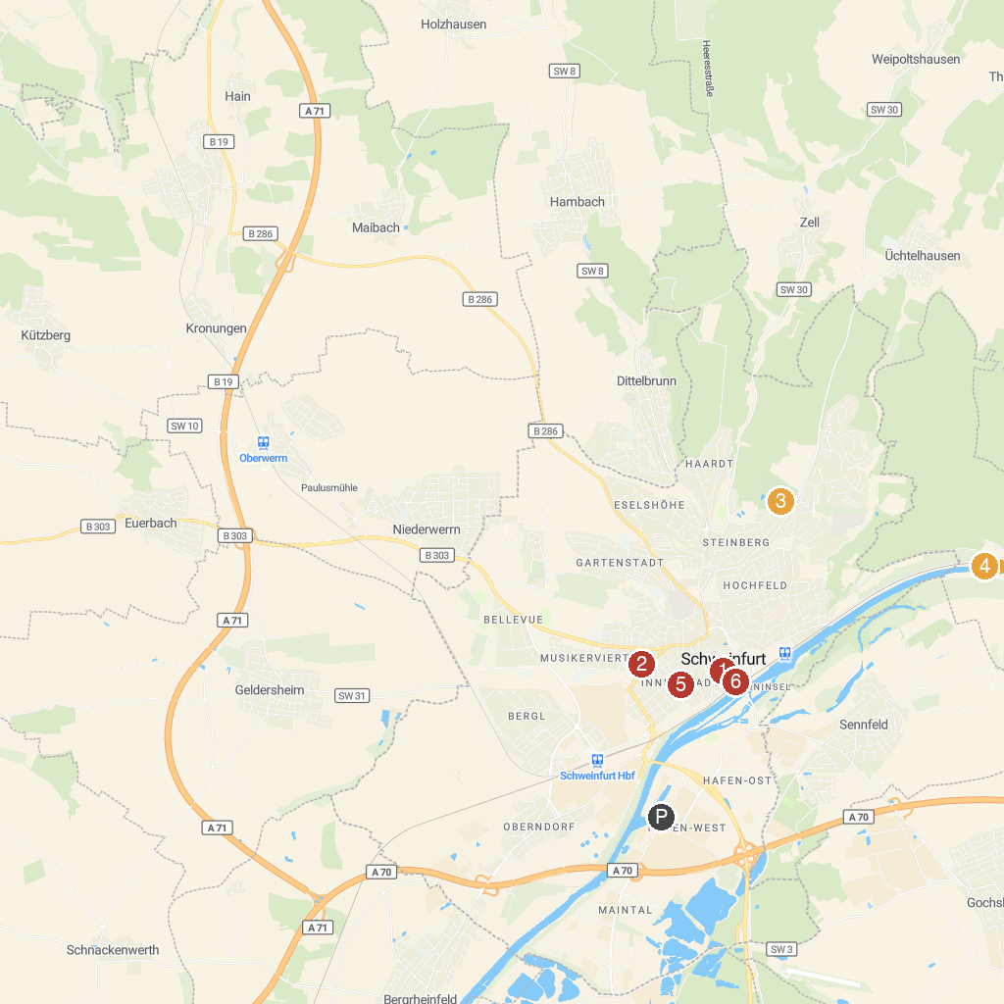
MAP KEY
1. Friedrich Rückert Denkmal | 4. Schloss Mainberg
2. St. Kilian | 5. Kunsthalle Schweinfurt
3. Wildpark an den Eichen | 6. Museum Georg Schäfer
P. Cruise port / terminal
Map © MapTiler © OpenStreetMap contributors · cruiseports.org

