Schwedt/Oder, Brandenburg, Germany
A peaceful Oder River stop where Baroque history meets wild wetlands — and Germany's only floodplain national park begins just beyond the pier.
⚓ Pier (river docking) · 🕒 Typical call: 6–8 hrs · 💶 Currency: Euro (€) · 🗣️ Language: German · 🚲 Cycle-friendly port
✍️ MY DAY IN PORT (FILL IN)
Ship / Date
In port | arrive ______ · all aboard ______
Booked excursion
Notes / meeting point
GETTING ASHORE
- Docking: Pier — Bollwerk Schwedt riverfront pontoon
- Walk to center: ~500–700 m (5–10 min, flat)
- Best For: Nature walks, cycling, national park wildlife
- Don't Miss: Lower Oder Valley National Park & Berliner Tor gate
GETTING AROUND
- 🚕 Taxi: €8–€15 — Local taxis are available from the port to Schwedt city center (roughly 3–5 km). The daytime base fare is €5 with ~€1.50
TOP THINGS TO DO
- Lower Oder Valley National Park — Germany's only floodplain national park sprawls across the polders south of town.
- Oder-Neisse Cycle Path Ride — One of Germany's most famous long-distance bike trails runs right through the port.
- Baroque Town Walk & Schlossgarten — The Margraves of Brandenburg-Schwedt left behind a grand park and the elegant Berliner Tor city gate, even as their palace was…
- Stadtmuseum Schwedt — A compact city museum inside a historic Huguenot-era house tracing Schwedt's story: Baroque splendor, WWII destruction, GDR…
- Birdwatching in the Polders — The Oder floodplains are one of Europe's premier stopover sites for migratory birds — tens of thousands of cranes and wild swans…
BEST WALKS
- Bollwerk to Berliner Tor & Schlossgarten: 1.2 km · 15 min · flat — Walk north from the pier along the Oder promenade, turn into the Lindenallee boulevard lined with…
- Town Center & St. Catherine's Church: 0.8 km · 10 min · flat — Head straight from the pier to the Karthausplatz town square and duck into the restored late-Gothic…
cruiseports.org/schwedt-oder · Confirm terminal & all-aboard time with your ship

Schwedt/Oder, Brandenburg, Germany — Port Map
Red = walkable sights · Amber = excursions farther out · P = cruise terminal
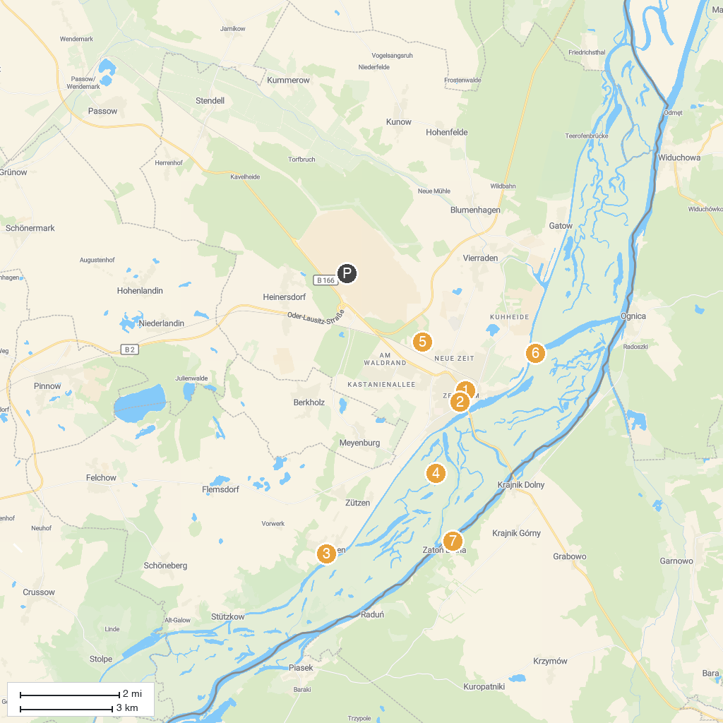
MAP KEY
1. Berlischky-Pavillon | 5. Nationalpark Unteres Odertal
2. Stadtmuseum | 6. Park Monplaisir
3. Schloss Criewen | 7. Schleuse Schwedt
4. Ratusz | 8. Valley of Love
P. Cruise port / terminal
Map © MapTiler © OpenStreetMap contributors · cruiseports.org

