Scarborough, Tobago, Trinidad and Tobago
Tobago's capital greets ships at a modern deepwater pier steps from the town center — with rainforest reserves, coral reefs, and rum-shack beaches just a short ride away.
⚓ Docked (deepwater pier) · 🕒 Typical call: 7-9 hrs · 💵 TTD / USD accepted · 🗣️ English · 🌴 Caribbean island
✍️ MY DAY IN PORT (FILL IN)
Ship / Date
In port | arrive ______ · all aboard ______
Booked excursion
Notes / meeting point
GETTING ASHORE
- Docking: Deep-water pier in town center — no tendering for most ships
- Walk to center: 5–10 min on foot to shops, market, and Fort King George taxi stand
- Best For: Snorkeling Buccoo Reef, Pigeon Point beach, colonial fort views
- Don't Miss: Nylon Pool glass-bottom boat tour and the Scarborough Municipal Market
GETTING AROUND
- 🚕 Taxi: USD $15–25 to Pigeon Point; negotiate beforehand — Licensed taxis (H-plates) wait at the pier. Fares are unmetered so agree on a price before you get in; US dollars widely
- 📱 Rideshare: ❌ not available
TOP THINGS TO DO
- Buccoo Reef & Nylon Pool Glass-Bottom Boat — A classic Tobago excursion: snorkel the living coral of Buccoo Reef then wade in the shallow, milky-clear Nylon Pool sandbar — a…
- Pigeon Point Heritage Park — Tobago's postcard beach: a thatched-roof jetty, calm turquoise water, and powdery white sand.
- Fort King George — 18th-century British fortification perched above Scarborough with sweeping views of the Caribbean.
- Argyle Waterfall Hike — Tobago's tallest waterfall cascades in three tiers through rainforest.
- Main Ridge Forest Reserve Birdwatching — The oldest protected rainforest in the Western Hemisphere is a birdwatcher's paradise — motmots, toucans, and hummingbirds thrive…
BEST WALKS
- Town Center & Market Stroll: 1 km · 20 min · Easy · Flat — Exit the cruise terminal gate onto Carrington Street, walk through the downtown grid to the…
- Up to Fort King George: 1.5 km · 30 min · Moderate · Uphill — From the market, follow Fort Street uphill to Fort King George.
WEATHER · DAYLIGHT · MONEY
Month | High °F | Low °F | Rainy days
May | 84 | 77 | 12
Jul | 83 | 77 | 24
Sep | 85 | 79 | 21
Daylight: May 5:40AM–6:18PM · Jul 5:47AM–6:30PM · Sep 5:52AM–6:03PM
cruiseports.org/scarborough · Confirm terminal & all-aboard time with your ship

Scarborough, Tobago, Trinidad and Tobago — Port Map
Red = walkable sights · Amber = excursions farther out · P = cruise terminal
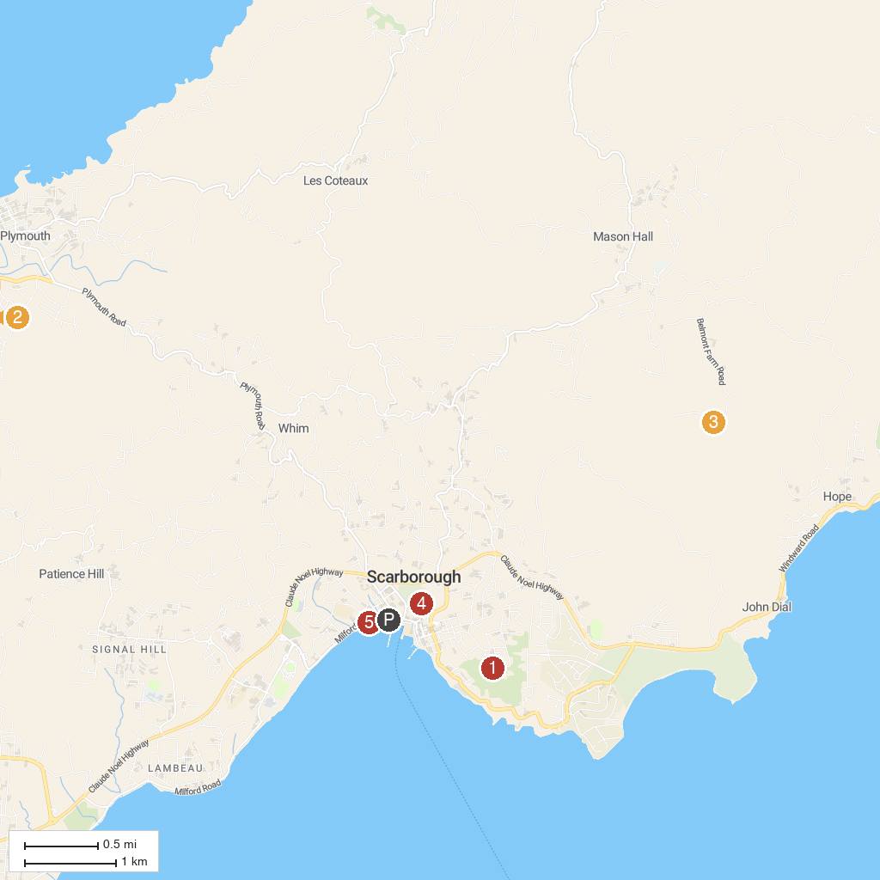
MAP KEY
1. Fort King George | 4. Corbin Local Wildlife
2. Fort Milford | 5. Scarborough Botanical Garden
3. Great Courland Bay (Turtle Beach) | 6. I Love Tobago Sign
P. Cruise port / terminal
Map © MapTiler © OpenStreetMap contributors · cruiseports.org

