Savusavu, Vanua Levu, Fiji
A sleepy yachting town on Fiji's second island, where geothermal vents bubble up through the waterfront, black pearls grow in the bay, and the coral reefs offshore rank among the Pacific's finest.
⚓ Tender (no cruise pier) · 🕒 Typical call: 6–8 hrs · 💵 Fijian Dollar (FJD) · 🗣️ Fijian / English
✍️ MY DAY IN PORT (FILL IN)
Ship / Date
In port | arrive ______ · all aboard ______
Booked excursion
Notes / meeting point
GETTING ASHORE
- Docking: Tender to Savusavu wharf
- Walk to center: ~5 min from wharf
- Best For: Diving · Pearls · Hot Springs
- Don't Miss: J. Hunter Pearls farm tour
GETTING AROUND
- 🚕 Taxi: FJ$2.30 flagfall + FJ$0.10/100m (~US$1–$8) — Taxis congregate at the dock and town center. Metered fares are regulated; agree on price before departing for out-of-to
- 📱 Rideshare: ❌ not available
TOP THINGS TO DO
- Savusavu Hot Springs — Geothermal vents right on the town waterfront bubble visibly at the surface — locals use them to boil corn on the cob.
- J. Hunter Pearls Farm Tour — Fiji's finest black pearl farm runs guided tours through its cultivation process — grafting, growing, and harvesting the…
- Diving & Snorkeling (Jean-Michel Cousteau area) — The reefs around Savusavu and Namena Marine Reserve offer some of Fiji's best diving — soft coral, manta rays, and excellent…
- Waisali Rainforest Reserve — A community-managed rainforest reserve in the Savusavu highlands with forest trails, bird life, and a waterfall.
- Lesiaceva Point & Bay Beaches — The peninsula east of town (Lesiaceva Point / Daku area) has calm, sheltered beaches backed by palms — good for swimming and a…
BEST WALKS
- Waterfront & Hot Springs Walk: ~1.5 km · 45 min · easy — From the wharf, stroll the main street past the Savusavu market, the waterfront hot springs (look…
- To J. Hunter Pearls Showroom: ~1 km · 20 min · easy — A short walk or quick taxi east along the waterfront road to the J.
WEATHER · DAYLIGHT · MONEY
Month | High °F | Low °F | Rainy days
May | 81 | 75 | 19
Jul | 79 | 73 | 16
Sep | 80 | 73 | 18
Daylight: May 6:19AM–5:38PM · Jul 6:32AM–5:44PM · Sep 5:58AM–5:57PM
cruiseports.org/savusavu · Confirm terminal & all-aboard time with your ship

Savusavu, Vanua Levu, Fiji — Port Map
Red = walkable sights · Amber = excursions farther out · P = cruise terminal
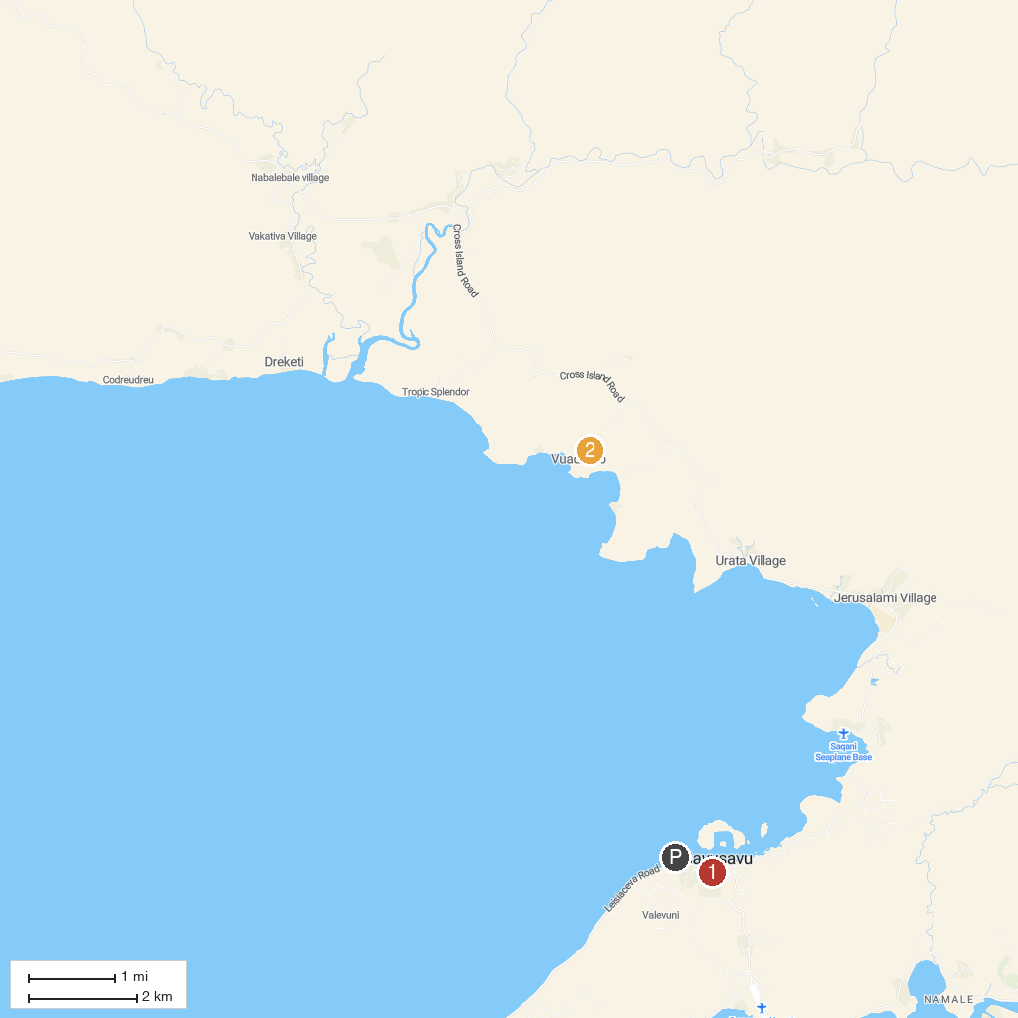
MAP KEY
1. Nakama Thermal Hot Springs | 2. Muanivatu Trails
P. Cruise port / terminal
Map © MapTiler © OpenStreetMap contributors · cruiseports.org

