Savona, Liguria, Italy
A real Italian city, not a tourist set. The Palacrociere terminal drops you steps from a medieval fortress, the best chickpea street food on the Riviera, and a world-class Apple Museum that makes absolutely no sense — and is perfect for it.
⚓ Pier (Palacrociere Terminal) · 🕒 Typical call: 8-10 hrs (often homeport) · 💶 Currency: Euro (€) · 🗣️ Language: Italian
✍️ MY DAY IN PORT (FILL IN)
Ship / Date
In port | arrive ______ · all aboard ______
Booked excursion
Notes / meeting point
GETTING ASHORE
- Docking: Always pier — Palacrociere Terminal, Berths 1 & 2
- Walk to center: 10 min to Via Paleocapa; 5 min to Old Harbor
- Best For: Authentic Italy, local food, day trips to Genoa or Cinque Terre
- Don't Miss: Farinata & Panissa street food; Priamar Fortress views
GETTING AROUND
- 🚕 Taxi: €5–€15 — Taxis are available outside the terminal. The short distance to the city center keeps fares low; longer trips to nearby
- 📱 Rideshare: ✅ Uber Taxi
TOP THINGS TO DO
- Priamar Fortress — Walk up to this massive 16th-century Genoese fortress that dominates the seafront.
- Savona's Sistine Chapel — Pope Sixtus IV — who commissioned the Roman original — built this Baroque mausoleum in Savona for his parents.
- Day Trip to Genoa — Board a direct train and reach Europe's largest medieval historic center in under an hour.
- Finale Ligure & Finalborgo — A 20-minute train ride brings you to one of Italy's most beautiful medieval walled villages, set above a good beach town on the…
- Fornaci Beach — Savona's Blue Flag city beach is a 15-20 minute walk west from the terminal along the Corso Colombo promenade.
BEST WALKS
- Old Harbor & Historic Center Loop: 2.5 km · 45-60 min · flat — Cross the drawbridge to the Vecchia Darsena, then walk past the Torre Leon Pancaldo to Via…
- Priamar Fortress Walk: 1.5 km · 30-40 min · gentle uphill — From the Old Harbor, follow the seafront promenade east to the base of the Priamar headland.
WEATHER · DAYLIGHT · MONEY
Month | High °F | Low °F | Rainy days
May | 69 | 57 | 14
Jul | 82 | 70 | 9
Sep | 77 | 64 | 9
Daylight: May 5:59AM–8:46PM · Jul 5:56AM–9:07PM · Sep 7:05AM–7:36PM
cruiseports.org/savona · Confirm terminal & all-aboard time with your ship

Savona, Liguria, Italy — Port Map
Red = walkable sights · Amber = excursions farther out · P = cruise terminal
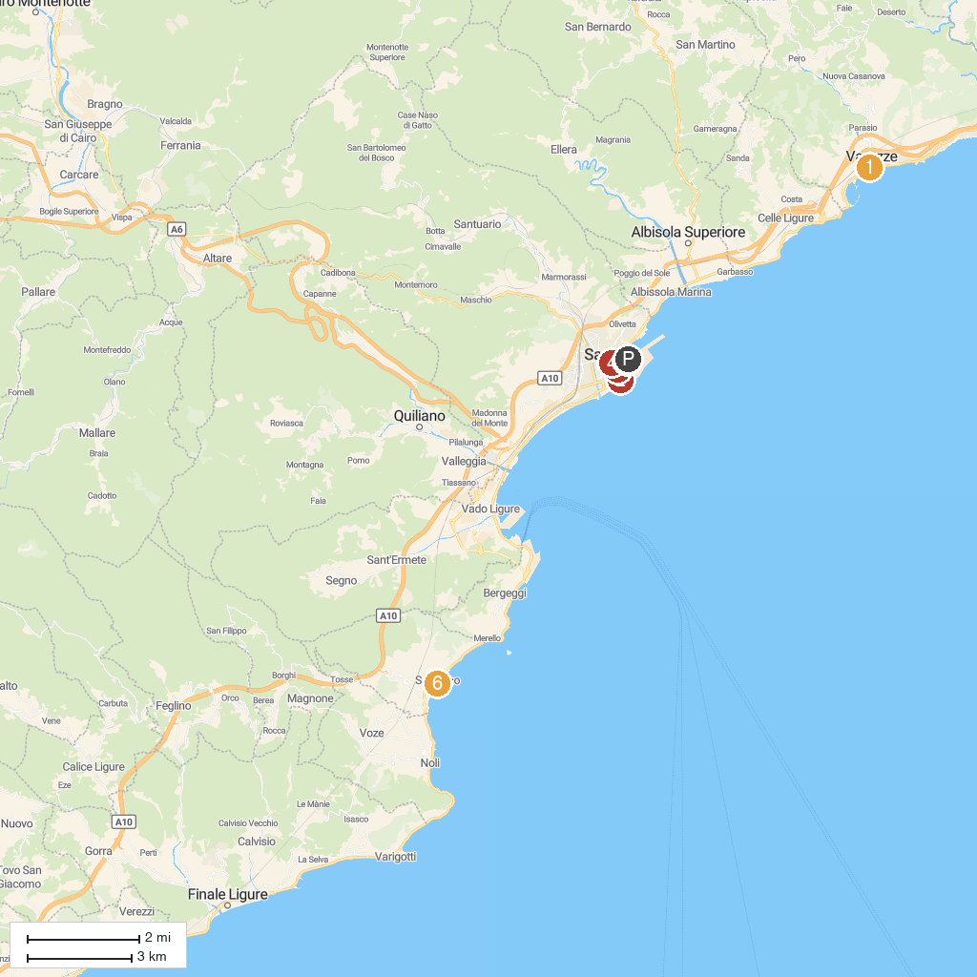
MAP KEY
1. Parrocchia di S. Ambrogio | 5. All About Apple Museum
2. Museo Sandro Pertini e Renata Cuneo | 6. Bagni Astoria
3. Torre Brandale | 7. Church of San Paragorio
4. Oratorio del Cristo Risorto
P. Cruise port / terminal
Map © MapTiler © OpenStreetMap contributors · cruiseports.org

