Saverne, Alsace, France
Saverne sits where the Vosges Mountains meet the Alsatian plain, its glowing pink-sandstone château mirrored in the Marne-Rhine Canal. Step off the barge and you're already at the palace gates.
⚓ Docked (canal quay) · 🕒 Typical call: 6–8 hrs · 💶 Euro (€) · 🗣️ French / Alsatian dialect
✍️ MY DAY IN PORT (FILL IN)
Ship / Date
In port | arrive ______ · all aboard ______
Booked excursion
Notes / meeting point
GETTING ASHORE
- Docking: Canal quayside at Port de Plaisance — no tender, flat gangway onto paved towpath
- Walk to center: 3–5 min to Grand Rue; Château des Rohan right at the dock
- Best For: Alsatian architecture, flammekueche, rose gardens, castle hiking
- Don't Miss: Château du Haut-Barr ruins — the "Eye of Alsace" with sweeping Rhine Plain views
GETTING AROUND
- 🚕 Taxi: €10–€20 — Local taxis are available in Saverne for short trips. The town is compact so fares are typically modest; short hops with
- 📱 Rideshare: ✅ Uber
TOP THINGS TO DO
- Château des Rohan & Museum — The "Alsatian Versailles" — a massive 18th-century pink sandstone palace whose formal gardens spill down to the canal.
- Château du Haut-Barr Castle Ruins — Perched 470 m above town on three sandstone outcrops, the "Eye of Alsace" delivers sweeping views of the Rhine plain.
- La Roseraie — Saverne Rose Garden — France's second-oldest rose garden, with 8,500 rose bushes representing 800 varieties, set at the foot of the Vosges foothills.
- Grand Rue Walking Tour & Maison Katz — Saverne's pedestrianised main street is lined with colourful half-timbered Alsatian houses.
- Alsatian Winstub Lunch — Settle into a local Winstub (Alsatian tavern) for flammekueche fresh from a wood-fired oven, choucroute garnie, and a glass of…
BEST WALKS
- Canal Quay to Maison Katz Town Walk: 1.2 km · 20 min · Flat — From the Port de Plaisance, cross to the Château des Rohan gardens, stroll along Quai du Château…
- Canal Towpath to the Rose Garden: 1.5 km one way · 30 min · Flat — Head west along the shaded Marne-Rhine Canal towpath from the marina to La Roseraie.
WEATHER · DAYLIGHT · MONEY
Month | High °F | Low °F | Rainy days
May | 66 | 50 | 12
Jul | 79 | 61 | 11
Sep | 71 | 54 | 9
Daylight: May 5:49AM–9:05PM · Jul 5:44AM–9:28PM · Sep 7:07AM–7:42PM
cruiseports.org/saverne · Confirm terminal & all-aboard time with your ship

Saverne, Alsace, France — Port Map
Red = walkable sights · Amber = excursions farther out · P = cruise terminal
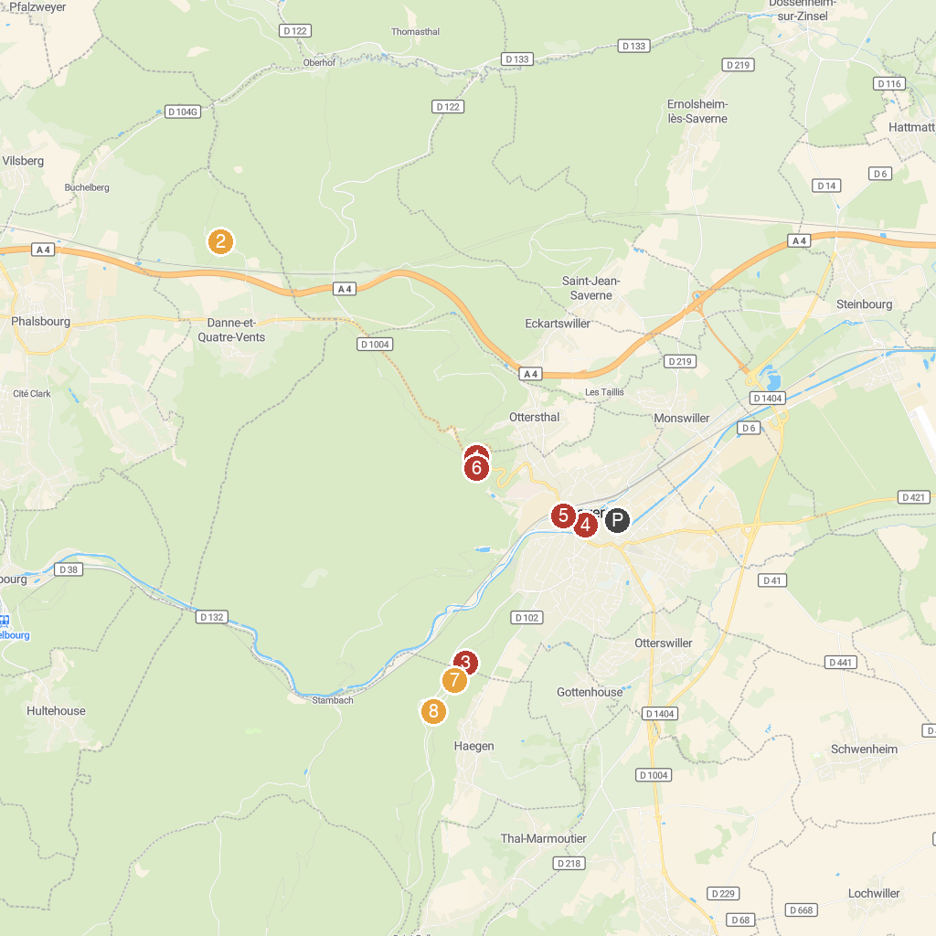
MAP KEY
1. du col de Saverne Botanical Garden | 5. La Roseraie de Saverne
2. Pélerinage Notre-Dame-de-Bonne-Fontaine | 6. Rocher du Saut du Prince Charles
3. Château du Haut-Barr | 7. Saverne semaphore tower
4. Locks No. 30 - 31 | 8. Château du Grand-Geroldseck
P. Cruise port / terminal
Map © MapTiler © OpenStreetMap contributors · cruiseports.org

