Savannah, Tennessee, USA
A quiet Tennessee River town with enormous Civil War footprints — Shiloh's battlefield lies just 10 miles away, and Savannah's own storied streets connect you to Grant, gunboats, and Southern catfish tradition.
⚓ River dock (Wayne Jerrolds River Park) · 🕒 Typical call: 6-8 hrs · 💵 USD · 🗣️ English
✍️ MY DAY IN PORT (FILL IN)
Ship / Date
In port | arrive ______ · all aboard ______
Booked excursion
Notes / meeting point
GETTING ASHORE
- Docking: River dock at Wayne Jerrolds River Park on the Tennessee River — ships tie up dockside, no tendering
- Walk to center: Downtown Savannah is a short walk (~5 min) from the river park
- Best For: Civil War history, river scenery, small-town Southern culture, catfish dining
- Don't Miss: Shiloh National Military Park — one of the best-preserved Civil War battlefields in the US
GETTING AROUND
- 🚕 Taxi: Varies — River City Taxi (731-925-0366) is the local cab service. Useful for reaching Shiloh battlefield (~10 miles) or Pickwick
- 📱 Rideshare: ✅ Uber
TOP THINGS TO DO
- Shiloh National Military Park — One of the Civil War's bloodiest two-day battles (April 1862) is preserved across nearly 4,000 acres.
- Tennessee River Museum — Traces the Tennessee River Valley from prehistoric Native Americans and the Trail of Tears through the Civil War gunboat era to…
- Savannah Historic District Walk — A self-guided 2-mile loop through 41 preserved historic homes and structures, the downtown Savannah Theater, and the old cemetery.
- Pickwick Landing State Park — A recreation hub on Pickwick Lake — roughly 43,000 acres of clear TVA reservoir water with fishing, hiking, birdwatching, and an…
- Catfish Country Dining — Savannah bills itself the "Catfish Capital of the World." Hagy's Catfish Hotel — a Tennessee institution since 1938 — serves…
BEST WALKS
- Riverfront to Historic Downtown: 0.5 miles · Easy · 15-20 min — Stroll from Wayne Jerrolds River Park along the Tennessee River bank, past the riverfront park…
- Savannah Historic District Loop: 2 miles · Easy · 45-60 min — Pick up the self-guided brochure at the Tennessee River Museum and walk past 41 historic homes…
WEATHER · DAYLIGHT · MONEY
Month | High °F | Low °F | Rainy days
May | 83 | 65 | 10
Jul | 90 | 75 | 18
Sep | 84 | 70 | 15
Daylight: May 6:26AM–8:15PM · Jul 6:29AM–8:31PM · Sep 7:08AM–7:29PM
cruiseports.org/savannah-tn · Confirm terminal & all-aboard time with your ship

Savannah, Tennessee, USA — Port Map
Red = walkable sights · Amber = excursions farther out · P = cruise terminal
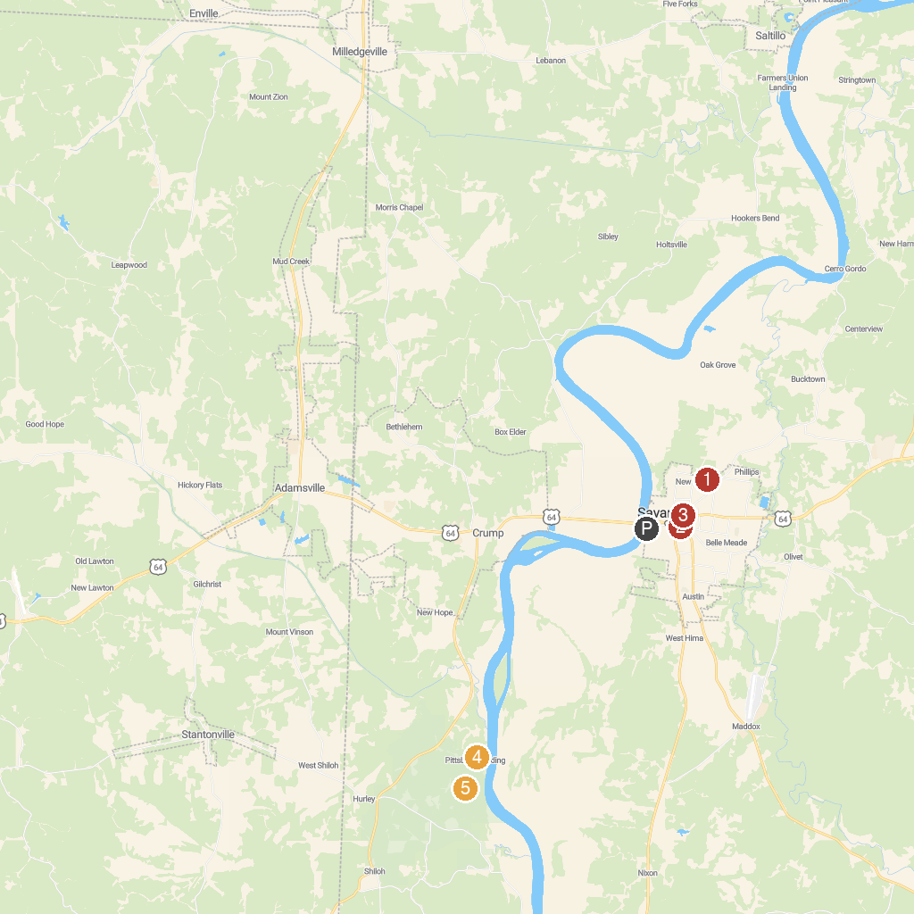
MAP KEY
1. Buford Pusser Home & Museum | 5. Shiloh Battlefield Visitor Center
2. Savannah Parks & Recreation - Baseball field | 6. Shiloh National Military Park
3. Savannah Veterans' Park | 7. Shiloh Indian Mounds National Historic Landmark
4. Tennessee Street Park | 8. The Hornet’s Nest
P. Cruise port / terminal
Map © MapTiler © OpenStreetMap contributors · cruiseports.org

