Savannah, Georgia, USA
One of America's best-preserved historic cities, Savannah greets river cruisers with Spanish moss–draped squares, Federal-era mansions, and a lively waterfront just steps from the dock.
⚓ Docked – River Street Market Landing · 🕒 Typical call: full day · 💵 USD · 🗣️ English · 🚶 Extremely walkable
✍️ MY DAY IN PORT (FILL IN)
Ship / Date
In port | arrive ______ · all aboard ______
Booked excursion
Notes / meeting point
GETTING ASHORE
- Docking: Docked at River Street Market Landing, downtown Savannah
- Walk to center: Steps — River Street and City Market are immediately adjacent
- Best For: History lovers, architecture, Southern food, ghost tours
- Don't Miss: Forsyth Park fountain & Bonaventure Cemetery
GETTING AROUND
- 🚕 Taxi: $12–$18 — Metered taxis are readily available at the Savannah cruise terminal. The Historic District is about 3–4 miles away; city
- 📱 Rideshare: ✅ Uber, Lyft
- 🚌 Hop-on hop-off: ✅ Old Town Trolley Tours
TOP THINGS TO DO
- Historic District Trolley Tour — Hop-on hop-off narrated trolley routes cover all 22 squares, Forsyth Park, Juliette Gordon Low's birthplace, and the Victorian…
- Bonaventure Cemetery Walk — Made famous by 'Midnight in the Garden of Good and Evil,' this Victorian-era cemetery along the Wilmington River is hauntingly…
- Wormsloe Historic Site — A breathtaking 1.5-mile avenue of live oaks leads to the ruins of colonial Georgia's oldest standing structure.
- Tybee Island Beach Day — Just 18 miles east of downtown, Tybee Island has sandy Atlantic beaches, a historic lighthouse, and dolphin eco-tours.
- Southern Food & Squares Self-Walk — Grab a to-go cup (Savannah allows open containers in the Historic District) and graze your way through City Market — Low Country…
BEST WALKS
- River Street to Forsyth Park: 1.5 miles one-way · ~35 min · flat — Start on cobblestone River Street at the waterfront, climb to Bay Street, then stroll south through…
- City Market & Cathedral Loop: 0.8 miles · ~20 min · flat — A short loop from the waterfront to City Market (galleries, restaurants, live music courtyard)…
WEATHER · DAYLIGHT · MONEY
Month | High °F | Low °F | Rainy days
May | 83 | 65 | 10
Jul | 90 | 75 | 18
Sep | 84 | 70 | 15
Daylight: May 6:26AM–8:15PM · Jul 6:29AM–8:31PM · Sep 7:08AM–7:29PM
cruiseports.org/savannah-ga · Confirm terminal & all-aboard time with your ship

Savannah, Georgia, USA — Port Map
Red = walkable sights · Amber = excursions farther out · P = cruise terminal
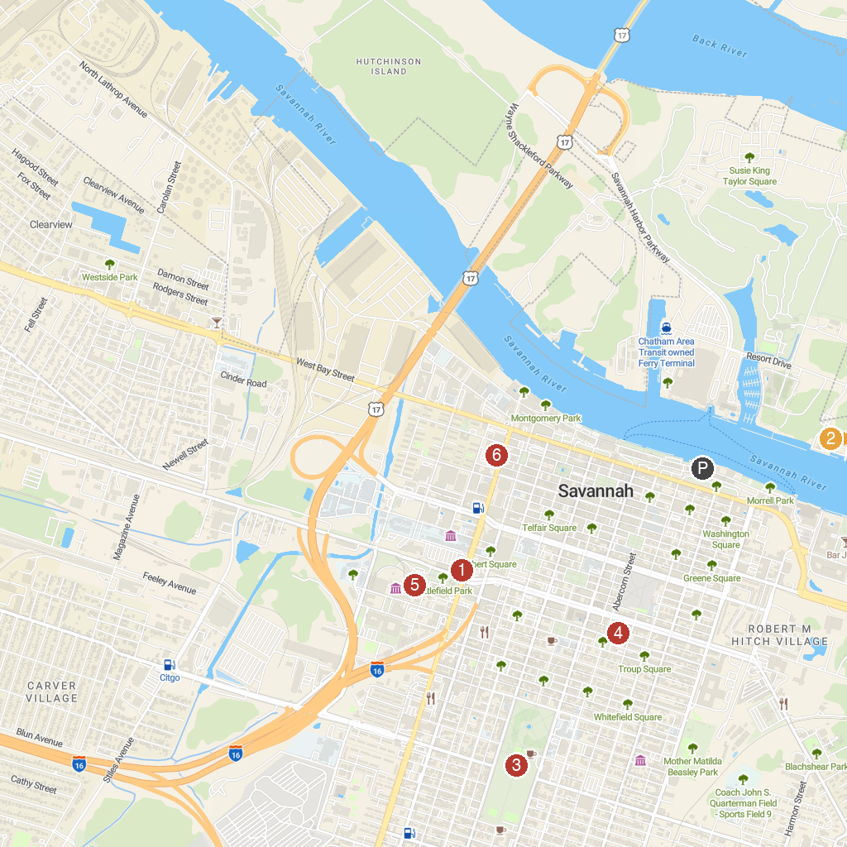
MAP KEY
1. Savannah Historic District | 5. The Cathedral Basilica of St. John the Baptist
2. Old Fort Jackson | 6. Georgia State Railroad Museum
3. Forsyth Park | 7. Ships Of The Sea Maritime Museum
4. Skidaway Island State Park
P. Cruise port / terminal
Map © MapTiler © OpenStreetMap contributors · cruiseports.org

