Sault Ste Marie, Ontario, Canada
Known as 'The Soo,' this twin-city port straddles the US-Canada border where all Great Lakes shipping must pass through the legendary Soo Locks — watch 1,000-foot freighters slide through with inches to spare.
⚓ Pier (Roberta Bondar Marina) · 🕒 Typical call: 8-10 hrs · 💵 Canadian Dollar (CAD) / USD across border · 🗣️ English · 🌊 Great Lakes
✍️ MY DAY IN PORT (FILL IN)
Ship / Date
In port | arrive ______ · all aboard ______
Booked excursion
Notes / meeting point
GETTING ASHORE
- Docking: Pier — Roberta Bondar Marina, Canadian side
- Walk to center: 3–5 min to Queen St, 12–15 min to Bushplane Museum
- Best For: Engineering history, Great Lakes freighters, Canadian wilderness
- Don't Miss: Watching a laker transit the Soo Locks
GETTING AROUND
- 🚕 Taxi: C$5–C$15 — Local taxis (UCab, Soo Yellow Cab) operate citywide with metered fares starting at C$4.40 plus C$1.80/km. The cruise ter
- 📱 Rideshare: ✅ Uride, EZ Ride
- 🚌 Hop-on hop-off: ✅ Big Ben Double-Decker Bus
TOP THINGS TO DO
- Soo Locks Park & Observation Deck — Stand on the US observation platform and watch 1,000-foot Great Lakes freighters squeeze through the locks with inches of…
- Canadian Bushplane Heritage Centre — Hands-on museum in an original hangar showcasing the history of bush flying and forest firefighting.
- Soo Locks Boat Tour — Board a tour boat from the Canadian marina and transit through both the US and Canadian lock systems — getting the laker-eye view…
- Museum Ship Valley Camp (US side) — A retired 550-foot Great Lakes freighter turned museum with 100+ exhibits including two lifeboats from the Edmund Fitzgerald.
- Ermatinger-Clergue National Historic Site — Two of the oldest stone buildings northwest of Toronto, depicting fur trade and pioneer life from 1808–1870.
BEST WALKS
- Waterfront Boardwalk to Bushplane Museum: 2.5 km round-trip | Flat | ~40 min — Head east from Roberta Bondar Park along the 2 km waterfront boardwalk, passing public art and…
- Downtown Heritage Walk: 1.5 km loop | Flat | ~30 min — From the pier, stroll up to Queen Street for shops and cafes, then swing by Ermatinger-Clergue…
WEATHER · DAYLIGHT · MONEY
Month | High °F | Low °F | Rainy days
May | 60 | 41 | 9
Jul | 74 | 57 | 10
Sep | 67 | 53 | 12
Daylight: May 6:03AM–9:04PM · Jul 6:00AM–9:26PM · Sep 7:16AM–7:48PM
cruiseports.org/sault-ste-marie · Confirm terminal & all-aboard time with your ship

Sault Ste Marie, Ontario, Canada — Port Map
Red = walkable sights · Amber = excursions farther out · P = cruise terminal
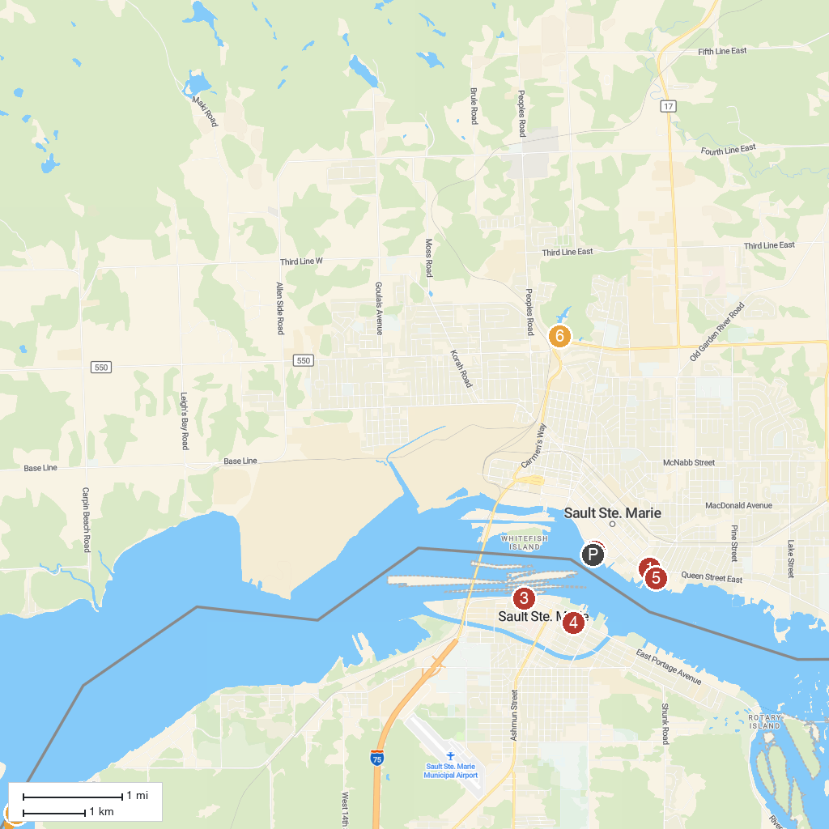
MAP KEY
1. Ermatinger Clergue National Historic Site | 5. Entomica Insectarium
2. Roberta Bondar Park and Tent Pavilion | 6. Fort Creek Conservation Area
3. Great Lakes Shipwreck Historical Society | 7. Round Island Point Nature Preserve
4. Holy Name of Mary Proto-Cathedral Catholic Church, Sault Sainte Marie
P. Cruise port / terminal
Map © MapTiler © OpenStreetMap contributors · cruiseports.org

