Sassnitz, Rügen, Germany
Germany's largest island delivers dramatic chalk cliffs plunging into the Baltic, dense UNESCO beech forests, and a charming harbor town rich in 19th-century resort heritage.
⚓ Pier (Mukran Port, 6 km from town) · 🕒 Typical call: 8–10 hrs · 💶 Euro (€) — carry cash · 🗣️ German (English in tourist areas)
✍️ MY DAY IN PORT (FILL IN)
Ship / Date
In port | arrive ______ · all aboard ______
Booked excursion
Notes / meeting point
GETTING ASHORE
- Docking: Pier at Mukran Port, ~6 km south of Sassnitz town; shuttle or taxi required
- Walk to center: Not walkable from Mukran — take cruise shuttle, bus Line 22, or taxi
- Best For: Chalk cliff hikes, UNESCO beech forests, Baltic seafood, amber hunting
- Don't Miss: Königsstuhl cliff skywalk in Jasmund National Park
GETTING AROUND
- 🚕 Taxi: €17–21 — Taxis wait at Mukran Port and can take you to Sassnitz town center (~7 km, ~9 min). Base fare is €4.00 with regulated pe
TOP THINGS TO DO
- Jasmund National Park & Königsstuhl Skywalk — Hike cliffside trails through ancient beech forest to the 118-meter Königsstuhl chalk cliff.
- Prora — The Colossus of Rügen — A 4.5 km concrete monolith built by the Nazis for 20,000 holidaymakers that was never completed.
- HMS Otus Submarine Museum — Climb inside a decommissioned British Oberon-class submarine moored in Sassnitz's Old Harbor.
- Binz Beach & Resort Promenade — Rügen's premier Baltic resort — wide sandy beach, classic wicker Strandkörbe chairs, an elegant pier, and grand white spa villas…
- Hochuferweg Cliff Path Hike — Walk the free cliffside trail through Jasmund's old-growth beech forest, with glimpses of the Baltic far below.
BEST WALKS
- Sassnitz Harbor Stroll: 1.5 km · 30 min · Easy · Free — From the Old Harbor, walk out along the Sassnitz Mole — a 1.45 km stone breakwater ending at the…
- Old Town & Bäderarchitektur: 1 km · 20 min · Easy · Free — Wander the steep streets of Sassnitz's historic center.
WEATHER · DAYLIGHT · MONEY
Month | High °F | Low °F | Rainy days
May | 57 | 49 | 9
Jul | 68 | 61 | 14
Sep | 64 | 57 | 10
Daylight: May 5:00AM–9:04PM · Jul 4:50AM–9:31PM · Sep 6:38AM–7:21PM
cruiseports.org/sassnitz-rugen · Confirm terminal & all-aboard time with your ship

Sassnitz, Rügen, Germany — Port Map
Red = walkable sights · Amber = excursions farther out · P = cruise terminal
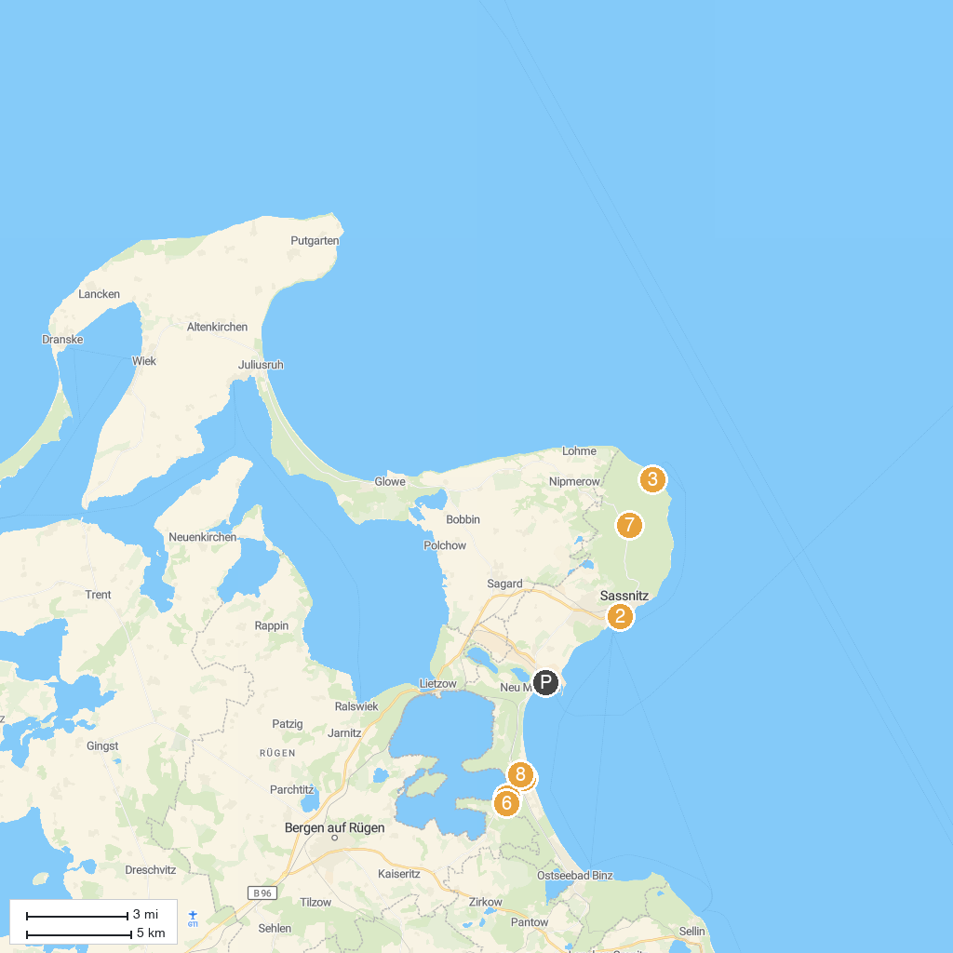
MAP KEY
1. Sassnitz Ferry Port GmbH | 5. Baumwipfelpfad im Naturerbe Zentrum Rügen
2. Erlebniswelt U-Boot | 6. Aussichtplattform Adlerhorst - Baumwipfelpfad Rügen Naturerbezentrum Rügen
3. Victoria-Sicht | 7. Jasmund National Park
4. Sand sculpture festival in Binz | 8. Rügen Railway & Technology Museum
P. Cruise port / terminal
Map © MapTiler © OpenStreetMap contributors · cruiseports.org

