Sark Island, Channel Islands, UK
The last feudal state in Europe until 2008, Sark bans all motor vehicles — the only sounds here are birdsong, wind, and the clatter of horse hooves on gravel lanes.
⚓ Tender port · 🕒 Typical call: 6-8 hrs · 💷 GBP / Guernsey Pound · 🗣️ English · 🌑 World's first Dark Sky Island
✍️ MY DAY IN PORT (FILL IN)
Ship / Date
In port | arrive ______ · all aboard ______
Booked excursion
Notes / meeting point
GETTING ASHORE
- Docking: Tender — ships anchor offshore; tenders land at Maseline Harbour or Creux Harbour
- Walk to centre: Steep Harbour Hill climb (~10 min) or ride the iconic "Toast-Rack" tractor-bus (£2 cash)
- Best For: Cycling, cliff walks, La Coupée isthmus, cream teas, total digital detox
- Don't Miss: La Coupée — a 260 ft drop on either side of a narrow stone causeway connecting Great & Little Sark
GETTING AROUND
- 📱 Rideshare: ❌ not available
TOP THINGS TO DO
- La Coupée & Little Sark — Walk the narrow stone causeway with a 260-foot sheer drop on both sides to reach Little Sark.
- Bicycle Island Circuit — Hire a bike at the top of Harbour Hill and loop Sark's gravel lanes past cliff-top viewpoints, La Seigneurie, and the Window in…
- La Seigneurie Gardens — Visit the walled gardens of the island's feudal lord.
- Dixcart Bay Beach — A 20-minute walk downhill through wooded Dixcart Valley brings you to a secluded pebble-and-sand beach framed by high cliffs.
- Sark Village & Cream Tea — Wander The Avenue, peek into the Sark Museum (donation entry), find the world's smallest active prison (two cells), and settle in…
BEST WALKS
- Village to La Coupée: 5 km round trip · 1.5-2 hrs · Mostly flat — From The Avenue walk southwest along Rue de la Seigneurie past La Seigneurie Gardens, then continue…
- Harbour Hill to Dixcart Bay: 3 km round trip · 1-1.5 hrs · Downhill out, uphill return — From the village head east through Dixcart Valley woodland to reach Dixcart Bay beach.
WEATHER · DAYLIGHT · MONEY
Month | High °F | Low °F | Rainy days
May | 54 | 51 | 10
Jul | 62 | 59 | 7
Sep | 63 | 60 | 10
Daylight: May 5:25AM–8:46PM · Jul 5:20AM–9:10PM · Sep 6:46AM–7:22PM
cruiseports.org/sark-island · Confirm terminal & all-aboard time with your ship

Sark Island, Channel Islands, UK — Port Map
Red = walkable sights · Amber = excursions farther out · P = cruise terminal
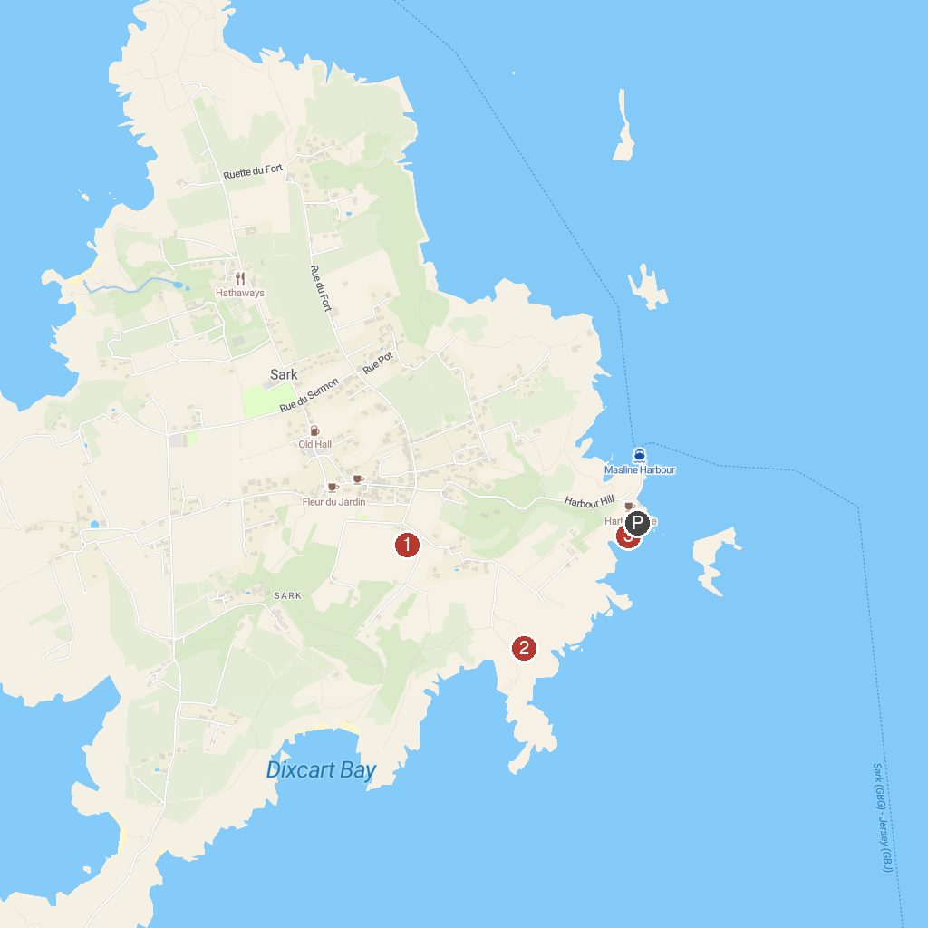
MAP KEY
1. La Valette Underground Military Museum | 5. Sark Henge
2. Clarence Battery | 6. Creux Harbour
3. Guernsey Museum at Candie | 7. Beau Sejour Leisure Centre
4. Sark Bike Hire | 8. Vale Castle
P. Cruise port / terminal
Map © MapTiler © OpenStreetMap contributors · cruiseports.org

