Sarande, Albanian Riviera, Albania
Tucked between mountains and the sparkling Ionian Sea, Sarande punches well above its weight — a UNESCO World Heritage site 18 km away, a mysterious bottomless spring inland, and postcard beaches at Ksamil, all for Albanian prices.
⚓ Pier (small ships) or Tender (large ships) · 🕒 Typical call: 8-10 hrs · 💶 Currency: Albanian Lek (Euros widely accepted) · 🗣️ Language: Albanian (English & Italian spoken in tourist areas)
✍️ MY DAY IN PORT (FILL IN)
Ship / Date
In port | arrive ______ · all aboard ______
Booked excursion
Notes / meeting point
GETTING ASHORE
- Docking: Pier for smaller ships; large ships anchor and tender in
- Walk to center: 5 min from pier; 10 min from tender dock to promenade
- Best For: Ancient ruins, natural wonders, Ionian beaches, budget dining
- Don't Miss: Butrint National Park (UNESCO) and the Blue Eye spring
GETTING AROUND
- 🚕 Taxi: €5–€15 — Taxis are available near the port and Nëne Tereza Square. Fares are not metered — agree on the price before departing. S
- 📱 Rideshare: ✅ Patoko, Clust, VrapOn
TOP THINGS TO DO
- Butrint National Park (UNESCO) — An extraordinary archaeological park 18 km south of Sarande spanning Greek, Roman, Byzantine, and Venetian ruins set in a lush…
- Blue Eye Spring (Syri i Kaltër) — A surreal karst spring 30 minutes inland whose deep sapphire center — surrounded by rings of turquoise — looks exactly like a…
- Ksamil Beach & Islands — Dubbed the 'Maldives of Albania', Ksamil village (14 km south) boasts white-sand beaches, impossibly clear water, and three small…
- Ionian Speedboat Tour — Explore hidden sea caves, wild coves, and remote beaches like Kakome inaccessible by land.
- Sarande Town Walk: Promenade & Lekursi Castle — Stroll the palm-lined Lungomare, explore the 5th-century synagogue ruins with mosaic floors, then take a taxi up to 16th-century…
BEST WALKS
- Lungomare Promenade to Synagogue Ruins: 1.5 km · 20 min · Flat & paved — Walk east along the palm-lined promenade from the pier, passing cafes and restaurants, then turn…
- Monastery of 40 Saints Ruins: 1 km from pier · Easy uphill · 30 min — A short walk up from the waterfront leads to the ruins of the Byzantine monastery that gives…
WEATHER · DAYLIGHT · MONEY
Month | High °F | Low °F | Rainy days
May | 73 | 58 | 10
Jul | 88 | 71 | 3
Sep | 80 | 65 | 8
Daylight: May 5:25AM–7:47PM · Jul 5:24AM–8:07PM · Sep 6:21AM–6:48PM
cruiseports.org/sarande · Confirm terminal & all-aboard time with your ship

Sarande, Albanian Riviera, Albania — Port Map
Red = walkable sights · Amber = excursions farther out · P = cruise terminal
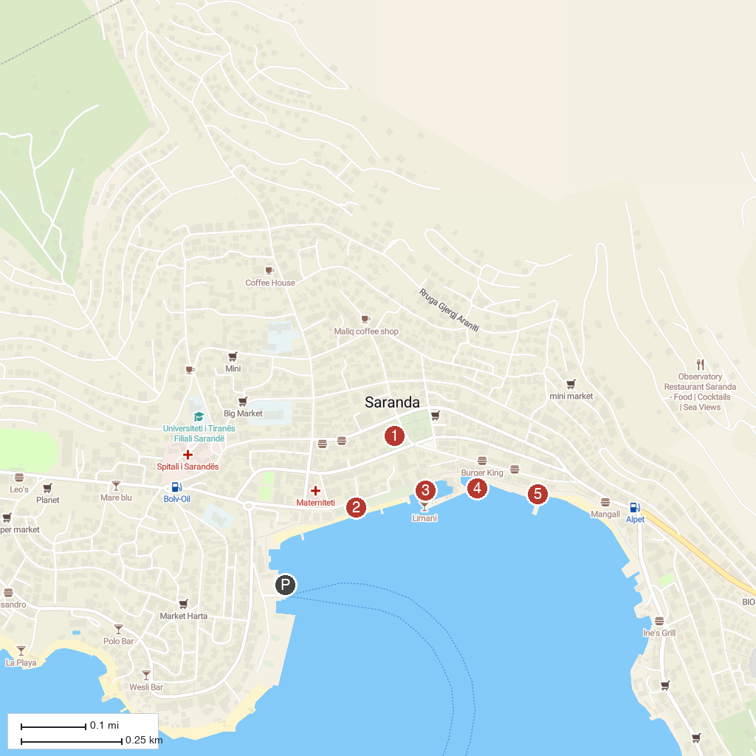
MAP KEY
1. Synagogue - Basilica, Archeological Remains | 4. Joni Tour Sarande
2. Hasan Tahsini Monument | 5. Prince Ennio
3. Agios Spiridon Beach | 6. Jet ski place
P. Cruise port / terminal
Map © MapTiler © OpenStreetMap contributors · cruiseports.org

