Tomakomai, Hokkaido, Japan
Hokkaido's industrial port punches above its weight: it's your launchpad to cosmopolitan Sapporo, the jaw-dropping Upopoy Ainu national park, and the crystalline waters of Lake Shikotsu — all within 90 minutes.
⚓ Pier (docked) · 🕒 Typical call: 8-10 hrs · 💴 Japanese Yen (JPY) · 🗣️ Japanese
✍️ MY DAY IN PORT (FILL IN)
Ship / Date
In port | arrive ______ · all aboard ______
Booked excursion
Notes / meeting point
GETTING ASHORE
- Docking: Pier — all ships dock at Tomakomai Port
- Walk to center: ~10 min to Sea Station Plat market; Sapporo 1 hr by train
- Best For: Sapporo city day trip, Ainu culture, volcanic scenery
- Don't Miss: Upopoy National Ainu Museum (opened 2020) near Shiraoi
GETTING AROUND
- 🚕 Taxi: ¥1,800–¥2,200 (~$12–14) — Taxis from Tomakomai West Port Ferry Terminal to Tomakomai Station take about 5–10 minutes. Meters run; no pre-negotiati
- 📱 Rideshare: ✅ Uber
TOP THINGS TO DO
- Sapporo City Highlights — Hit Sapporo's must-sees: Odori Park and the TV Tower for skyline views, the 1878 Clock Tower, and the grand red-brick Former…
- Upopoy National Ainu Museum — Japan's landmark Ainu cultural center opened in 2020 near Shiraoi (between Tomakomai and Sapporo).
- Lake Shikotsu — Japan's northernmost non-freezing caldera lake sits ~45 min from the port.
- Sapporo Beer Museum & Garden — Sapporo was literally built on beer — the historic 1890s brewery complex includes a free museum tracing Japan's brewing history…
- Mount Tarumae Hike — This active stratovolcano above Lake Shikotsu offers a rewarding climb with fumaroles venting at the summit crater.
BEST WALKS
- Tomakomai Waterfront & Sea Station: 1 km · 15 min · Flat — A short stroll from the cruise pier to the Sea Station Plat Seaport Market — a lively seafood…
- Sapporo City Center Walk: 3 km · 45 min · Flat — From Sapporo Station, walk south through Odori Park to the Clock Tower and Former Hokkaido…
WEATHER · DAYLIGHT · MONEY
Month | High °F | Low °F | Rainy days
May | 59 | 46 | 12
Jul | 72 | 63 | 14
Sep | 70 | 59 | 15
Daylight: May 4:11AM–6:48PM · Jul 4:09AM–7:09PM · Sep 5:13AM–5:43PM
cruiseports.org/sapporo-tomakomai · Confirm terminal & all-aboard time with your ship

Tomakomai, Hokkaido, Japan — Port Map
Red = walkable sights · Amber = excursions farther out · P = cruise terminal
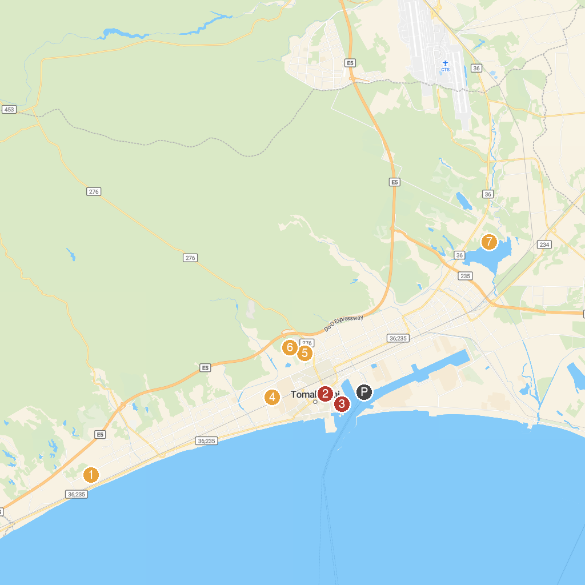
MAP KEY
1. Yunominoyu Hot Spring | 5. Hokkocho Mirainomori Park
2. Hokusei Park | 6. Tomakomai Midorigaoka Park
3. Tomakomaishi Sun Garden | 7. Kintaro Pond
4. Minato Park | 8. Lake Utonai Sanctuary
P. Cruise port / terminal
Map © MapTiler © OpenStreetMap contributors · cruiseports.org

