Otaru, Hokkaido, Japan
Ships dock at Otaru, a beautifully preserved Meiji-era port town on Hokkaido's Ishikari Bay. From canal-side gas lamps to legendary sushi alleys — and a quick train to Sapporo — this is one of Japan's most rewarding cruise calls.
⚓ Pier (docked) · 🕒 Typical call: 8-10 hrs · 💴 Currency: Japanese Yen (JPY) · 🗣️ Language: Japanese · 🚂 Sapporo: 35 min by train
✍️ MY DAY IN PORT (FILL IN)
Ship / Date
In port | arrive ______ · all aboard ______
Booked excursion
Notes / meeting point
GETTING ASHORE
- Docking: Pier — No. 3 Wharf (small ships, walkable) or Katsunai Wharf (large ships, shuttle needed)
- Walk to Otaru Canal: 10 min from No. 3 Wharf; shuttle + 10 min from Katsunai
- Best For: Sushi, historic canal walks, glasswork shopping, Sapporo day trip
- Don't Miss: Kaisen-don at Sankaku Market and the canal at dusk
GETTING AROUND
- 🚕 Taxi: ¥1,200–¥1,500 — Taxis are available at the pier and take under 10 minutes to the city center. Primarily needed from Katsunai Wharf (~3 k
- 📱 Rideshare: ✅ Uber, GO Taxi
TOP THINGS TO DO
- Otaru Canal & Sakaimachi Street — Walk the 1923 canal lined with stone warehouses converted into cafes, shops, and glass studios.
- Sushi & Seafood at Sankaku Market — Otaru's Triangle Market sits steps from the train station — pick fresh crab, sea urchin, or scallops from the fishmongers and…
- Kitaichi Glass Workshop — Otaru converted its historic oil-lamp glass industry into an art form.
- Mt. Tengu Ropeway — A short bus ride from Otaru Station leads to the Mt.
- Sapporo City Highlights — Take the 35-minute train to Hokkaido's modern capital.
BEST WALKS
- Canal & Sakaimachi Loop: 2-3 km · 45-60 min · Easy — The classic Otaru stroll.
- Sapporo City Walk: 4 km in Sapporo · 2-3 hrs · Easy — From Sapporo Station walk south through the pedestrian mall to Odori Park, stroll its 1.5 km length…
WEATHER · DAYLIGHT · MONEY
Month | High °F | Low °F | Rainy days
May | 62 | 48 | 12
Jul | 75 | 64 | 11
Sep | 71 | 60 | 12
Daylight: May 4:12AM–6:52PM · Jul 4:09AM–7:13PM · Sep 5:15AM–5:46PM
cruiseports.org/sapporo-otaru · Confirm terminal & all-aboard time with your ship

Otaru, Hokkaido, Japan — Port Map
Red = walkable sights · Amber = excursions farther out · P = cruise terminal
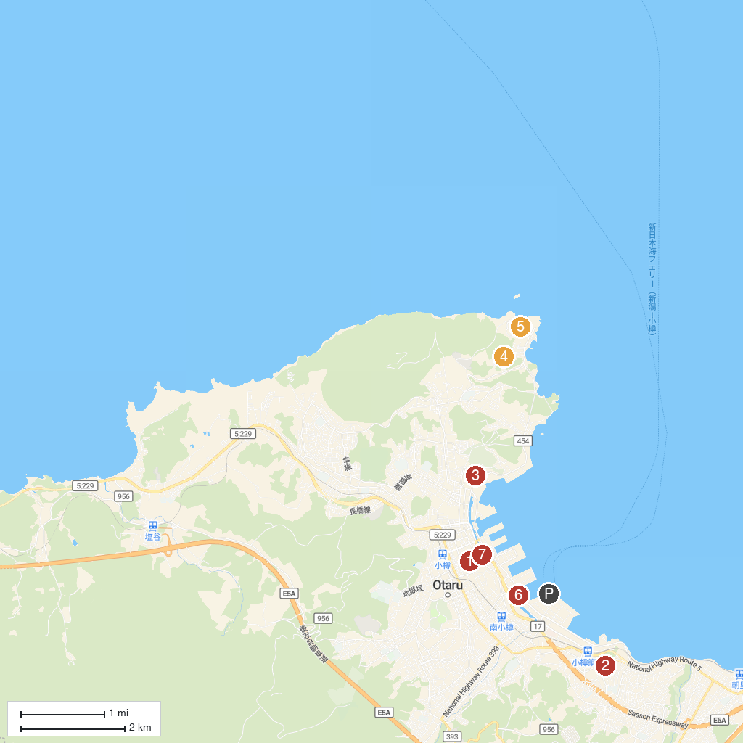
MAP KEY
1. Otaru City Museum of Art | 5. Otaru Aquarium
2. Hiraiso Park | 6. 小樽青の洞窟受付 カネヒデマリンR.X.A.クルーズ
3. Otaru City General Museum | 7. Ebisuya Otaru Rickshaw
4. Old Aoyama Villa (Herring Palace)
P. Cruise port / terminal
Map © MapTiler © OpenStreetMap contributors · cruiseports.org

