Sapelo Island, Georgia, USA
One of America's most protected and least-visited barrier islands, Sapelo is home to a living Gullah-Geechee community, a candy-striped lighthouse, and wild beaches unmarked by development.
⚓ Ferry/tender arrival — no cruise pier · 🕒 Typical call: 4-6 hrs · 💵 USD — bring cash · 🗣️ English (Geechee dialect in Hog Hammock) · 🦟 Insects intense spring–fall — DEET essential
✍️ MY DAY IN PORT (FILL IN)
Ship / Date
In port | arrive ______ · all aboard ______
Booked excursion
Notes / meeting point
GETTING ASHORE
- Docking: No cruise pier — small ships anchor offshore or tender; access via Georgia DNR state ferry from Meridian, GA
- Walk to Center: Marsh Landing dock to Hog Hammock ~3 miles; golf cart or tour bus needed
- Best For: Gullah-Geechee culture, undeveloped beaches, historic lighthouse, nature & birding
- Don't Miss: Hog Hammock heritage tour, Sapelo Lighthouse climb, Nanny Goat Beach shelling
GETTING AROUND
- 📱 Rideshare: ❌ not available
TOP THINGS TO DO
- Hog Hammock Gullah-Geechee Heritage Tour — Walk the last intact Gullah-Geechee community on Sapelo with a descendant guide.
- Sapelo Lighthouse — Built in 1820 and fully restored in 1998, the candy-striped brick lighthouse is one of the oldest on the Georgia coast.
- Nanny Goat Beach — A wide, pristine stretch of white sand backed by natural dunes and sea oats on the island's southeast tip.
- Tabby Ruins — Chocolate Plantation — At the island's remote north end, the oyster-shell tabby ruins of Thomas Spalding's 19th-century cotton plantation and sugar mill…
- Native Shell Rings & Wildlife Walk — Sapelo's Native American shell rings — circular middens dating back 4,500 years — are among the oldest evidence of human…
BEST WALKS
- Hog Hammock Village Walk: ~0.5 miles · Easy · Cultural — If you arrive with a tour group or private guide, walk the unpaved lanes of Hog Hammock to see St.
- Nanny Goat Beach Stroll: ~1 mile · Easy · Beach — Once at the beach pavilion (golf cart or tour bus required to reach it), walk south along the…
WEATHER · DAYLIGHT · MONEY
Month | High °F | Low °F | Rainy days
May | 81 | 69 | 11
Jul | 88 | 77 | 18
Sep | 83 | 74 | 16
Daylight: May 6:29AM–8:14PM · Jul 6:31AM–8:30PM · Sep 7:09AM–7:30PM
cruiseports.org/sapelo-island-ga · Confirm terminal & all-aboard time with your ship

Sapelo Island, Georgia, USA — Port Map
Red = walkable sights · Amber = excursions farther out · P = cruise terminal
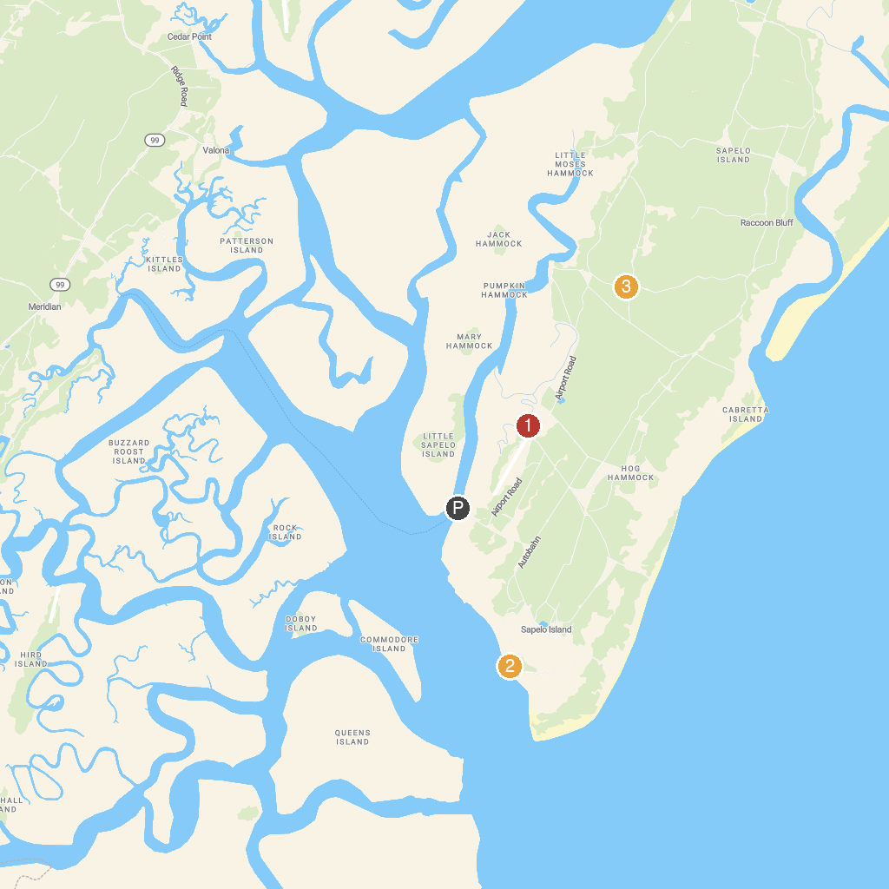
MAP KEY
1. Fort King George State Historic Site | 3. Sapelo Lighthouse
2. Sapelo Island National Estuarine Research Reserve | 4. Sapelo Island Wildlife Management Area
P. Cruise port / terminal
Map © MapTiler © OpenStreetMap contributors · cruiseports.org

