São Tomé Island, São Tomé and Príncipe
Straddling the equator in the Gulf of Guinea, São Tomé Island is Africa's 'Chocolate Island' — a lush, volcanic world of crumbling colonial plantations, ancient cacao groves, and unhurried leve-leve living.
⚓ Mixed: pier for small ships, tender for larger vessels · 🕒 Typical call: 7–10 hrs · 💵 Euros widely accepted (local Dobra/STN) · 🗣️ Portuguese spoken · 🍫 Famous for cacao & chocolate
✍️ MY DAY IN PORT (FILL IN)
Ship / Date
In port | arrive ______ · all aboard ______
Booked excursion
Notes / meeting point
GETTING ASHORE
- Docking: Tender for large ships; small ships dock at Porto de São Tomé
- Walk to center: 10–15 min (≈1 km) from tender landing to Independence Square
- Best For: Chocolate lovers, history seekers, nature & rainforest fans
- Don't Miss: Claudio Corallo chocolate tasting; Roça Água Izé plantation ruins
GETTING AROUND
- 🚕 Taxi: €5–€15 — Taxis wait at the pier; fares must be negotiated before boarding as there are no meters. Euros are widely accepted along
- 📱 Rideshare: ❌ not available
TOP THINGS TO DO
- Claudio Corallo Chocolate Tasting — Visit the laboratory of one of the world's most respected chocolatiers.
- Roça Água Izé Plantation Ruins — One of the island's largest colonial cacao plantations, now hauntingly beautiful and half-reclaimed by jungle.
- Pico Cão Grande Viewpoint — Drive south through equatorial rainforest to see this dramatic 370 m volcanic plug rising sheer from the jungle canopy.
- São Sebastião National Museum & Fort — A 16th-century Portuguese fort at the edge of Ana Chaves Bay houses a modest but fascinating museum covering the slave trade…
- Praia dos Tamarindos Beach — A calm, shaded bay on the north coast with warm turquoise water and wild tamarind trees overhead — one of the best swimming…
BEST WALKS
- City Center Heritage Walk: 1–1.5 hrs · Flat · Free — From the tender pier, walk to Independence Square, admire the pink Presidential Palace, visit the…
WEATHER · DAYLIGHT · MONEY
Month | High °F | Low °F | Rainy days
May | 83 | 78 | 22
Jul | 80 | 74 | 12
Sep | 81 | 75 | 21
Daylight: May 5:25AM–5:33PM · Jul 5:35AM–5:43PM · Sep 5:25AM–5:31PM
cruiseports.org/sao-tome-island · Confirm terminal & all-aboard time with your ship

São Tomé Island, São Tomé and Príncipe — Port Map
Red = walkable sights · Amber = excursions farther out · P = cruise terminal
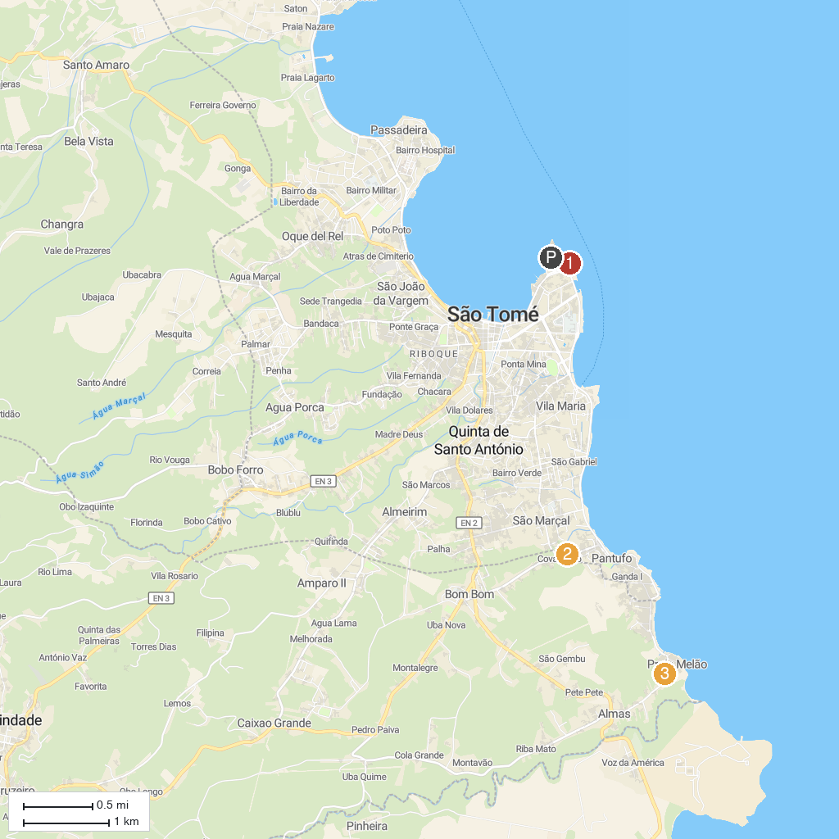
MAP KEY
1. Hellmouth | 4. L'Atelier Vanilha
2. Roça Água-Izé | 5. Kedsom surf school São Tomé
3. São Sebastião Museum
P. Cruise port / terminal
Map © MapTiler © OpenStreetMap contributors · cruiseports.org

