Tarrafal, São Nicolau, Cape Verde
One of Cape Verde's least-touched islands, São Nicolau rewards curious cruisers with volcanic highlands, ancient dragon trees, a therapeutic black-sand beach, and an authentically Cape Verdean pace of life.
⚓ Tender port · 🕒 Typical call: 6–8 hrs · 💵 Euro & Cape Verdean Escudo · 🗣️ Portuguese / Cape Verdean Creole · 🌊 Seasonal: Nov – Jun
✍️ MY DAY IN PORT (FILL IN)
Ship / Date
In port | arrive ______ · all aboard ______
Booked excursion
Notes / meeting point
GETTING ASHORE
- Docking: Tender to Tarrafal fishing harbour
- Walk to centre: 5–10 min flat walk from tender quay
- Best For: Hiking, authentic culture, off-the-beaten-path
- Don't Miss: Carbeirinho rock formations & Monte Gordo dragon trees
GETTING AROUND
- 🚕 Taxi: €1.60–€5 — Taxis wait near the quay on cruise days. Fares are unmetered — negotiate before you go. Short in-town rides run ~180–600
- 📱 Rideshare: ❌ not available
TOP THINGS TO DO
- Monte Gordo National Park Hike — Trek into the cloud-forest highlands of Monte Gordo (1,312 m) to find rare dragon trees (Dracaena draco), lush ferns, and…
- Ribeira Brava Historical Town — The colonial capital sits in a deep green valley 30 minutes from port.
- Carbeirinho Coastal Rock Formations — Just north of Tarrafal, wind and water have sculpted the volcanic coastline into smooth, surreal lunar formations — arguably the…
- Tarrafal Black Sand Beach — The jet-black volcanic sand right beside the port is rich in titanium and iodine.
- Cape Verdean Seafood Lunch in Tarrafal — Pull up a chair at a local restaurant for fresh-caught octopus, tuna, or wahoo; the national stew catchupa; and a shot of grogue…
BEST WALKS
- Tarrafal Town & Waterfront Stroll: 45 min · Easy · Flat — From the tender quay, walk along the seafront to the black-sand beach, then loop back through the…
- Praia de Baixo da Rocha Walk: 1 hr each way · Moderate · Coastal path — Follow the coastal track south from Tarrafal to reach a secluded white-sand beach that's often…
WEATHER · DAYLIGHT · MONEY
Month | High °F | Low °F | Rainy days
May | 77 | 70 | 0
Jul | 81 | 73 | 2
Sep | 84 | 77 | 6
Daylight: May 6:06AM–7:00PM · Jul 6:13AM–7:13PM · Sep 6:25AM–6:38PM
cruiseports.org/sao-nicolau-island · Confirm terminal & all-aboard time with your ship

Tarrafal, São Nicolau, Cape Verde — Port Map
Red = walkable sights · Amber = excursions farther out · P = cruise terminal
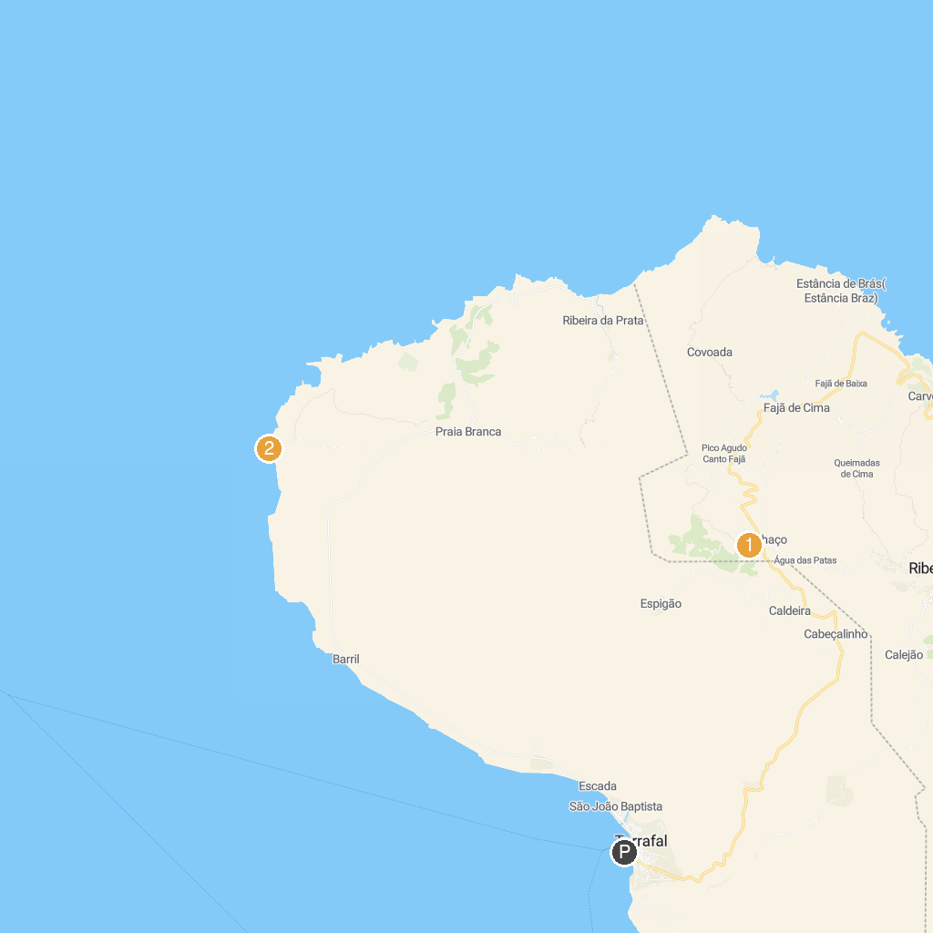
MAP KEY
1. Parque Natural Monte Gordo | 2. Carbeirinho
P. Cruise port / terminal
Map © MapTiler © OpenStreetMap contributors · cruiseports.org

