São Luís, Maranhão, Brazil
The only Brazilian state capital founded by the French, São Luís dazzles with thousands of azulejo-tiled colonial mansions and pulses to a reggae beat unlike anywhere else in South America.
⚓ Tender port (no cruise pier) · 🕒 Typical call: 6–8 hrs · 💵 Brazilian Real (BRL) · 🗣️ Portuguese · 🌡️ Hot & humid year-round
✍️ MY DAY IN PORT (FILL IN)
Ship / Date
In port | arrive ______ · all aboard ______
Booked excursion
Notes / meeting point
GETTING ASHORE
- Docking: Tender — no dedicated cruise pier; ships anchor offshore
- Walk to center: ~10–15 min by taxi from tender dock to UNESCO Historic Centre
- Best For: Colonial architecture, azulejo tiles, reggae culture, Lençóis day trips
- Don't Miss: Museu do Reggae Maranhão — the only reggae museum outside Jamaica
GETTING AROUND
- 🚕 Taxi: R$20–50 — Official taxis are available at the port. Fare to the historic center (Reviver area) is roughly R$20–50 depending on exa
- 📱 Rideshare: ✅ Uber, 99
TOP THINGS TO DO
- UNESCO Historic Centre Walking Tour — Stroll the 18th-century grid lined with Portugal-tile-clad mansions, visiting Palácio dos Leões, Teatro Arthur Azevedo, and…
- Museu do Reggae & Jamaican Culture — São Luís is Brazil's undisputed reggae capital — and this is the only reggae museum outside Jamaica.
- Lençóis Maranhenses Day Trip — Transfer ~5–6 hrs each way to the surreal landscape of white sand dunes and turquoise freshwater lagoons at Lençóis Maranhenses…
- Alcântara Colonial Town Ferry — A roughly 1–1.5 hr boat ride across the bay from the Praia Grande waterfront reaches Alcântara, a faded colonial gem with…
- Casa das Tulhas Market & Maranhense Cuisine — Browse the lively covered market in the Historic Centre — try cuxá rice, fish moqueca, and the local specialty torta de camarão.
BEST WALKS
- Colonial Core Loop: 1–2 hrs | Mostly flat cobblestones | Free — Start at Praça João Lisboa, walk south along Rua Portugal past the azulejo façades, visit the…
- Waterfront Reviver to Historic Centre: 20 min | Uphill | Free — Walk from the tender landing at the Reviver waterfront up through the older lower city into the…
WEATHER · DAYLIGHT · MONEY
Month | High °F | Low °F | Rainy days
May | 85 | 76 | 27
Jul | 86 | 76 | 19
Sep | 88 | 78 | 10
Daylight: May 5:53AM–5:53PM · Jul 6:03AM–6:02PM · Sep 5:49AM–5:54PM
cruiseports.org/sao-luis · Confirm terminal & all-aboard time with your ship

São Luís, Maranhão, Brazil — Port Map
Red = walkable sights · Amber = excursions farther out · P = cruise terminal
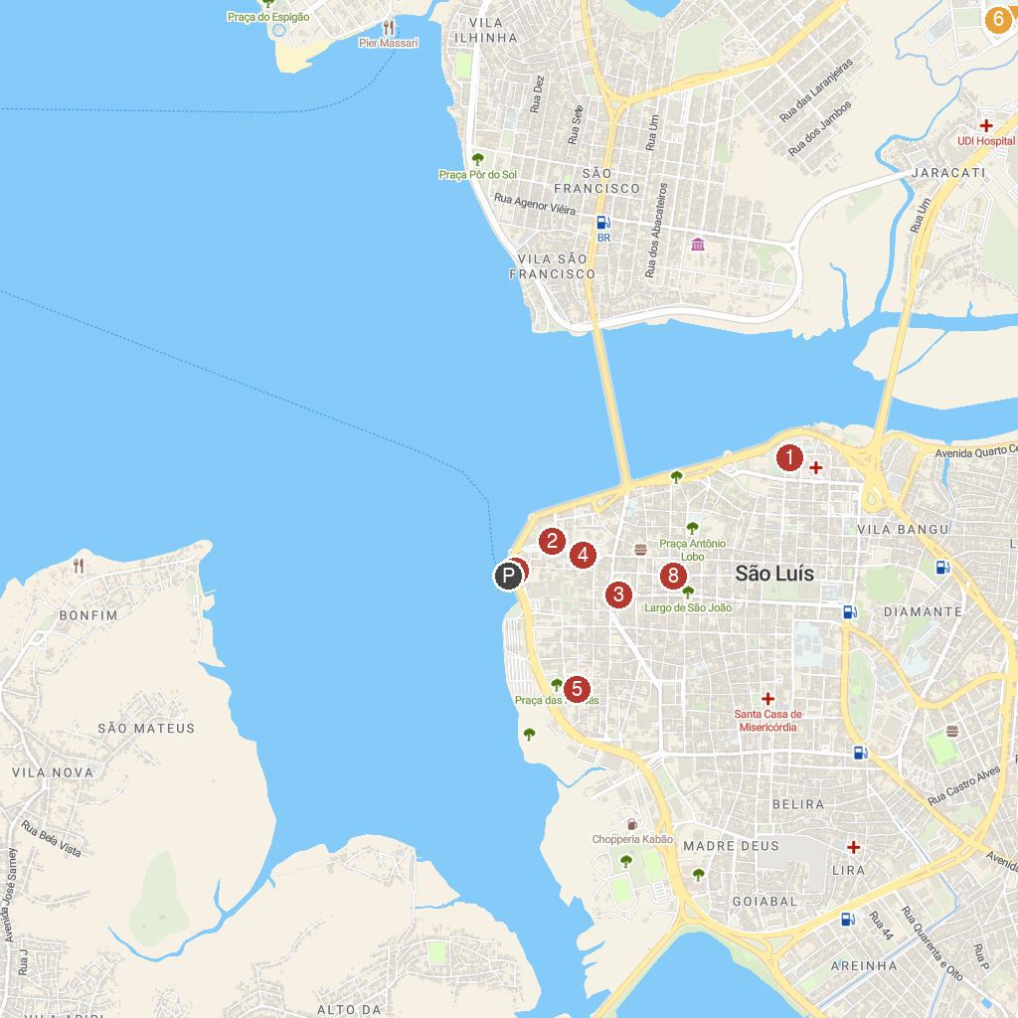
MAP KEY
1. Igreja de Nossa Senhora dos Remédios | 5. Convent of Mercês
2. City of St. Louis | 6. Praias da Avenida Litorânea
3. Igreja do Carmo | 7. Maranhao's House
4. Catedral Metropolitana de São Luis - Nossa Senhora da Vitória | 8. Museu Histórico e Artístico do Maranhão
P. Cruise port / terminal
Map © MapTiler © OpenStreetMap contributors · cruiseports.org

