São Jorge Island, Azores, Portugal
The 'Island of the Fajãs' rewards curious cruisers with towering cliffs, tiny cliff-foot villages, Europe's rarest coffee, and the sharpest cheese in Portugal.
⚓ Pier (small ships) / Tender (large ships) · 🕒 Typical call: 6–8 hrs · 💶 Currency: Euro (€) · 🗣️ Language: Portuguese (English spoken in tourism)
✍️ MY DAY IN PORT (FILL IN)
Ship / Date
In port | arrive ______ · all aboard ______
Booked excursion
Notes / meeting point
GETTING ASHORE
- Docking: Pier at Port of Velas for ships up to ~120 m; larger ships tender
- Walk to Center: 5–10 min flat walk from Velas marina to town center (~400 m)
- Best For: Hiking, volcanic natural pools, cheese tasting, scenic fajã drives
- Don't Miss: Poça Simão Dias natural pool at Fajã do Ouvidor & São Jorge cheese tasting
GETTING AROUND
- 🚕 Taxi: €80–€150/day — Taxis are available on the island and ideal for island touring. Full-day hire runs €80–€150 and can be shared among up t
- 📱 Rideshare: ❌ not available
TOP THINGS TO DO
- Fajã do Ouvidor & Poça Simão Dias — Drive 25 minutes to the north coast to see one of the Azores' most dramatic natural pools — deep turquoise water surrounded by…
- São Jorge Cheese Factory (Uniqueijo) — Tour the cooperative dairy in Beira (~10 min from Velas) and taste aged São Jorge cheese — raw cow's milk, sharp, spicy…
- Fajã dos Vimes Coffee Plantation — Visit Café Nunes at Fajã dos Vimes on the south coast — one of the only places in Europe where coffee is commercially grown.
- Fajã dos Cubres Lagoon & Hiking — Easily reachable by car or taxi, this UNESCO Biosphere Reserve fajã has a stunning crystal-clear lagoon.
- Urzelina Volcanic Tower — See the lone church tower rising from lava fields in Urzelina — the only structure to survive the 1808 volcanic eruption that…
BEST WALKS
- Velas Town & Preguiça Natural Pools: 1.5 km loop · Easy · ~30–45 min — From the marina, walk along the waterfront to the Jardim da República, through the historic center…
- Fajã dos Cubres Lagoon Walk: 2 km return · Easy–Moderate · ~1 hr at the fajã — Taxi or tour to Fajã dos Cubres, then walk the coastal path along the lagoon edge to the viewpoints…
WEATHER · DAYLIGHT · MONEY
Month | High °F | Low °F | Rainy days
May | 64 | 59 | 13
Jul | 72 | 67 | 12
Sep | 73 | 68 | 12
Daylight: May 6:40AM–8:57PM · Jul 6:40AM–9:16PM · Sep 7:34AM–8:00PM
cruiseports.org/sao-jorge-island-azores · Confirm terminal & all-aboard time with your ship

São Jorge Island, Azores, Portugal — Port Map
Red = walkable sights · Amber = excursions farther out · P = cruise terminal
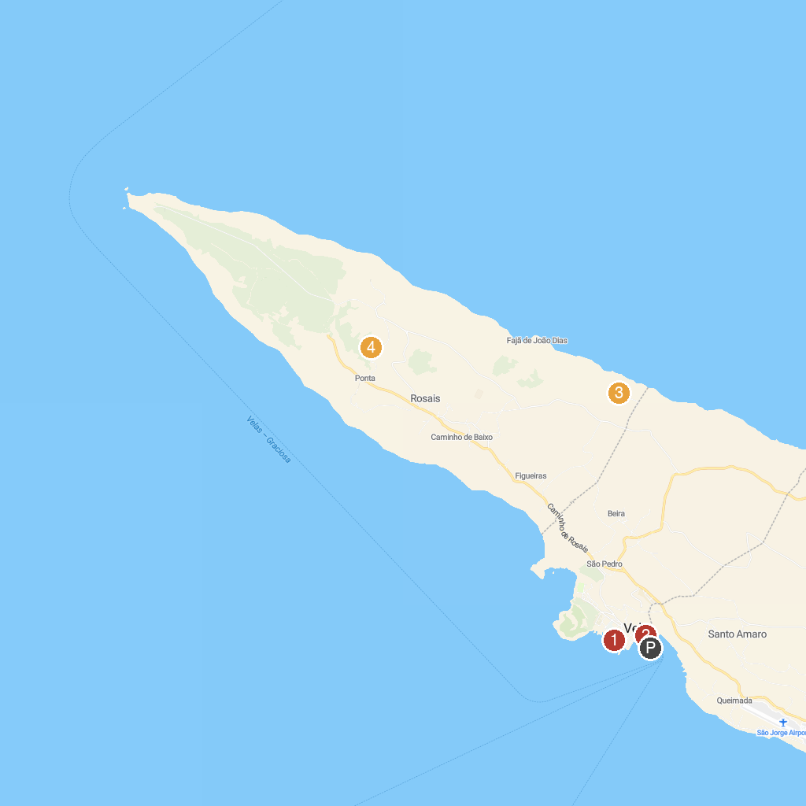
MAP KEY
1. Arco Natural de Velas | 3. Baloiço Fajã de João Dias
2. Sea Explorers Azores | 4. Pico da Velha Viewpoint
P. Cruise port / terminal
Map © MapTiler © OpenStreetMap contributors · cruiseports.org

