São Francisco do Sul, Santa Catarina, Brazil
One of Brazil's three oldest cities, São Francisco do Sul sits on a bay island where 300-year-old pastel colonial buildings line cobblestone streets and a landmark maritime museum anchors the waterfront — all steps from where ships dock.
⚓ Pier (commercial port, short ride to center) · 🕒 Typical call: 7-9 hrs · 💵 Brazilian Real (BRL); cards widely accepted · 🗣️ Portuguese — little English spoken · 🏖️ Beaches 15-20 min by taxi/Uber
✍️ MY DAY IN PORT (FILL IN)
Ship / Date
In port | arrive ______ · all aboard ______
Booked excursion
Notes / meeting point
GETTING ASHORE
- Docking: Cruise ships berth at the commercial port; free shuttle or short taxi to the historic center (~5 min)
- Walk to Center: ~10 min walk or 5-min taxi from port gate to historic cobblestone streets
- Best For: Colonial history, maritime museum, beach day, small-town Brazil vibes
- Don't Miss: Museu Nacional do Mar — one of Latin America's finest maritime museums, right on the waterfront
GETTING AROUND
- 🚕 Taxi: R$15–30 — Taxis are typically available at the pier. Short rides around the compact historic center are inexpensive; agree on fare
- 📱 Rideshare: ✅ Uber, 99
TOP THINGS TO DO
- Historic Center Walking Tour — Stroll the national heritage zone — 150+ preserved 18th- and 19th-century colonial buildings, the 1699 Igreja Matriz church, and…
- Museu Nacional do Mar — One of Latin America's top maritime museums, housed in a restored 19th-century waterfront warehouse.
- Praia da Enseada Beach Day — The island's most popular ocean beach — a horseshoe bay with calm water, soft sand, beach-chair rentals, bars, and restaurants.
- Forte Marechal Luz & Viewpoint — Built in 1909 to guard the bay, this hilltop fort retains its original cannons and offers 360° views of the ocean and Babitonga…
- Babitonga Bay Boat Trip — Cruise the calm bay waters, spot coastal wildlife, and explore the small islands of the Babitonga archipelago — mangroves…
BEST WALKS
- Colonial Heart of São Francisco do Sul: ~2 km · 45-60 min · Easy · Cobblestones — A loop through the core of the historic district, taking in the 1699 church, the old market, the…
- Morro da Boa Vista Viewpoint: ~1.5 km one-way · 30 min · Easy-moderate uphill — A short uphill walk from the historic center to the Morro da Boa Vista overlook for panoramic views…
WEATHER · DAYLIGHT · MONEY
Month | High °F | Low °F | Rainy days
May | 72 | 64 | 14
Jul | 69 | 59 | 9
Sep | 72 | 63 | 15
Daylight: May 6:46AM–5:35PM · Jul 7:01AM–5:39PM · Sep 6:11AM–6:07PM
cruiseports.org/sao-francisco-do-sul · Confirm terminal & all-aboard time with your ship

São Francisco do Sul, Santa Catarina, Brazil — Port Map
Red = walkable sights · Amber = excursions farther out · P = cruise terminal
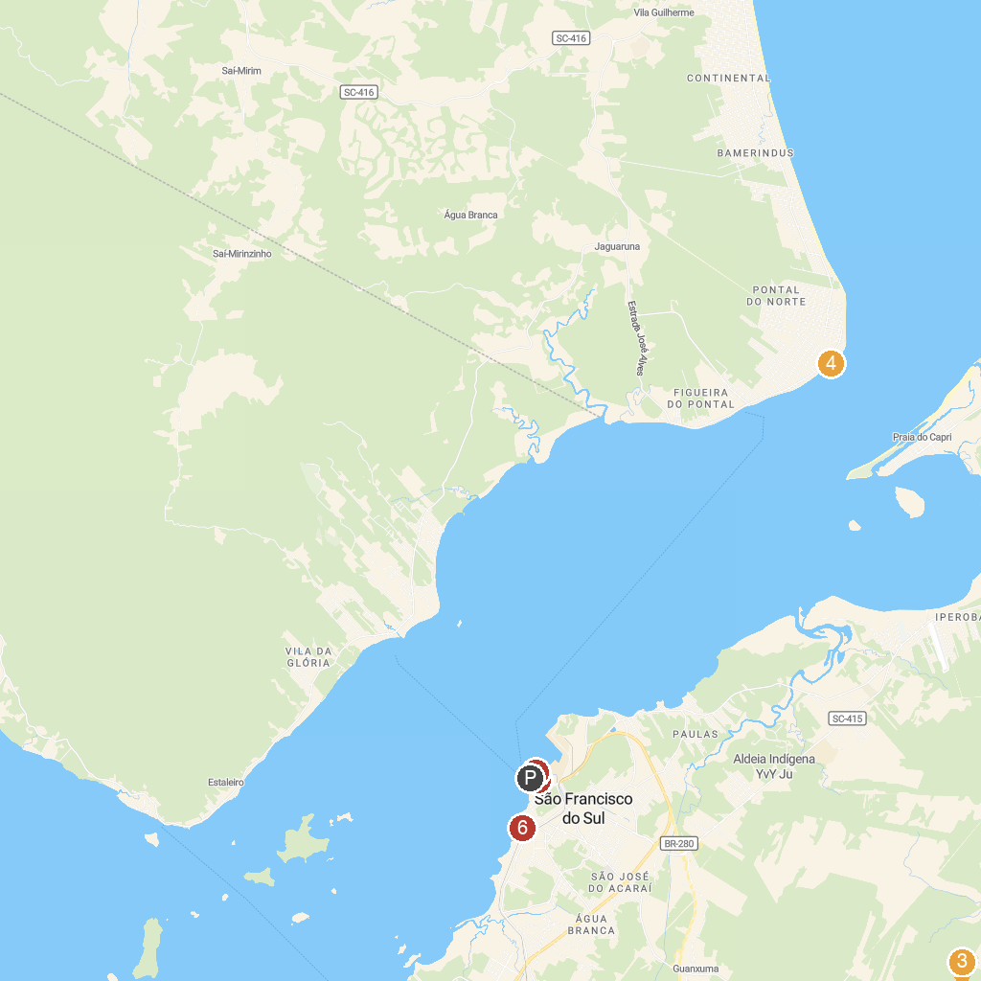
MAP KEY
1. Forte Marechal Luz | 5. Itapoá Lighthouse
2. Parque Ecológico Municipal | 6. Sailor Friend Tours
3. Visit São Chico | 7. Sea National Museum Craft Brazilian
4. Parque Estadual Acaraí | 8. History Mayor José Schmidt Museum
P. Cruise port / terminal
Map © MapTiler © OpenStreetMap contributors · cruiseports.org

