Sanya, Hainan, China
China's southernmost city delivers turquoise bays, a towering sea goddess, and one of Asia's most unexpected tropical escapes — all accessible from a modern pier on futuristic Phoenix Island.
⚓ Pier (Phoenix Island) · 🕒 Typical call: 8-10 hrs · 💴 Chinese Yuan (RMB/CNY) · 🗣️ Mandarin Chinese · 🏖️ Beach destination
✍️ MY DAY IN PORT (FILL IN)
Ship / Date
In port | arrive ______ · all aboard ______
Booked excursion
Notes / meeting point
GETTING ASHORE
- Docking: Pier — Phoenix Island International Cruise Terminal
- Walk to center: 20 min across bridge to Sanya Bay Road; taxi recommended for most sights
- Best For: Beaches, Buddhist culture, tropical seafood, duty-free shopping
- Don't Miss: Nanshan Temple's 108 m Guanyin statue rising from the South China Sea
GETTING AROUND
- 🚕 Taxi: ¥10–30 (~$1.40–$4.20 USD) — Metered taxis start at around ¥10–11 for the first 2.5 km. A taxi to the city center or Sanya Bay area typically costs ¥
- 📱 Rideshare: ✅ DiDi
TOP THINGS TO DO
- Nanshan Temple & Sea Guanyin — The 108-metre, three-sided white Guanyin statue stands in the South China Sea at the Nanshan Buddhism Cultural Tourism Zone…
- Yalong Bay Beach Day — Sanya's finest beach — 7 km of fine white sand and crystal-clear water backed by international resorts.
- Li & Miao Ethnic Culture — Binglanggu Valley — Hainan's indigenous Li and Miao peoples showcase traditional tattooing, bamboo weaving, and song-and-dance performances in a…
- Yalong Bay Tropical Paradise Forest Park — Lush rainforest park above Yalong Bay featuring glass skywalks, suspension rope bridges, and panoramic sea views — a dramatic…
- First Market Seafood & Hainan Food Tour — Pick live lobster, crab, or prawns at the famous Dai Yi Shi Chang market, then have them cooked to order at a neighbouring…
BEST WALKS
- Sanya Bay Coconut Promenade: 1.5 km • Easy • 20-30 min • Free — Cross the Phoenix Island bridge to the mainland and turn left along Sanya Bay Road — a palm-lined…
- Pier to First Market: 3 km one-way • Easy • 40 min walk or short taxi • Free — Flat walk or quick taxi ride from the bridge to Sanya's most atmospheric local market for seafood…
WEATHER · DAYLIGHT · MONEY
Month | High °F | Low °F | Rainy days
May | 87 | 80 | 18
Jul | 87 | 80 | 24
Sep | 86 | 79 | 21
Daylight: May 6:08AM–7:07PM · Jul 6:14AM–7:21PM · Sep 6:29AM–6:44PM
cruiseports.org/sanya · Confirm terminal & all-aboard time with your ship

Sanya, Hainan, China — Port Map
Red = walkable sights · Amber = excursions farther out · P = cruise terminal
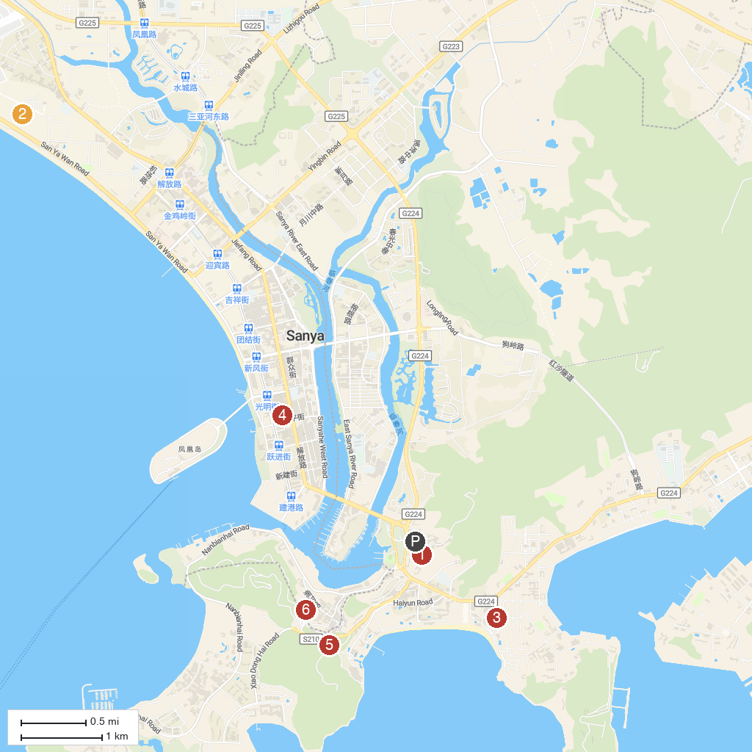
MAP KEY
1. Luhuitou Plaza | 5. Yalong Bay Tropic Paradise Forest Park
2. 三亚湾 | 6. Luhuitou Park （East Gate）
3. 大东海广场 | 7. Luhuitou Peak Park
4. China Sanya Phoenix Island
P. Cruise port / terminal
Map © MapTiler © OpenStreetMap contributors · cruiseports.org

