Santorini, Greece
A tender port like no other — your ship anchors inside a flooded volcano while whitewashed villages cling to cliffs 300 metres above. Here's how to make every hour count.
⚓ Tender Port (no docking) · 🕒 Typical call: 8–10 hrs · 💶 Euro (EUR) · 🗣️ Greek · English widely spoken
✍️ MY DAY IN PORT (FILL IN)
Ship / Date
In port | arrive ______ · all aboard ______
Booked excursion
Notes / meeting point
GETTING ASHORE
- Docking: Tender only — caldera anchorage
- Up to Fira: Cable car €8 / 588 steps free
- Best For: Views · Wine · Volcanic history
- Don't Miss: Oia village & caldera rim trail
GETTING AROUND
- 🚕 Taxi: €25–€35 (Athinios port to Fira) — Very limited supply (~35–40 island-wide); waits can be long especially when ships are in. The main tender port (Skala) h
- 📱 Rideshare: ✅ Uber, Bolt
TOP THINGS TO DO
- Oia Village & Blue Domes — The postcard Santorini — whitewashed lanes, blue-domed churches, the world-famous caldera view.
- Caldera Catamaran & Hot Springs — Sail inside the caldera, hike the active volcanic islet of Nea Kameni, then swim in the warm sulfur hot springs.
- Volcanic Wine Tasting — Santorini's Assyrtiko grapes grow in basket-woven vines in volcanic ash — unlike any other wine on earth.
- Akrotiri — Pompeii of the Aegean — A Minoan city buried 3,600 years ago, now under a climate-controlled enclosure.
- Fira to Oia Caldera Hike — The 10 km clifftop trail from Fira to Oia is one of the great walks of the Aegean — caldera views the entire way.
BEST WALKS
- Fira Caldera Rim Stroll: 1–2 km · 30–45 min · easy — Walk the paved clifftop path through Fira past boutiques, cafes, and dramatic caldera overlooks.
- Fira → Firostefani → Imerovigli: ~2 km · 45 min one-way · easy — The caldera-edge promenade north from Fira.
- Fira → Oia Caldera Trail (Route 9): ~10 km · 3.5–4.5 hrs · moderate — The classic clifftop hike north along the caldera rim to Oia.
WEATHER · DAYLIGHT · MONEY
Month | High °F | Low °F | Rainy days
May | 72 | 64 | 2
Jul | 84 | 75 | 0
Sep | 80 | 72 | 1
Daylight: May 6:11AM–8:17PM · Jul 6:12AM–8:35PM · Sep 7:00AM–7:25PM
cruiseports.org/santorini · Confirm terminal & all-aboard time with your ship

Santorini, Greece — Port Map
Red = walkable sights · Amber = excursions farther out · P = cruise terminal
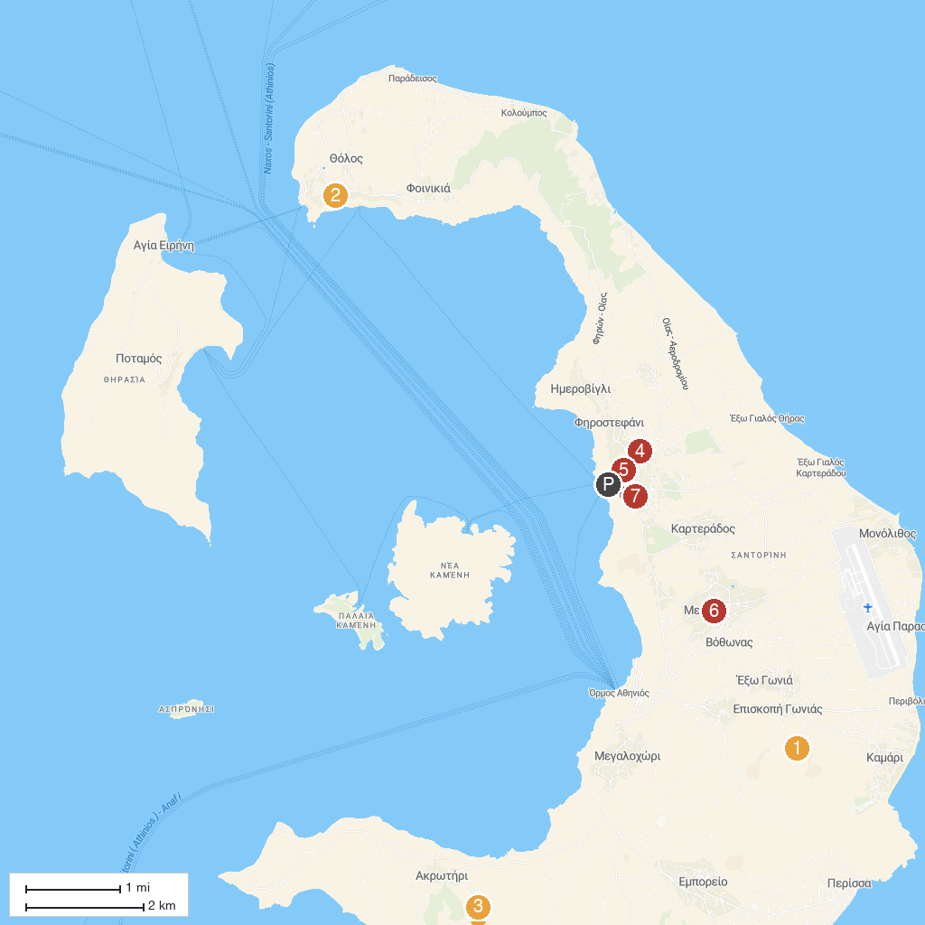
MAP KEY
1. Panagia Episkopi | 5. Archaeological Museum of Thera
2. The Virgin Mary of the Akathist Hymn Church | 6. Αρχοντικό Αργυρού
3. Akrotiri | 7. Bellonio Cultural Center
4. "Emmanuel A. Lignos" Santorini Folklore Museum
P. Cruise port / terminal
Map © MapTiler © OpenStreetMap contributors · cruiseports.org

