Santo Domingo, Dominican Republic
The oldest European city in the Americas — cobblestone streets, the first cathedral and fortress of the New World, all a short ride from your ship across the Ozama River.
⚓ Docked (Sans Souci / Don Diego) · 🕒 Typical call: 8–10 hrs · 💵 Dominican Peso (DOP) · USD ok · 🗣️ Spanish · some English
✍️ MY DAY IN PORT (FILL IN)
Ship / Date
In port | arrive ______ · all aboard ______
Booked excursion
Notes / meeting point
GETTING ASHORE
- Docking: Sans Souci pier
- To Zona Colonial: 5–10 min ride
- Best For: History · Architecture
- Don't Miss: Catedral Primada
GETTING AROUND
- 🚕 Taxi: $5–$20 USD — Taxis wait outside Don Diego and Sans Souci terminals. The Colonial Zone is about 2 km away (5–10 min). Agree on fare be
- 📱 Rideshare: ✅ Uber, Bolt
- 🚌 Hop-on hop-off: ✅
TOP THINGS TO DO
- Zona Colonial Walking Tour — The UNESCO-listed colonial quarter: Catedral Primada (first cathedral in the Americas, 1540), Alcázar de Colón (Diego Columbus's…
- Alcázar de Colón & Las Casas Reales — The fortified palace of Columbus's son and the museum of Royal Houses, telling the story of Spain's first colonial capital.
- Los Tres Ojos & City Highlights — A drive out to the Three Eyes limestone caves and lagoons, often paired with the Columbus Lighthouse (Faro a Colón) and a…
- Boca Chica Beach Escape — A shallow, calm Caribbean beach about 30 km east — the easiest beach day from Santo Domingo if you'd rather swap history for sand.
BEST WALKS
- Zona Colonial essentials loop: ~2.5 km · 2–3 hrs · easy · 30 min from pier — From the Sans Souci cruise pier it's about a 30-minute walk to the fort and the heart of the Zona…
- Fortaleza Ozama & riverfront: ~1.5 km · 1 hr · easy — The oldest formal military structure in the Americas, with the Tower of Homage and views over the…
- Calle El Conde stroll: ~1 km · 45 min · easy — The pedestrianized spine of the old city — shops, cafés, street musicians, and colonial facades…
WEATHER · DAYLIGHT · MONEY
Month | High °F | Low °F | Rainy days
May | 85 | 73 | 21
Jul | 88 | 75 | 21
Sep | 87 | 75 | 22
Daylight: May 6:06AM–7:06PM · Jul 6:11AM–7:19PM · Sep 6:27AM–6:41PM
cruiseports.org/santo-domingo · Confirm terminal & all-aboard time with your ship

Santo Domingo, Dominican Republic — Port Map
Red = walkable sights · Amber = excursions farther out · P = cruise terminal
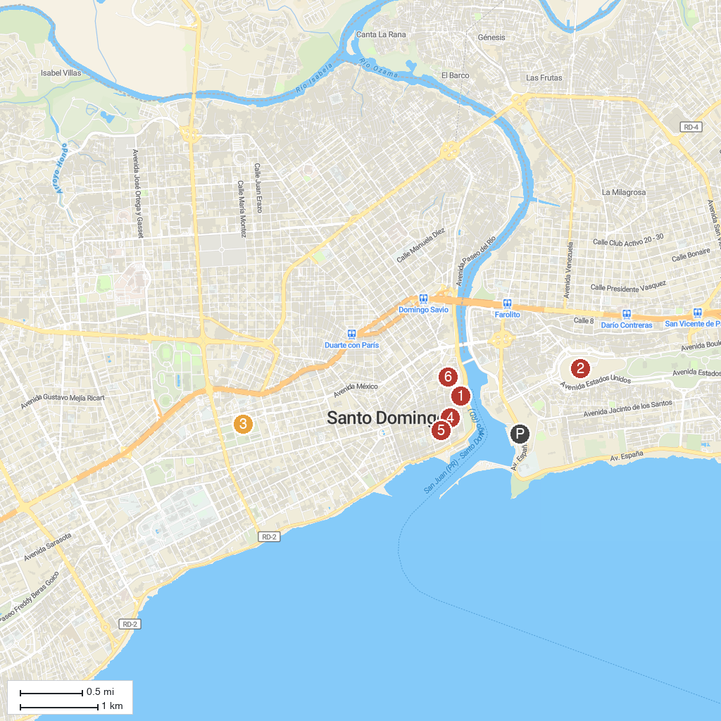
MAP KEY
1. Chapel of Our Lady of Remedies | 4. Catedral Primada de las Américas de Santo Domingo
2. Columbus Lighthouse | 5. Dominican Convent
3. Museo Nacional de Historia y Geografia | 6. Wax Museum Juan Pablo Duarte
P. Cruise port / terminal
Map © MapTiler © OpenStreetMap contributors · cruiseports.org

