Santarém, Pará, Brazil
Where the blue-green Tapajós crashes into the muddy Amazon, Santarém is your gateway to white-sand river beaches, cathedral rainforest, and one of nature's most arresting color-clash spectacles.
⚓ Docked (river quay) or tender depending on ship size · 🕒 Typical call: 8–10 hrs · 💵 Brazilian Real (BRL) · 🗣️ Portuguese
✍️ MY DAY IN PORT (FILL IN)
Ship / Date
In port | arrive ______ · all aboard ______
Booked excursion
Notes / meeting point
GETTING ASHORE
- Docking: Santarém river quay (downtown)
- Walk to center: 5–10 min on foot
- Best For: Alter do Chão · Amazon wildlife
- Don't Miss: Meeting of the Waters
GETTING AROUND
- 🚕 Taxi: R$30–50 (approx. $6–10 USD) — Taxis wait outside the port gate and can take you to the city center (~2–3 km away) in about 10 minutes. Agree on a fare
- 📱 Rideshare: ✅ Uber
TOP THINGS TO DO
- Meeting of the Waters — Seen from a boat, the vivid blue-green Tapajós and the chocolate-brown Amazon run side by side without mixing for several…
- Alter do Chão Beach — Called the 'Caribbean of the Amazon', Alter do Chão's white sand spits and crystal-clear Tapajós water are strikingly beautiful.
- Tapajós National Forest — A vast protected tract of primary Amazon rainforest starting just south of Alter do Chão.
- Amazon River Wildlife Boat Trip — Early-morning or dusk boat trips along the Amazon and Tapajós floodplain hunt for pink river dolphins, caimans, sloths, and…
- Waterfront Market & Centro Cultural João Fona — The Mercado Modelo on the waterfront sells açaí, exotic Amazon fruits, dried fish, and regional crafts.
BEST WALKS
- Waterfront promenade & market: ~1.5 km · 1 hr · easy — From the Cais do Porto, follow the riverside promenade past the Mercado Modelo to the waterfront…
- Alter do Chão village stroll: ~1 km · 30 min · easy (after taxi/tour transfer) — Once at Alter do Chão, a short walk from the main square to the water's edge passes craft shops…
WEATHER · DAYLIGHT · MONEY
Month | High °F | Low °F | Rainy days
May | 84 | 76 | 30
Jul | 85 | 77 | 19
Sep | 89 | 79 | 8
Daylight: May 6:35AM–6:35PM · Jul 6:45AM–6:44PM · Sep 6:31AM–6:36PM
cruiseports.org/santarem · Confirm terminal & all-aboard time with your ship

Santarém, Pará, Brazil — Port Map
Red = walkable sights · Amber = excursions farther out · P = cruise terminal
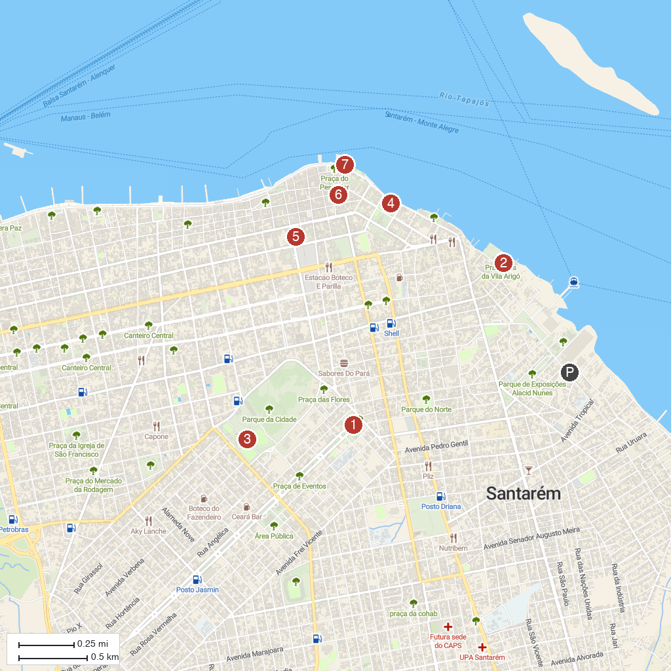
MAP KEY
1. Bible Square | 5. Centro de artesanato Cristo rei
2. Orla da Vila Arigó | 6. Museu Dica Frazão
3. Parque da Cidade | 7. Orla de Santarém
4. CENTRO CULTURAL - JOÃO FONA
P. Cruise port / terminal
Map © MapTiler © OpenStreetMap contributors · cruiseports.org

