Santander, Cantabria, Spain
Santander ships dock steps from the old city — stroll to Renzo Piano's Centro Botín, catch a bus to the royal Magdalena Palace, or keep walking all the way to the grand sweep of El Sardinero beach.
⚓ Pier (docked) · 🕒 Typical call: 8-10 hrs · 💶 Euro (€) · 🗣️ Spanish
✍️ MY DAY IN PORT (FILL IN)
Ship / Date
In port | arrive ______ · all aboard ______
Booked excursion
Notes / meeting point
GETTING ASHORE
- Docking: Pier — Maritime Station, central waterfront
- Walk to centre: 5 min on foot from gangway
- Best for: Beaches, modern art, tapas, bay ferry hop
- Don't miss: Centro Botín & a plate of rabas (fried squid)
GETTING AROUND
- 🚕 Taxi: €10–€13 — Regulated taxis queue outside the terminal. Daytime flag drop is €1.61 with a €1.10/km rate; the short city-center run t
- 📱 Rideshare: ✅ Uber
- 🚌 Hop-on hop-off: ✅ City Sightseeing Santander
TOP THINGS TO DO
- Bilbao & the Guggenheim — Ride 1 hr east to Bilbao's titanium Guggenheim Museum — one of the most spectacular buildings on Earth — plus the lively Casco…
- Altamira Cave Replica & Santillana del Mar — The Altamira 'Sistine Chapel of prehistory' is now preserved behind glass; the museum's replica lets you walk among…
- Centro Botín Art Walk — Renzo Piano's striking cultural centre floats over the bay on stilts just 8 min from the ship.
- Magdalena Peninsula Walk — A 30-min walk or quick bus ride brings you to the Magdalena Palace grounds — a former royal summer residence with free access to…
- El Sardinero Beach — Santander's grand 19th-century casino overlooks Primera and Segunda beaches at El Sardinero — 2.5 km of fine sand backed by a…
BEST WALKS
- Waterfront to Magdalena Peninsula: 3.5 km · ~45 min · easy coastal path — From the Maritime Station, walk east along Paseo de Pereda past Centro Botín, up through Jardines…
- Old Town & Cathedral Loop: 1.5 km · ~25 min · easy — Head uphill from the Botín to the twin-naved Catedral de Santander, then wander the pedestrian…
WEATHER · DAYLIGHT · MONEY
Month | High °F | Low °F | Rainy days
May | 65 | 53 | 14
Jul | 74 | 62 | 12
Sep | 73 | 60 | 12
Daylight: May 6:50AM–9:32PM · Jul 6:48AM–9:53PM · Sep 7:55AM–8:24PM
cruiseports.org/santander · Confirm terminal & all-aboard time with your ship

Santander, Cantabria, Spain — Port Map
Red = walkable sights · Amber = excursions farther out · P = cruise terminal
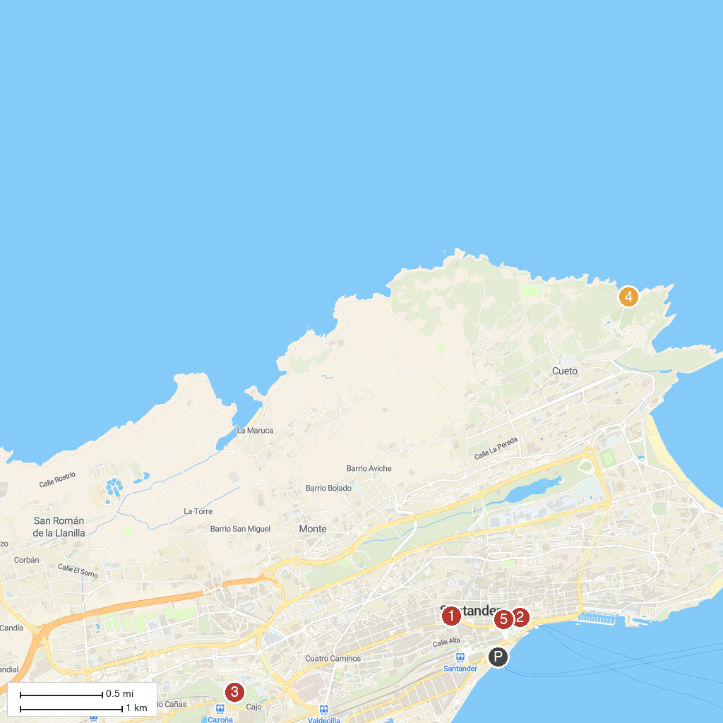
MAP KEY
1. Cueva El Pendo | 5. Doctor Morales Park
2. Parque de la Naturaleza de Cabárceno | 6. Centro de Arte Faro Cabo Mayor (FCM)
3. Museo de Arte Moderno y Contemporáneo de Santander y Cantabria | 7. Muralla de Santander
4. Museum of Prehistory and Archaeology of Cantabria
P. Cruise port / terminal
Map © MapTiler © OpenStreetMap contributors · cruiseports.org

