Santa Marta, Colombia
Colombia's oldest surviving city, set between the Sierra Nevada mountains and the Caribbean — gateway to Tayrona's jungle beaches, the Lost City of the Tayrona, and the house where Simón Bolívar breathed his last.
⚓ Docked at Sociedad Portuaria · 🕒 Typical call: 8–10 hrs · 💵 Colombian Peso (COP) · 🗣️ Spanish
✍️ MY DAY IN PORT (FILL IN)
Ship / Date
In port | arrive ______ · all aboard ______
Booked excursion
Notes / meeting point
GETTING ASHORE
- Docking: Sociedad Portuaria / Puerto de Santa Marta
- To center: 5-min walk to Parque de los Novios
- Best For: History · Nature · Beaches
- Don't Miss: Tayrona National Park
GETTING AROUND
- 🚕 Taxi: $5–$7 USD — Taxis queue at the port exit. Agree on the fare before boarding — there are no meters for the port-to-center route. City
- 📱 Rideshare: ✅ Uber, InDrive
TOP THINGS TO DO
- Tayrona National Park — The crown jewel of the Colombian Caribbean — a UNESCO-protected mosaic of jungle, coral reef, and turquoise coves where the…
- Quinta de San Pedro Alejandrino — The colonial hacienda on the outskirts of Santa Marta where Simón Bolívar, Liberator of South America, spent his final days and…
- Minca Cloud Forest & Waterfalls — A 45-minute drive into the foothills of the Sierra Nevada brings you to the village of Minca, surrounded by coffee farms…
- Historic Centre & Taganga Village — Walk the cobblestone streets of Colombia's oldest city — the Catedral de Santa Marta (one of South America's oldest), Parque de…
BEST WALKS
- Port to Parque de los Novios & the Cathedral: ~1.5 km · 45 min · easy — Head straight from the pier along Calle 10 into the historic centre.
- Simón Bolívar statues & Malecón waterfront: ~2 km · 1 hr · easy — Follow the renovated Malecón waterfront promenade past the Estatua de Simón Bolívar and the old…
- El Rodadero Beach: ~3 km by taxi · 2 hrs · easy — A short taxi ride south of the port brings you to El Rodadero, Santa Marta's most popular beach…
WEATHER · DAYLIGHT · MONEY
Month | High °F | Low °F | Rainy days
May | 86 | 79 | 15
Jul | 87 | 79 | 16
Sep | 86 | 78 | 20
Daylight: May 5:34AM–6:12PM · Jul 5:41AM–6:24PM · Sep 5:46AM–5:57PM
cruiseports.org/santa-marta · Confirm terminal & all-aboard time with your ship

Santa Marta, Colombia — Port Map
Red = walkable sights · Amber = excursions farther out · P = cruise terminal
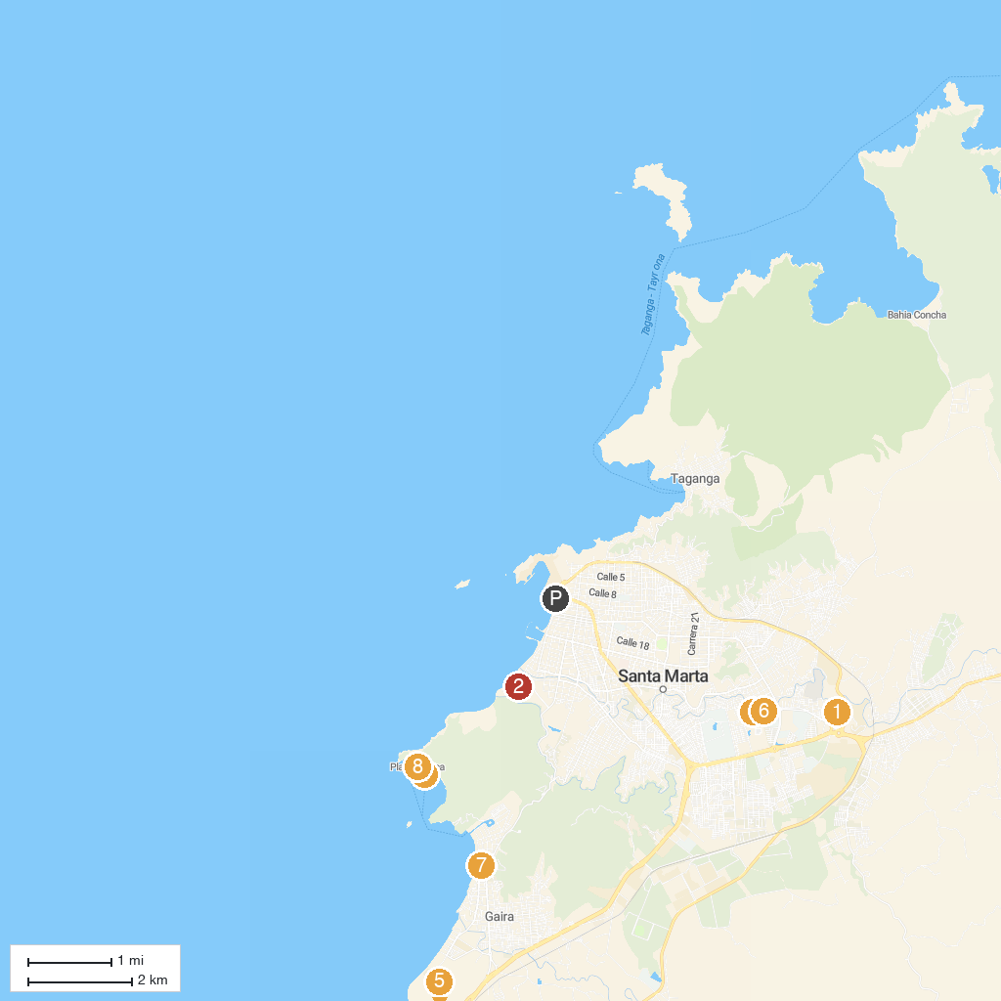
MAP KEY
1. Iglesia de Mamatoco | 5. Condominio Marino Cabo Tortuga
2. San Fernando | 6. Quinta de San Pedro Alejandrino
3. Altar of the Fatherland | 7. Acuario Mundo Marino
4. Acuario Rodadero Santa Marta | 8. Playa Blanca
P. Cruise port / terminal
Map © MapTiler © OpenStreetMap contributors · cruiseports.org

