Santa Maria Island, Azores, Portugal
The oldest and sunniest island in the Azores, Santa Maria rewards curious cruisers with golden-sand beaches (a rarity in the archipelago), a fortress that predates Columbus's return voyage, and a landscape unlike any other volcanic island in the Atlantic.
⚓ Tender for large ships; small ships may dock · 🕒 Typical call: 7–9 hrs · 💶 Currency: Euro (€) · 🗣️ Language: Portuguese (English widely spoken) · ☀️ Warmest, driest island in the Azores
✍️ MY DAY IN PORT (FILL IN)
Ship / Date
In port | arrive ______ · all aboard ______
Booked excursion
Notes / meeting point
GETTING ASHORE
- Docking: Tender for most cruise ships; small/expedition vessels (<120m) can dock at Vila do Porto pier
- Walk to center: ~1.2 km / 15–20 min uphill from tender pier to Vila do Porto
- Best For: Beaches, hiking, Columbus history, authentic Azorean culture
- Don't Miss: Praia Formosa beach, Fort of São Brás, and the Columbus chapel at Anjos
GETTING AROUND
- 🚕 Taxi: €5–€15 — Taxis available at the port and around Vila do Porto, roughly 2 km from the cruise pier. Some drivers offer private isla
- 📱 Rideshare: ❌ not available
TOP THINGS TO DO
- Praia Formosa Beach Day — Santa Maria's showpiece — a long crescent of pale-gold sand with calm, clear Atlantic water.
- Columbus at Anjos Village — In 1493, Christopher Columbus stopped at Anjos on his return from the Americas — his crew prayed at the tiny Ermida dos Anjos…
- Island Jeep Safari — Cover Santa Maria's contrasting landscapes in one circuit — the red clay badlands of Barreiro da Faneca, the crater-like São…
- Barreiro da Faneca — The Red Desert — This protected landscape of undulating bright-red clay is unique in the Azores — formed by ancient erosion rather than volcanic…
- Whale & Dolphin Watching — Santa Maria's warm Atlantic waters host common, bottlenose, and spotted dolphins year-round, with sperm whales and other…
BEST WALKS
- Pier to Vila do Porto Historic Center: 1.2 km · 15–20 min · Uphill · Easy–Moderate — From the marina tender dock, follow the main road uphill past the marina facilities into Vila do…
- São Lourenço Bay Viewpoint Walk: Short loop · ~1 hr · Easy — From the road above São Lourenço Bay (reachable by taxi/car, ~25 min from port), a short trail…
WEATHER · DAYLIGHT · MONEY
Month | High °F | Low °F | Rainy days
May | 63 | 61 | 8
Jul | 70 | 68 | 4
Sep | 72 | 70 | 10
Daylight: May 6:32AM–8:41PM · Jul 6:33AM–8:59PM · Sep 7:23AM–7:47PM
cruiseports.org/santa-maria-island-azores · Confirm terminal & all-aboard time with your ship

Santa Maria Island, Azores, Portugal — Port Map
Red = walkable sights · Amber = excursions farther out · P = cruise terminal
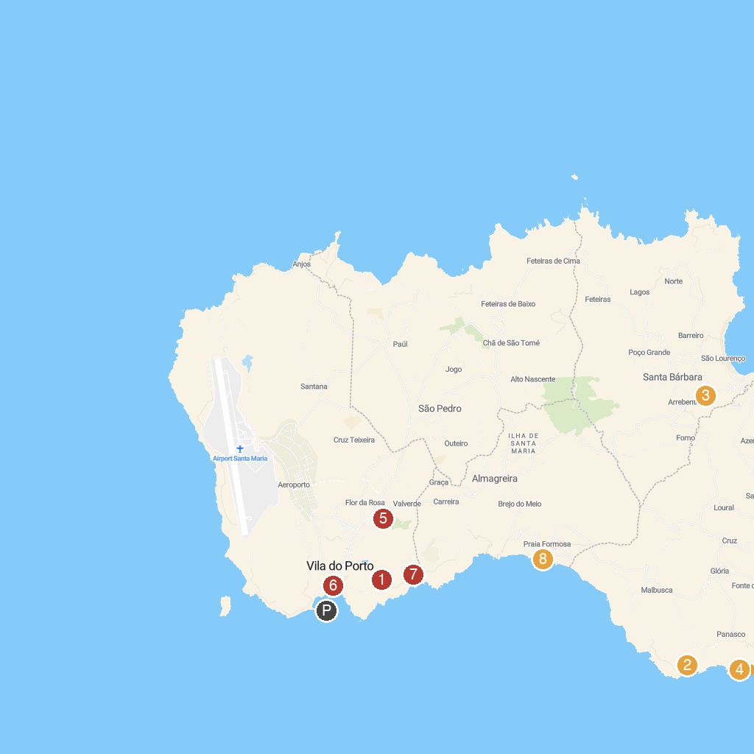
MAP KEY
1. Monumento Natural da Pedreira do Campo | 5. Recreational Forest Reserve of Valverde Eng. Emiliano Costa
2. Ribeira de Maloás | 6. Forte de São Brás
3. Poço da Pedreira | 7. Gruta do Figueiral
4. Ponta do Castelo | 8. Praia Formosa
P. Cruise port / terminal
Map © MapTiler © OpenStreetMap contributors · cruiseports.org

