Santa Maria di Leuca, Puglia, Italy
De Finibus Terrae — the Romans called it 'the End of the Earth.' Stand at Puglia's heel and watch two seas meet beneath a clifftop sanctuary where an ancient temple once stood.
⚓ Tender (large ships) / small ships dock · 🕒 Typical call: 6–8 hrs · 💶 Euro (€) · 🗣️ Italian
✍️ MY DAY IN PORT (FILL IN)
Ship / Date
In port | arrive ______ · all aboard ______
Booked excursion
Notes / meeting point
GETTING ASHORE
- Docking: Large cruise ships anchor and tender into Porto Marina di Leuca; smaller luxury vessels can dock at the marina
- Walk to Center: ~10 min flat walk from tender pier to promenade; clifftop sanctuary is 20–30 min on foot (284 steps) or 5 min by taxi
- Best For: Sea cave boat tours, clifftop views, Salentine food and wine, eclectic Belle Époque villas
- Don't Miss: A boat tour of the Grotte di Leuca sea caves — the highlight of any Leuca call
GETTING AROUND
- 🚕 Taxi: €7–15 — Local taxis are available for short hops around town or transfers to nearby villages. Short in-town rides start around €
- 📱 Rideshare: ❌ not available
TOP THINGS TO DO
- Grotte di Leuca Sea Cave Tour — The coastline is honeycomb with spectacular sea caves carved by millennia of wave action.
- Sanctuary & Lighthouse Clifftop — Walk or ride up to the Basilica Santuario di Santa Maria de Finibus Terrae, built on the site of an ancient temple to Minerva.
- Pescoluse — Salento's Maldives Beach — Twenty minutes north by taxi, Pescoluse's wide, flat, white-sand beach with shallow turquoise water genuinely rivals the Caribbean.
- Lecce Baroque City Tour — Known as the 'Florence of the South,' Lecce's golden-stone Baroque architecture — Piazza del Duomo, Basilica di Santa Croce, and…
- Salento Food & Wine Tasting — Puglia is Italy's culinary powerhouse — orecchiette, frisella, pasticciotto pastry, and the legendary caffè in ghiaccio con latte…
BEST WALKS
- Promenade & Belle Époque Villas: ~1 km · flat · 20–30 min · free — Stroll the Lungomare Cristoforo Colombo from the marina past whimsical 19th-century eclectic villas…
- Monumental Staircase to the Sanctuary: ~1 km · steep · 30–40 min up · free — From the promenade, take the Scalinata Monumentale — 284 grand steps flanking the terminal point of…
WEATHER · DAYLIGHT · MONEY
Month | High °F | Low °F | Rainy days
May | 72 | 60 | 8
Jul | 88 | 74 | 3
Sep | 81 | 69 | 7
Daylight: May 5:32AM–7:54PM · Jul 5:31AM–8:13PM · Sep 6:27AM–6:54PM
cruiseports.org/santa-maria-di-leuca · Confirm terminal & all-aboard time with your ship

Santa Maria di Leuca, Puglia, Italy — Port Map
Red = walkable sights · Amber = excursions farther out · P = cruise terminal
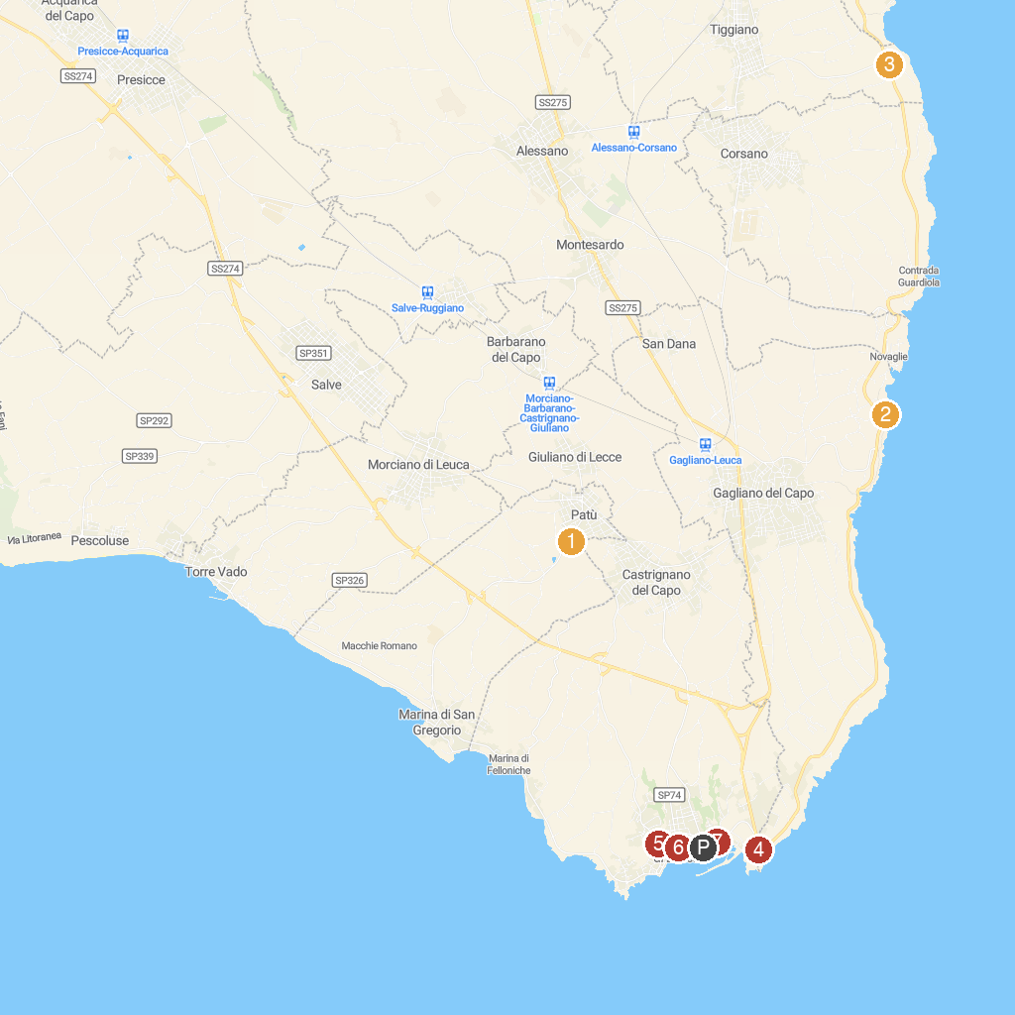
MAP KEY
1. Centopietre | 5. Palazzo dei Principi Gallone
2. Grotte Cipolliane | 6. Leuca Tourist Association Pro Loco
3. Torre Nasparo | 7. Christ the King
4. Santuario di Santa Maria de Finibus Terrae | 8. Leucos
P. Cruise port / terminal
Map © MapTiler © OpenStreetMap contributors · cruiseports.org

