Santa Margherita Ligure, Liguria, Italy
Pastel villas, turquoise water, and the best pesto you'll ever eat — Santa Margherita Ligure is the Italian Riviera done right, without Portofino's price tag.
⚓ Tender (no pier) · 🕒 Typical call: 7-9 hrs · 💶 Currency: Euro · 🗣️ Language: Italian · ⛵ Gateway to Portofino
✍️ MY DAY IN PORT (FILL IN)
Ship / Date
In port | arrive ______ · all aboard ______
Booked excursion
Notes / meeting point
GETTING ASHORE
- Docking: Tender — ships anchor offshore, ~10–15 min ride to harbor
- Walk to center: 5 min flat walk from tender dock to Piazza Mazzini
- Best For: Day trip to Portofino, pesto lunch, scenic coastal walk
- Don't Miss: Ferry to Portofino, trompe-l'œil architecture, fresh focaccia
GETTING AROUND
- 🚕 Taxi: €12–€25 — Taxis are available near the harbor and train station. The most popular ride is to Portofino (4–5 km), costing roughly €
TOP THINGS TO DO
- Ferry to Portofino — Hop the public ferry for 15 minutes and arrive in one of Italy's most photographed villages.
- Coastal Walk to Portofino — A 5 km flat-to-gentle coastal path through pine forest and past hidden coves connects Santa Margherita to Portofino.
- Villa Durazzo & Gardens — A 17th-century palace set in terraced Italianate gardens above town.
- Ligurian Food Walk — Hunt down the best pesto in Liguria, try Focaccia di Recco (thin pastry with molten Stracchino cheese), and finish with a cup of…
- Paraggi Beach — One of the few sandy beaches on this stretch of Riviera, halfway between Santa Margherita and Portofino.
BEST WALKS
- Waterfront Promenade Loop: 1.5 km · 20–30 min · Flat — Stroll from the tender pier along the palm-lined Lungomare past the Baroque church of Santa…
- Villa Durazzo Garden Walk: 1 km · 20 min · Gentle uphill — From the harbor, follow the cobblestone path uphill to Villa Durazzo's terraced gardens.
WEATHER · DAYLIGHT · MONEY
Month | High °F | Low °F | Rainy days
May | 69 | 58 | 14
Jul | 82 | 71 | 6
Sep | 76 | 65 | 10
Daylight: May 5:56AM–8:43PM · Jul 5:53AM–9:04PM · Sep 7:02AM–7:33PM
cruiseports.org/santa-margherita-ligure · Confirm terminal & all-aboard time with your ship

Santa Margherita Ligure, Liguria, Italy — Port Map
Red = walkable sights · Amber = excursions farther out · P = cruise terminal
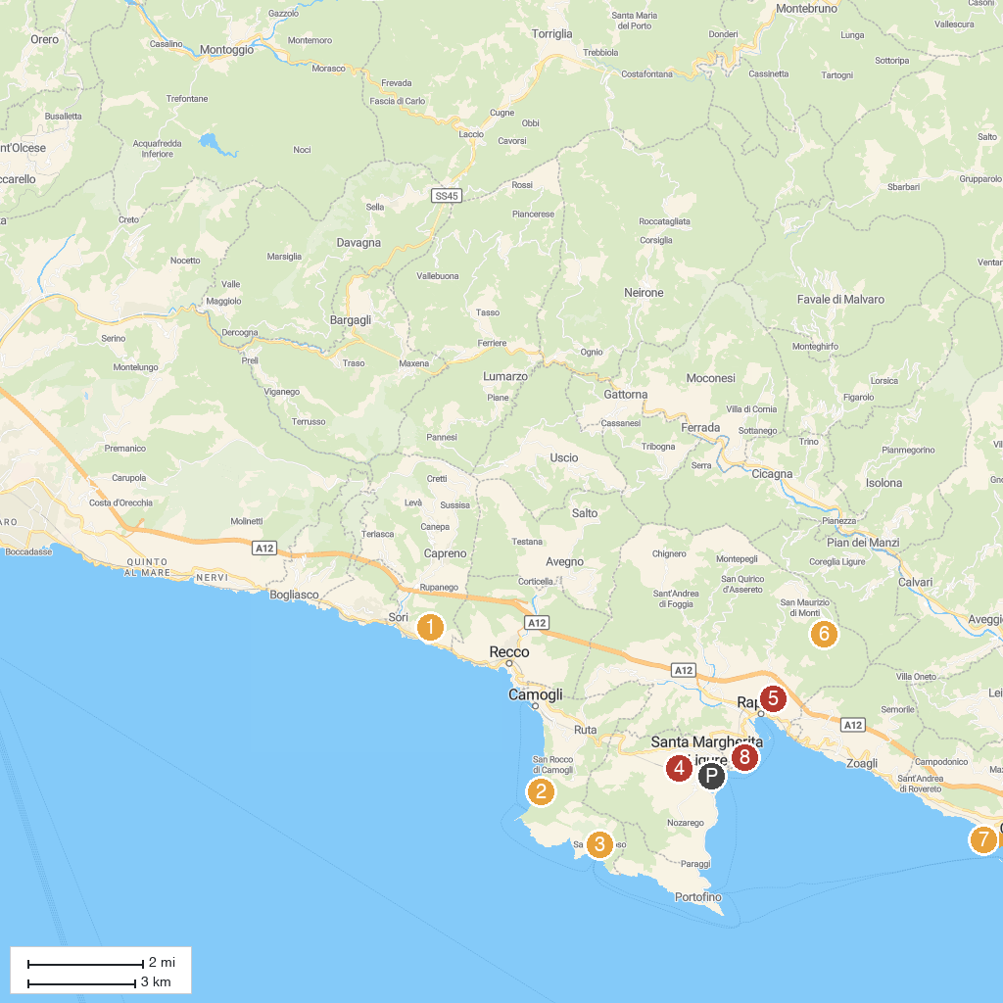
MAP KEY
1. Chiesa di Sant'Apollinare | 5. Funivia Rapallo Montallegro Stazione a Valle
2. San Nicolò di Capodimonte | 6. Funivia Rapallo - Montallegro / Stazione a monte
3. Abbazia di San Fruttuoso | 7. Parco di Villa Rocca
4. Chiesa di San Siro | 8. Tower of Punta Pagana
P. Cruise port / terminal
Map © MapTiler © OpenStreetMap contributors · cruiseports.org

