Santa Cruz Island, Galápagos, Ecuador
The beating heart of the Galápagos. In Puerto Ayora, marine iguanas share the sidewalk, sea lions nap on park benches, and the world's most famous tortoise research station is a short walk from the pier.
⚓ Tender (anchor in Academy Bay) · 🕒 Typical call: 6–8 hrs · 💵 US Dollar (USD) · 🗣️ Spanish · 🐢 Expedition ships only
✍️ MY DAY IN PORT (FILL IN)
Ship / Date
In port | arrive ______ · all aboard ______
Booked excursion
Notes / meeting point
GETTING ASHORE
- Docking: Tender — ships anchor in Academy Bay; pangas (Zodiacs) ferry passengers to the Muelle de Pasajeros
- Walk to center: 0 min — pier lands directly on Avenida Charles Darwin, the main waterfront strip
- Best For: Endemic wildlife encounters, giant tortoise trekking, snorkeling volcanic crevices
- Don't Miss: Giant tortoises in the Highlands (El Chato) and the Fish Market pelican/sea lion circus
GETTING AROUND
- 🚕 Taxi: $1.50–$2 in town; $15–$20 to highlands — White pickup trucks serve as taxis on the island. Fares within Puerto Ayora are very cheap; trips into the Santa Cruz hi
- 📱 Rideshare: ❌ not available
TOP THINGS TO DO
- Galápagos Highlands & Giant Tortoises — A 20-minute taxi ride into the misty highlands brings you face-to-face with free-roaming giant tortoises at El Chato or Primicias…
- Charles Darwin Research Station — Walk 15 minutes from the pier to the world's most famous conservation station.
- Las Grietas Snorkel — A volcanic crevice filled with crystal-clear brackish water — one of the most unusual snorkel spots in the world.
- Tortuga Bay Beach Day — A 40-minute walk (or $10 water taxi) through a cactus forest leads to one of the most beautiful beaches in South America.
- Puerto Ayora Waterfront Walk — Avenida Charles Darwin runs from the pier through town.
BEST WALKS
- Pier to Darwin Research Station: 1.2 km · 15 min · Easy — Follow Avenida Charles Darwin northeast from the pier past the fish market and waterfront…
- Laguna de las Ninfas Boardwalk: 0.5 km loop · 20 min · Easy — A peaceful wooden boardwalk threading through mangrove forest around a brackish lagoon.
- Waterfront to Tortuga Bay Trailhead: 1.5 km · 20 min to trailhead · then 2.5 km to beach — Walk west along Avenida Charles Darwin through town to the Tortuga Bay ranger station.
WEATHER · DAYLIGHT · MONEY
Month | High °F | Low °F | Rainy days
May | 80 | 74 | 22
Jul | 77 | 71 | 17
Sep | 75 | 69 | 12
Daylight: May 5:55AM–5:59PM · Jul 6:05AM–6:09PM · Sep 5:53AM–5:59PM
cruiseports.org/santa-cruz-island · Confirm terminal & all-aboard time with your ship

Santa Cruz Island, Galápagos, Ecuador — Port Map
Red = walkable sights · Amber = excursions farther out · P = cruise terminal
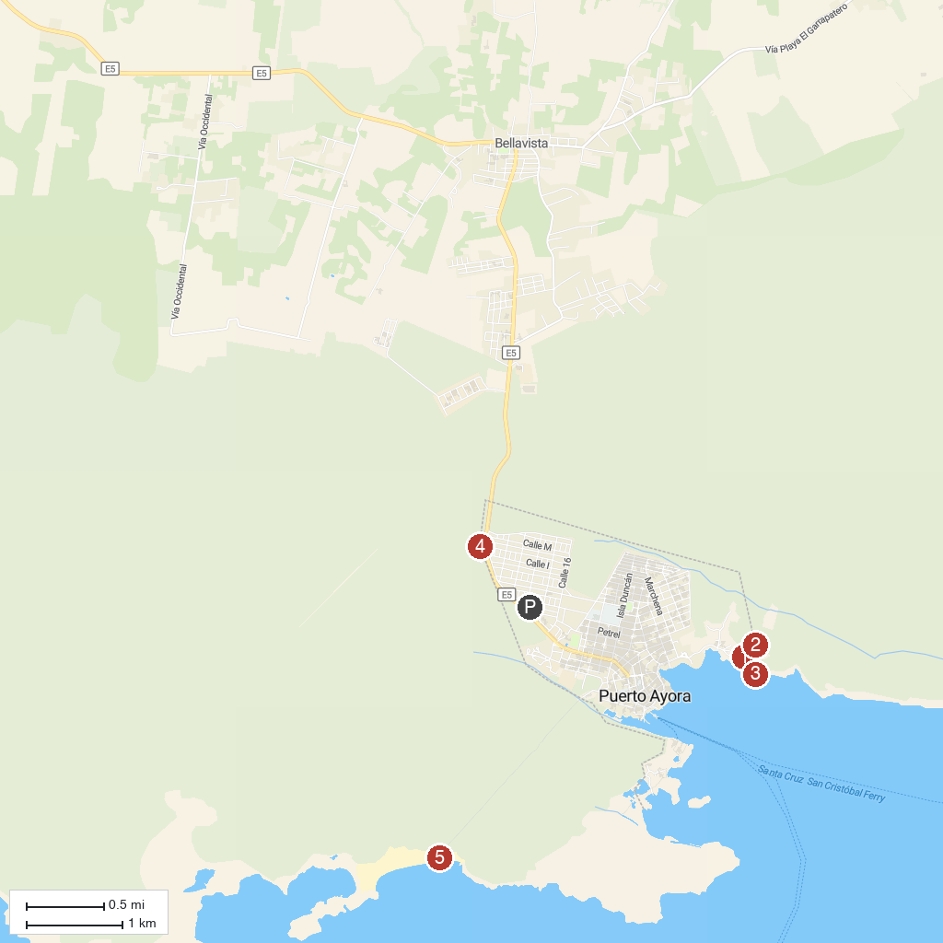
MAP KEY
1. Parque Nacional Galápagos | 5. El Mirador de Los Tuneles
2. Charles Darwin Research Station | 6. Tortuga Bay Beach
3. Fausto Llerena breeding center | 7. Lava Tunnel
4. La Ratonera
P. Cruise port / terminal
Map © MapTiler © OpenStreetMap contributors · cruiseports.org

