Santa Cruz de la Palma, La Palma, Canary Islands, Spain
La Palma is the greenest and least-visited of the main Canary Islands, and its capital delivers a rare prize: a perfectly preserved 16th-century colonial town a five-minute walk from the cruise pier.
⚓ Docked (Muelle de Santa Cruz) · 🕒 Typical call: 7-9 hrs · 💶 Currency: Euro (€) · 🗣️ Language: Spanish · 🌿 UNESCO Biosphere Reserve
✍️ MY DAY IN PORT (FILL IN)
Ship / Date
In port | arrive ______ · all aboard ______
Booked excursion
Notes / meeting point
GETTING ASHORE
- Docking: Alongside at Muelle de Santa Cruz; city center is a 5-min walk
- Best For: Colonial architecture, local cigars, volcanic landscape drives
- Don't Miss: Avenida Marítima balconied houses and the Plaza de España
- Currency Tip: ATMs by the plaza; most shops and restaurants accept cards
GETTING AROUND
- 🚕 Taxi: ~€5 — Taxis wait at the port and city stands. The ride to the city center is very short and inexpensive; useful for passengers
- 📱 Rideshare: ❌ not available
- 🚌 Hop-on hop-off: ✅ La Palma City Tours
TOP THINGS TO DO
- Caldera de Taburiente National Park — An enormous volcanic caldera — one of the largest in the world — filled with Canarian pine forest and dramatic ravines.
- Santa Cruz Old Town Walking Tour — The Avenida Marítima balconied houses, the Renaissance-era Plaza de España, the Iglesia El Salvador, and the 17th-century Casa…
- Ruta de los Volcanes Hike — A spectacular ridge walk along the southern spine of the island through a series of craters and lava fields from the 1949 and…
- Local Cigar Factory & Rum Tasting — La Palma has a long tradition of hand-rolled cigars — small workshops near the centre welcome visitors.
- Los Tilos Laurisilva Forest — UNESCO-listed ancient laurel forest in the northeast of the island — mist-shrouded, lush, and eerily quiet.
BEST WALKS
- Avenida Marítima to Plaza de España: 1.5 km · 20 min · Flat · Free — La Palma's showpiece waterfront walk.
- Old Town Loop — Calles Real & O'Daly: 2 km · 30-40 min · Flat · Free — From the Plaza de España, walk up Calle Real / Calle O'Daly (the main pedestrian shopping street)…
WEATHER · DAYLIGHT · MONEY
Month | High °F | Low °F | Rainy days
May | 74 | 63 | 4
Jul | 82 | 70 | 1
Sep | 81 | 71 | 4
Daylight: May 7:20AM–8:54PM · Jul 7:23AM–9:10PM · Sep 7:56AM–8:15PM
cruiseports.org/santa-cruz-de-la-palma · Confirm terminal & all-aboard time with your ship

Santa Cruz de la Palma, La Palma, Canary Islands, Spain — Port Map
Red = walkable sights · Amber = excursions farther out · P = cruise terminal
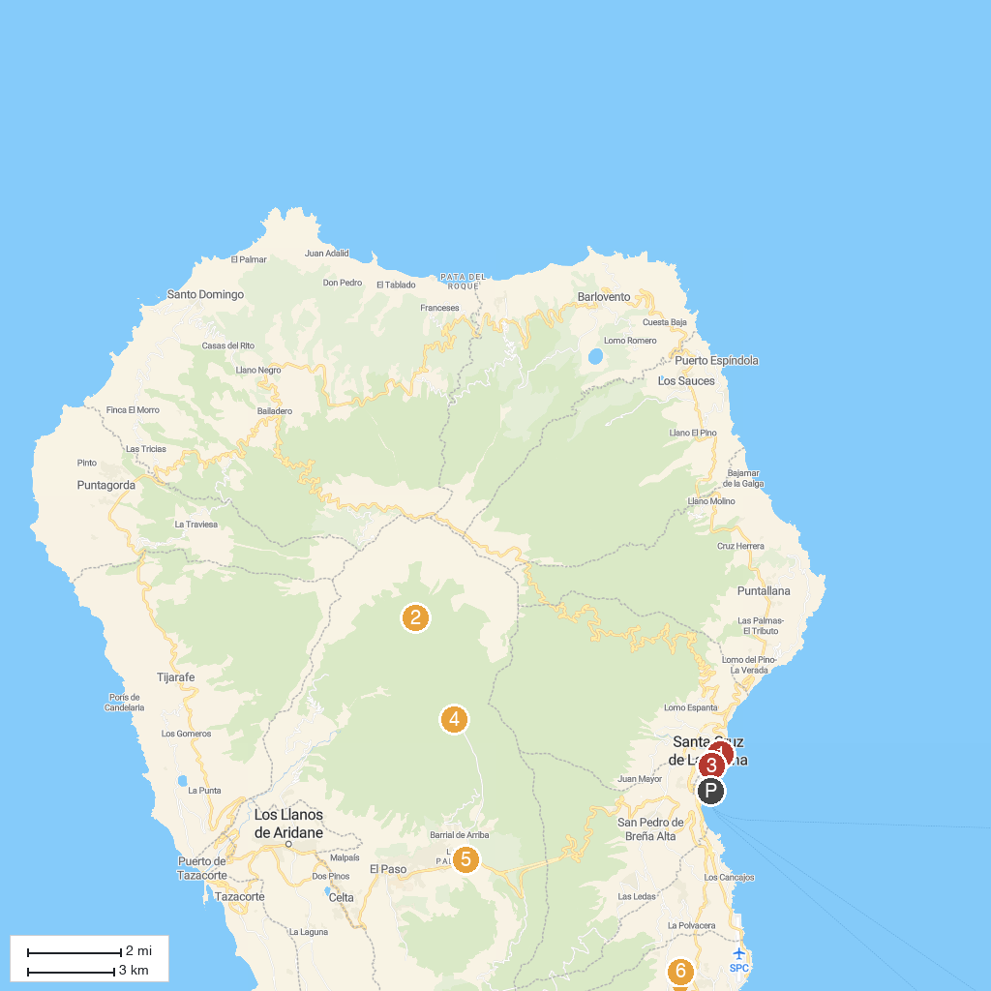
MAP KEY
1. Gran Telescopio Canarias | 5. Iglesia Matriz de El Salvador
2. Museo Insular de La Palma | 6. Mirador de La Cumbrecita
3. Caldera de Taburiente National Park | 7. Centro de Visitantes de La Caldera de Taburiente
4. Mirador de Los Andenes | 8. Parque Arqueológico de Belmaco
P. Cruise port / terminal
Map © MapTiler © OpenStreetMap contributors · cruiseports.org

