Santa Barbara, California, USA
The American Riviera — where Spanish Colonial architecture, world-class Pinot Noir, and Pacific beaches meet the mountains. Santa Barbara is walkable, gorgeous, and unlike any other U.S. port call.
⚓ Tender port (no pier) · 🕒 Typical call: 7-9 hrs · 💵 USD · 🗣️ English · 🌊 California coast
✍️ MY DAY IN PORT (FILL IN)
Ship / Date
In port | arrive ______ · all aboard ______
Booked excursion
Notes / meeting point
GETTING ASHORE
- Docking: Tender to Sea Landing, Santa Barbara Harbor
- Walk to center: 20 min to State Street; 15 min to Stearns Wharf
- Best For: Wine tasting, architecture, beaches, strolling downtown
- Don't Miss: Santa Barbara County Courthouse clock tower & Funk Zone wine trail
GETTING AROUND
- 🚕 Taxi: $10–$20 — Regulated taxis are available at the port. Base fare is $4–5 plus ~$3/mile; the short trip to State Street typically run
- 📱 Rideshare: ✅ Uber, Lyft
- 🚌 Hop-on hop-off: ✅
TOP THINGS TO DO
- Funk Zone Wine Trail — Santa Barbara County is famed for Pinot Noir and Chardonnay, and the Funk Zone — a converted industrial neighborhood just 15 min…
- Santa Barbara County Courthouse & El Mirador — Built after the 1925 earthquake in stunning Spanish-Moorish style, this working courthouse is free to explore.
- Stearns Wharf & Sea Center — California's oldest operating wharf (1872) stretches 2,300 feet into the harbor.
- Old Mission Santa Barbara — The 'Queen of the Missions' (1786) sits in the foothills about 2.5 miles from the harbor.
- Channel Islands & Whale Watch — The Santa Barbara Channel is a Marine Sanctuary.
BEST WALKS
- Harbor to Stearns Wharf Beach Stroll: 1.2 miles / 25 min / flat — From Sea Landing, head east along Cabrillo Boulevard's palm-lined path.
- Funk Zone & Lower State Street: 0.8 miles / 15-20 min / flat — From Stearns Wharf walk up State Street into the Funk Zone — wine tasting rooms, surf shops, and…
WEATHER · DAYLIGHT · MONEY
Month | High °F | Low °F | Rainy days
May | 73 | 56 | 2
Jul | 83 | 65 | 0
Sep | 83 | 64 | 1
Daylight: May 5:56AM–7:54PM · Jul 5:58AM–8:11PM · Sep 6:42AM–7:04PM
cruiseports.org/santa-barbara-ca · Confirm terminal & all-aboard time with your ship

Santa Barbara, California, USA — Port Map
Red = walkable sights · Amber = excursions farther out · P = cruise terminal
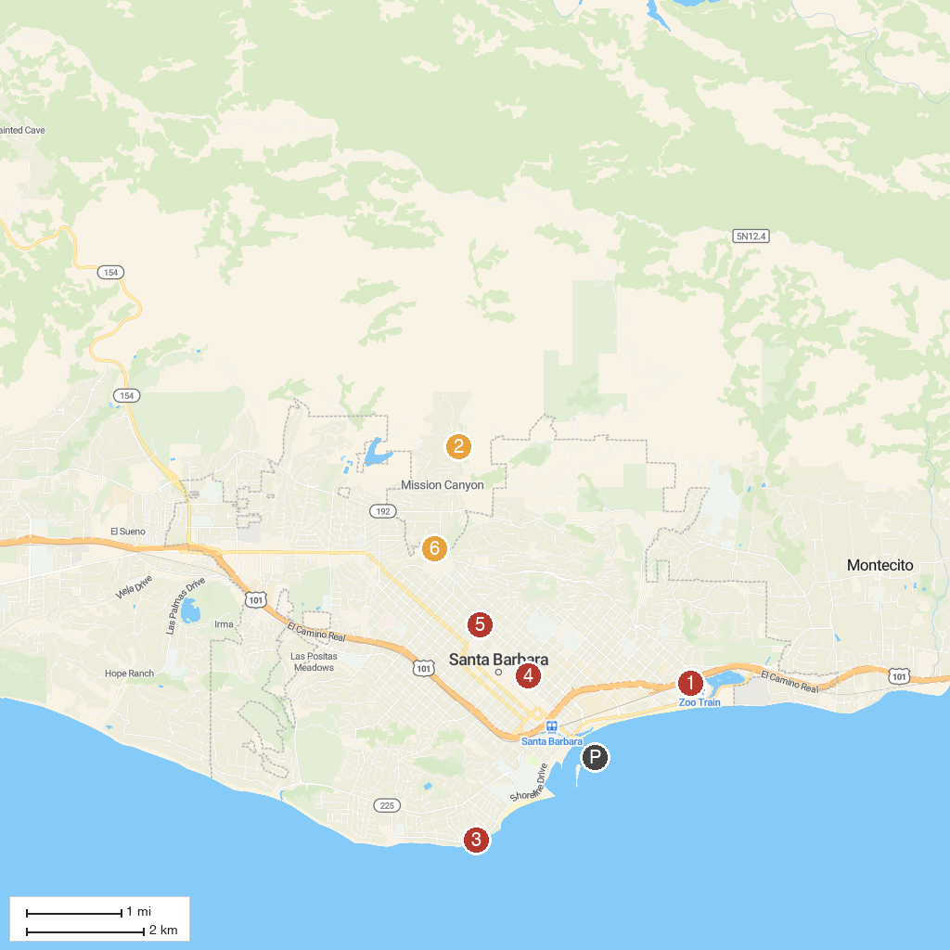
MAP KEY
1. Santa Barbara Zoo | 5. Shoreline Park
2. Chumash Painted Cave State Historic Park | 6. Santa Barbara Historical Museum
3. Goleta Beach Park | 7. Alice Keck Park Memorial Garden
4. Santa Barbara Botanic Garden | 8. Santa Barbara Museum of Natural History
P. Cruise port / terminal
Map © MapTiler © OpenStreetMap contributors · cruiseports.org

