Sandnessjøen, Helgeland, Norway
Seven jagged peaks loom over a compact island town just south of the Arctic Circle — Sandnessjøen packs Viking legends, a medieval churchyard, and some of Norway's most dramatic coastal scenery into a short shore day.
⚓ Pier (docked, town centre) · 🕒 Typical call: 6–8 hrs · 💳 Cashless — NOK, card everywhere · 🗣️ Norwegian (English widely spoken) · ☀️ Bright white nights in summer
✍️ MY DAY IN PORT (FILL IN)
Ship / Date
In port | arrive ______ · all aboard ______
Booked excursion
Notes / meeting point
GETTING ASHORE
- Docking: Pier — Horvnes Quay, ~10 min walk to town
- Walk to centre: 10–15 min from Horvnes; town fully walkable
- Best For: Mountain scenery, Viking history, coastal walks
- Don't Miss: Views of De Syv Søstre (Seven Sisters) & Petter Dass Museum
GETTING AROUND
- 🚕 Taxi: 100–150 NOK (~$9–14 USD) — Taxis from Horvnes quay (10 min north of center) cost roughly 100–150 NOK. Base fare ~100 NOK plus ~14.5 NOK/km. Local c
TOP THINGS TO DO
- Seven Sisters (De Syv Søstre) Hike — The seven jagged peaks rising across the sound are the defining image of Sandnessjøen.
- Petter Dass Museum & Alstahaug Medieval Church — About 12 km south of town, the Alstahaug rectory was home to 17th-century poet-priest Petter Dass.
- RIB Safari through the Helgeland Archipelago — Speed across the island-dotted Helgeland coast in a rigid inflatable boat, spotting white-tailed eagles, cormorants, and remote…
- Island Cycling — Herøy or Dønna — Take a ferry to flat, scenic Herøy (Herøy church, Herøy Museum) or Dønna (medieval church, Dønnes mountain viewpoint).
- White Nights or Northern Lights Experience — Summer calls (late May–July) enjoy near-perpetual bright 'white nights' — Sandnessjøen sits just south of the Arctic Circle, so…
BEST WALKS
- Harbour & Town Centre Stroll: 1.5 km · 30 min · Easy — Walk from the Horvnes pier along the harbour front into town, passing the marina, local cafes, and…
- Helgeland Bridge Viewpoint: ~3 km one-way · 1 hr · Easy–moderate — Walk or cycle out to view the Helgelandsbrua cable-stayed bridge connecting Alsta island to the…
WEATHER · DAYLIGHT · MONEY
Month | High °F | Low °F | Rainy days
May | 50 | 40 | 16
Jul | 62 | 53 | 17
Sep | 56 | 47 | 18
Daylight: Sep 6:30AM–7:36PM
cruiseports.org/sandnessjoen · Confirm terminal & all-aboard time with your ship

Sandnessjøen, Helgeland, Norway — Port Map
Red = walkable sights · Amber = excursions farther out · P = cruise terminal
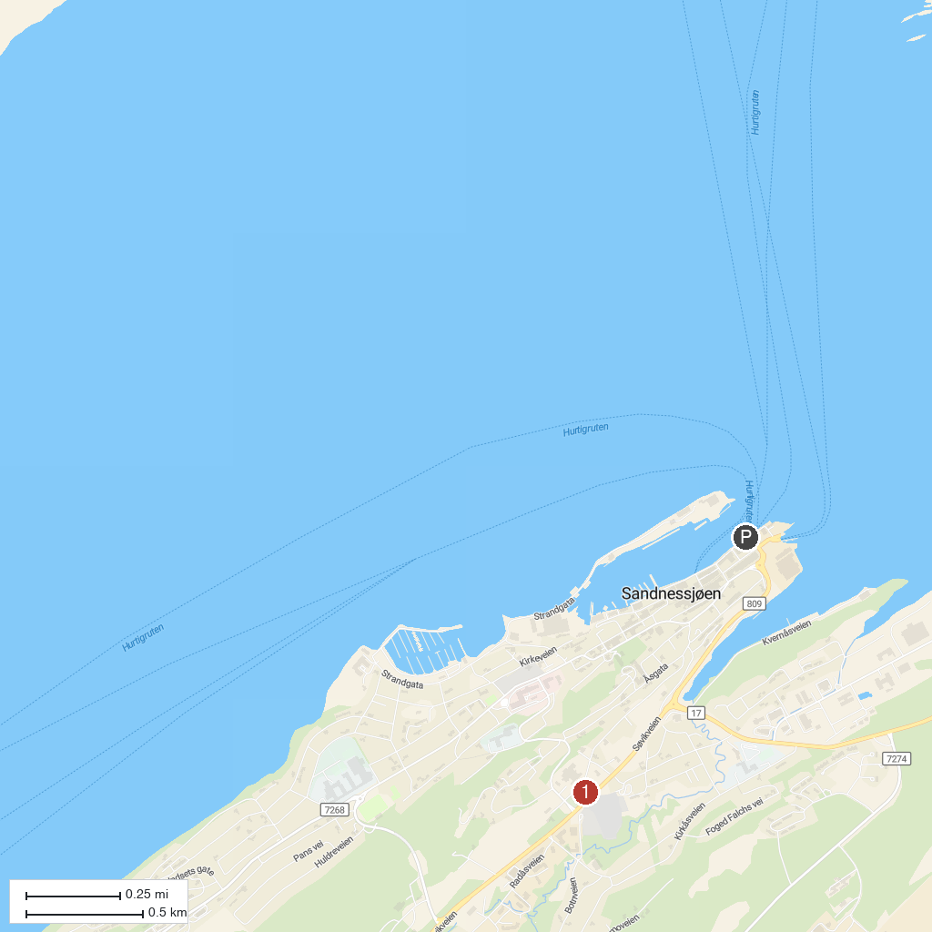
MAP KEY
1. Petter Dass Museum | 2. Torolvstein
P. Cruise port / terminal
Map © MapTiler © OpenStreetMap contributors · cruiseports.org

