Sandefjord, Vestfold, Norway
Once the whaling capital of the world, Sandefjord is a small, immaculate Norwegian town where giant blue whales hang from museum ceilings and a Viking burial mound waits just outside town. It's one of those ports where the history punches well above its size.
⚓ Docked (pier) · 🕒 Typical call: 6-8 hrs · 💳 Cashless — card only (NOK) · 🗣️ Norwegian (English universal) · 🐳 Whaling heritage
✍️ MY DAY IN PORT (FILL IN)
Ship / Date
In port | arrive ______ · all aboard ______
Booked excursion
Notes / meeting point
GETTING ASHORE
- Docking: Modern pier, central harbor — ships dock directly, no tender
- Walk to center: 5 min to Whaling Museum & town center on foot
- Best For: History buffs, walkers, seafood lovers
- Don't Miss: Hvalfangstmuseet (Whaling Museum) and the harbor monument
GETTING AROUND
- 🚕 Taxi: 150–200 NOK (~$14–19 USD) — Taxis are available at the port. Given the short distance, expect to pay close to the base fare. Hvalen Taxi is a local
- 📱 Rideshare: ✅ Uber
TOP THINGS TO DO
- Hvalfangstmuseet — Whaling Museum — One of the world's only museums dedicated solely to whaling.
- Gokstad Viking Burial Mound — The actual site where the famous 9th-century Gokstad longship was excavated in 1880.
- Midtåsen Sculpture Park — The former estate of shipping magnate Anders Jahre, now a public park with fjord panoramas, formal gardens, and outdoor sculpture.
- Harbour Seafood & Brygga 11 — Sandefjord punches above its weight on food.
- Badeparken & Harbour Promenade Walk — A short stroll from the pier to Sandefjord's Badeparken (bathing park) along the waterfront.
BEST WALKS
- Harbour & Whaling Heritage Loop: ~2 km · 30-40 min · Flat — Walk from the cruise pier along the waterfront to the Whaling Museum, then up to the Whaling…
- Town Centre Wander: ~1.5 km · 20-30 min · Flat — A relaxed stroll through Sandefjord's pedestrian streets.
WEATHER · DAYLIGHT · MONEY
Month | High °F | Low °F | Rainy days
May | 58 | 44 | 12
Jul | 69 | 56 | 13
Sep | 61 | 50 | 12
Daylight: May 4:47AM–9:44PM · Jul 4:31AM–10:17PM · Sep 6:48AM–7:38PM
cruiseports.org/sandefjord · Confirm terminal & all-aboard time with your ship

Sandefjord, Vestfold, Norway — Port Map
Red = walkable sights · Amber = excursions farther out · P = cruise terminal
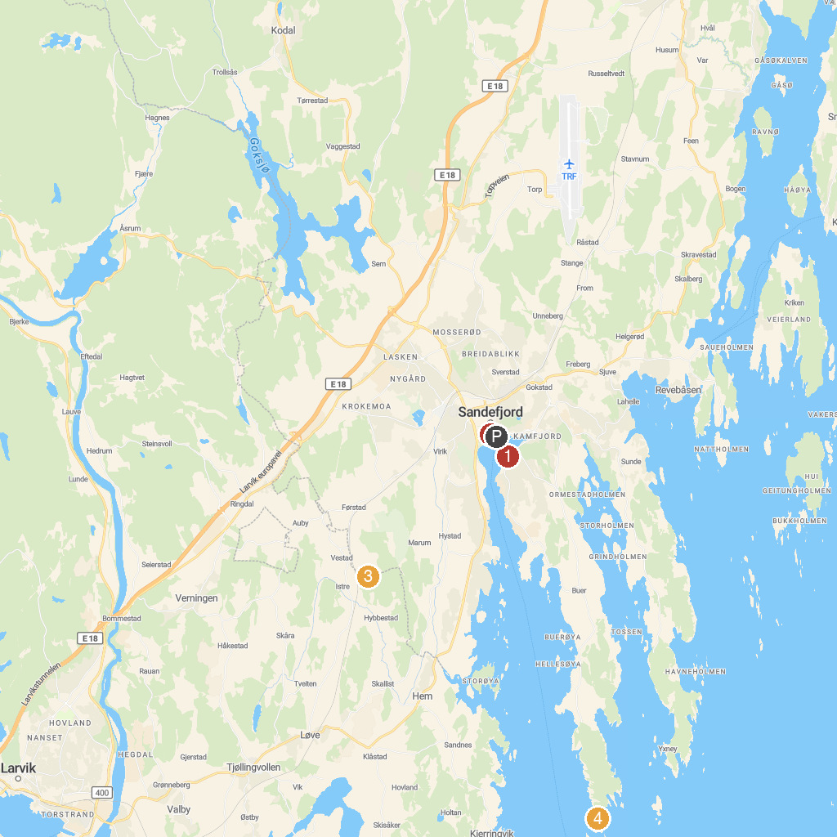
MAP KEY
1. Gokstad Coastal Association | 5. Torås Fortress
2. Hvalfangstmonumentet | 6. Aktiv Fritid Tjøme AS
3. Istrehågan, Iron age Cemetery | 7. Visitor Center Færder National Park
4. HKB 5/980 Vesterøen | 8. Tollerodden
P. Cruise port / terminal
Map © MapTiler © OpenStreetMap contributors · cruiseports.org

