Sandane, Vestland, Norway
At the innermost reach of Gloppefjorden, Sandane is one of Norway's least-crowded cruise ports — an unspoiled village where you can stand over a thundering waterfall, explore a museum of 44 historic timber buildings, or arrange a day trip to the Briksdal Glacier.
⚓ Tender port (most ships) · 🕒 Typical call: 7-9 hrs · 💴 Norwegian Krone (NOK) — Norway is cashless, cards everywhere · 🗣️ Norwegian (English widely spoken) · 🌿 Fjord & nature focus
✍️ MY DAY IN PORT (FILL IN)
Ship / Date
In port | arrive ______ · all aboard ______
Booked excursion
Notes / meeting point
GETTING ASHORE
- Docking: Tender for most cruise ships; small expedition vessels may dock at Sandane Kai
- Walk to center: 2 min from tender pontoon — town is immediately at the dock
- Best For: Open-air museum, waterfall hiking, glacier excursions, authentic village atmosphere
- Don't Miss: Nordfjord Folk Museum and the Fosseteateret waterfall platform over Holvikfossen in Trivselsskogen
GETTING AROUND
- 🚕 Taxi: NOK 100–300 (~–) — Local taxis are available in Sandane for short transfers or excursions into the surrounding Nordfjord region. Given the
- 📱 Rideshare: ❌ not available
TOP THINGS TO DO
- Nordfjord Folk Museum — One of Norway's finest open-air museums with 44 historic wooden buildings from the 17th–19th centuries, showing how fjord farmers…
- Trivselsskogen Waterfall Trail — A beloved network of forest and mountain trails above the town, built partly with Sherpa-laid stone stairs.
- Loen Skylift Day Trip — About an hour's drive away, the Loen Skylift is one of Europe's steepest cable cars — climbing 1,011 meters to Mount Hoven in…
- Briksdal Glacier Excursion — The Briksdalsbreen arm of the Jostedalsbreen ice sheet — Norway's largest glacier — is a 1.5-hour drive from Sandane.
- Sandane Sjøbad Sea Bath — A short 5-10 minute walk from the pier, this community sea bath has a grassy sunbathing area, diving tower, floating dock, and…
BEST WALKS
- Waterfront & Town Center Stroll: 1 km • 15 min • Flat • Free — From the tender pontoon, walk along the Gloppefjorden shoreline path and into the town center.
- Trivselsskogen — Holvikfossen & Viewpoints: 3-4 km • 1.5-2 hrs • Moderate • Free — Head uphill from the town center to Trivselsskogen forest.
- Nordfjord Folk Museum Walk: 1.5 km • 20 min • Easy uphill • Museum entry ~120 NOK — A straightforward uphill walk from the pier to the Nordfjord Folk Museum.
WEATHER · DAYLIGHT · MONEY
Month | High °F | Low °F | Rainy days
May | 56 | 43 | 16
Jul | 68 | 54 | 20
Sep | 60 | 49 | 18
Daylight: May 4:43AM–10:21PM · Jul 4:21AM–10:59PM · Sep 7:01AM–7:57PM
cruiseports.org/sandane · Confirm terminal & all-aboard time with your ship

Sandane, Vestland, Norway — Port Map
Red = walkable sights · Amber = excursions farther out · P = cruise terminal
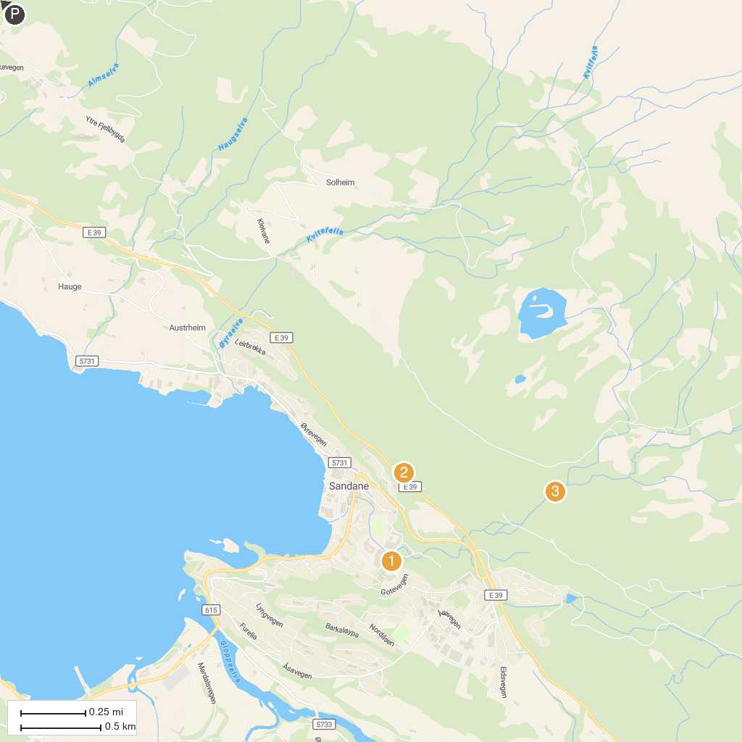
MAP KEY
1. Nordfjord Folk Museum | 4. Tvinnefossen
2. Trivselsskogen | 5. Fotostop Hornindalsvatnet
3. Fosseteateret Holvikfossen
P. Cruise port / terminal
Map © MapTiler © OpenStreetMap contributors · cruiseports.org

