Sandakan, Sabah, Malaysia
Once the capital of British North Borneo, Sandakan is now the world's best-value wildlife port — where a short drive from the pier puts you face-to-face with wild orangutans, the smallest bears on earth, and long-nosed proboscis monkeys deep in the rainforest.
⚓ Pier (commercial terminal) · 🕒 Typical call: 8–10 hrs · 💵 Malaysian Ringgit (MYR) · 🗣️ English widely spoken · 🦧 Wildlife destination
✍️ MY DAY IN PORT (FILL IN)
Ship / Date
In port | arrive ______ · all aboard ______
Booked excursion
Notes / meeting point
GETTING ASHORE
- Docking: Pier — Sandakan commercial port / cruise terminal, ~4.5 km from town
- Walk to center: Not walkable — port is in an active industrial zone; take shuttle or Grab
- Best For: Wildlife (orangutans, sun bears, proboscis monkeys), WWII history
- Don't Miss: Sepilok Orangutan Rehabilitation Centre 10 AM feeding + Sun Bear Centre next door
GETTING AROUND
- 🚕 Taxi: RM 20–50 — Taxis are available at the port and offer the most direct route to the city center. Most operate without meters — agree
- 📱 Rideshare: ✅ Grab
TOP THINGS TO DO
- Sepilok Orangutan Rehabilitation Centre — World-famous sanctuary where orphaned orangutans are re-trained for life in the wild.
- Bornean Sun Bear Conservation Centre — Right next door to Sepilok — meet the world's smallest bear species, rescued from the illegal pet trade, on elevated boardwalks…
- Rainforest Discovery Centre (RDC) — A canopy walkway stretches high through the rainforest treetops near Sepilok — a paradise for birdwatchers and anyone wanting to…
- Labuk Bay Proboscis Monkey Sanctuary — A private sanctuary set in mangrove forest where Borneo's iconic long-nosed proboscis monkeys gather at feeding platforms at…
- Sandakan Memorial Park & Agnes Keith House — A sobering and beautifully maintained park on the site of the WWII POW camp where the infamous Sandakan Death Marches originated.
BEST WALKS
- Harbour Square to Pu Ji Shi Temple: 1.5 km | Easy–Moderate | 30–40 min — From the Sandakan Harbour Square area, walk uphill through the old town to the Pu Ji Shi Buddhist…
- Agnes Keith House & English Tea House: Easy | 30 min walk from Agnes Keith House to English Tea House — Visit the beautifully restored colonial wooden house of American author Agnes Keith — one of the…
WEATHER · DAYLIGHT · MONEY
Month | High °F | Low °F | Rainy days
May | 86 | 78 | 28
Jul | 86 | 77 | 26
Sep | 86 | 77 | 27
Daylight: May 5:52AM–6:15PM · Jul 6:00AM–6:26PM · Sep 5:58AM–6:07PM
cruiseports.org/sandakan · Confirm terminal & all-aboard time with your ship

Sandakan, Sabah, Malaysia — Port Map
Red = walkable sights · Amber = excursions farther out · P = cruise terminal
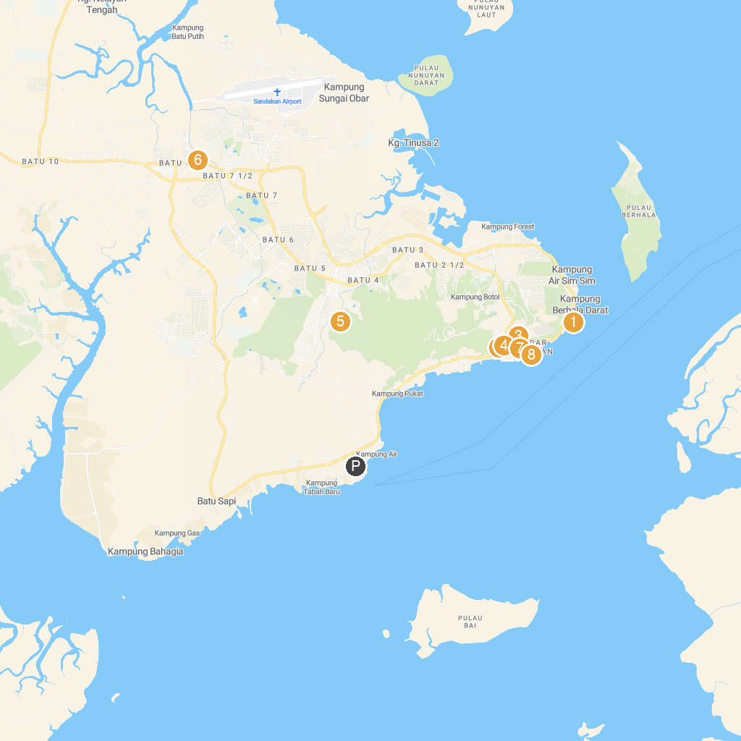
MAP KEY
1. Sandakan District Mosque | 5. Gilwell Scouts Nature Park Sandakan
2. St. Mary's Cathedral, Sandakan (1883/1961) | 6. Sandakan Crocodile Farm
3. Agnes Keith House | 7. Sandakan Heritage Trail
4. St. Michael's and All Angels Church, Sandakan | 8. Sandakan Waterfront
P. Cruise port / terminal
Map © MapTiler © OpenStreetMap contributors · cruiseports.org

