Sanary-sur-Mer, Provence, France
Pastel-painted houses, pointus fishing boats, and one of France's most celebrated weekly markets — Sanary-sur-Mer is the French Riviera without the glitz, all delivered steps from the tender pier.
⚓ Tender port (anchor in bay) · 🕒 Typical call: 6–8 hrs · 💶 Currency: Euro · 🗣️ Language: French
✍️ MY DAY IN PORT (FILL IN)
Ship / Date
In port | arrive ______ · all aboard ______
Booked excursion
Notes / meeting point
GETTING ASHORE
- Docking: Tender — ships anchor in the bay; tender drops off at Port de Sanary harbor
- Walk to center: 0 min — tender lands in the heart of town
- Best For: Slow Riviera days, markets, beaches, Provençal food
- Don't Miss: Wednesday harbor market (voted France's most beautiful)
GETTING AROUND
- 🚕 Taxi: €3.50 flag fall + €1–1.30/km — Taxis are available at the port entrance. Short in-town trips cost just a few euros; rides to Bandol or Toulon range fro
- 📱 Rideshare: ✅ Uber
TOP THINGS TO DO
- Wednesday Harbor Market — Voted France's most beautiful market, the Wednesday market stretches the full length of the harbor offering local cheeses, Bandol…
- Tour Romane & Underwater Archaeology Museum — Climb the c.
- Plage de Portissol — A sheltered sandy bay 15 minutes west of the harbor with lifeguards, showers, a marked snorkeling trail, and beachfront…
- Calanques Boat Excursion — Local operators depart from the harbor for the dramatic limestone inlets near Cassis — sheer white cliffs, turquoise water, and…
- Bandol Wine & Village — The world-famous Bandol AOC wine region — best known for its Mourvèdre reds and bone-dry rosé — begins just 10 minutes away by…
BEST WALKS
- Harbor to Chapel Panorama: 2.5 km round trip · Easy–Moderate · ~1 hr — From the harbor, follow the waterfront west past the Tour Romane, then head uphill to Chapelle…
- Harbor Stroll to Portissol Beach: 1.5 km one way · Easy · ~15 min — Walk west along the seafront promenade from the harbor past the Esplanade beach, continuing to the…
WEATHER · DAYLIGHT · MONEY
Month | High °F | Low °F | Rainy days
May | 70 | 57 | 7
Jul | 84 | 70 | 1
Sep | 78 | 65 | 6
Daylight: May 6:13AM–8:53PM · Jul 6:11AM–9:13PM · Sep 7:16AM–7:46PM
cruiseports.org/sanary-sur-mer · Confirm terminal & all-aboard time with your ship

Sanary-sur-Mer, Provence, France — Port Map
Red = walkable sights · Amber = excursions farther out · P = cruise terminal
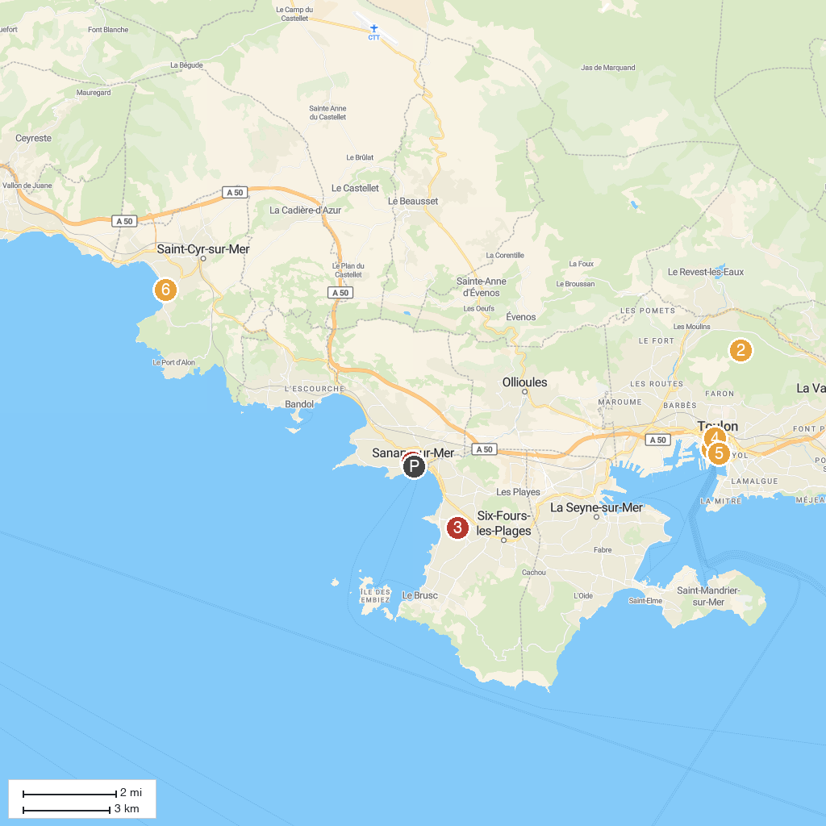
MAP KEY
1. Musée National de la Marine | 5. The Little Trains of Toulon
2. Zoo Fauverie Du Mont Faron | 6. Museum Tauroentum
3. Coudou Parc | 7. Tour de Sanary-sur-Mer
4. Hotel des Arts (Mediterranean Center of Art)
P. Cruise port / terminal
Map © MapTiler © OpenStreetMap contributors · cruiseports.org

