Sanremo, Liguria, Italy
The Queen of the Riviera dei Fiori — Belle Époque grandeur, labyrinthine medieval alleys, a landmark Art Nouveau casino, and a cycling path along the sea. Smaller ships dock right in the harbor; larger vessels tender to the old port, steps from everything.
⚓ Tender (larger ships) / Docked (small ships) · 🕒 Typical call: 6–9 hrs · 💶 Currency: Euro (€) · 🗣️ Italian (French & English widely understood)
✍️ MY DAY IN PORT (FILL IN)
Ship / Date
In port | arrive ______ · all aboard ______
Booked excursion
Notes / meeting point
GETTING ASHORE
- Docking: Tender to Porto Vecchio (large ships); smaller vessels dock at Porto Sole
- Walk to Center: 5–10 min from tender pier to Piazza Colombo / Via Matteotti
- Best For: Belle Époque architecture, cycling path, medieval quarter, day trips to Monaco
- Don't Miss: La Pigna medieval quarter, Casino di Sanremo, Villa Nobel, sardenaira pizza
GETTING AROUND
- 🚕 Taxi: €9–15 — Taxis are available at the port and city center stands. Radio Taxi Sanremo operates 24/7; meter starts at ~€3.60 plus ~€
TOP THINGS TO DO
- La Pigna Medieval Quarter Walk — Explore the labyrinth of covered alleyways, archways, and tiny piazzas of San Remo's medieval heart, climbing to the Santuario…
- Casino di Sanremo & Belle Époque Promenade — Stroll Corso dell'Imperatrice — the palm-lined seafront promenade — to the magnificent 1905 Art Nouveau Casino.
- Villa Nobel Museum — Alfred Nobel spent his final years here.
- Coastal Cycling Path (La Pista Ciclabile) — A 24-km flat bike path built on a former railway line hugs the coast from San Remo toward Ospedaletti and beyond.
- Day Trip to Monaco by Train — San Remo's train station connects to Ventimiglia, where you cross into France and reach Monaco in about 25 minutes more.
BEST WALKS
- Harbor to La Pigna & Madonna della Costa: 2.5 km | ~1.5–2 hrs | Moderate (steep upper section) — Walk from the tender pier along Via Nino Bixio into the city center, then climb the stepped lanes…
- Seafront Promenade & Casino Walk: 3 km round trip | ~1 hr | Easy flat — From the old port, walk west through the center toward Corso dell'Imperatrice's towering palm-lined…
WEATHER · DAYLIGHT · MONEY
Month | High °F | Low °F | Rainy days
May | 69 | 57 | 10
Jul | 81 | 71 | 5
Sep | 76 | 65 | 7
Daylight: May 6:03AM–8:47PM · Jul 6:01AM–9:08PM · Sep 7:08AM–7:38PM
cruiseports.org/san-remo · Confirm terminal & all-aboard time with your ship

Sanremo, Liguria, Italy — Port Map
Red = walkable sights · Amber = excursions farther out · P = cruise terminal
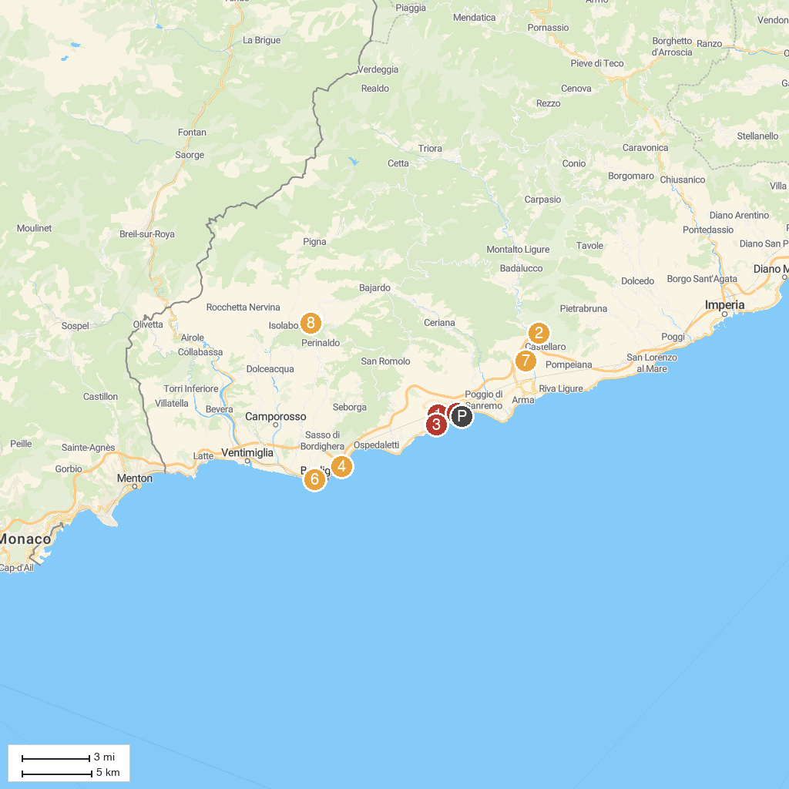
MAP KEY
1. Santuario Diocesano Nostra Signora Assunta - Madonna della Costa | 5. Villa Ormond
2. Sanctuary of Our Lady of Lampedusa | 6. Palazzo del Parco
3. Casinò di Sanremo | 7. Convento San Domenico
4. Giardino Esotico Pallanca | 8. Castello della lucertola
P. Cruise port / terminal
Map © MapTiler © OpenStreetMap contributors · cruiseports.org

