San Juan Islands, Washington, USA
A mosaic of forested islands adrift in the Salish Sea, the San Juans deliver orca sightings, farm-to-table food, and car-free cycling — all within striking distance of the continent's most dramatic marine scenery.
⚓ Docked or Tendered (varies by line) · 🕒 Typical call: 6-9 hrs · 💵 USD · 🗣️ English · 🐋 Orca country
✍️ MY DAY IN PORT (FILL IN)
Ship / Date
In port | arrive ______ · all aboard ______
Booked excursion
Notes / meeting point
GETTING ASHORE
- Docking: Most ships dock or anchor off Friday Harbor, San Juan Island; tenders used by smaller vessels
- Walk to center: Dock is right in Friday Harbor village — shops and restaurants within 2 min
- Best For: Whale watching, sea kayaking, cycling, local seafood
- Don't Miss: Lime Kiln Point State Park for shoreside orca spotting
GETTING AROUND
- 🚕 Taxi: $20–25 — Eco Taxi & Tours (all-electric) and Island Taxi & Tours serve San Juan Island. In-town Friday Harbor trips run $20–25; l
- 📱 Rideshare: ❌ not available
- 🚌 Hop-on hop-off: ✅
TOP THINGS TO DO
- Whale-Watching Cruise — Board a dedicated whale-watch vessel out of Friday Harbor for 3-4 hours in prime orca territory.
- Sea Kayaking the Coastline — Paddle rocky coves and kelp forests with a guided kayak tour departing from Friday Harbor.
- Lime Kiln Point State Park & Whale Watch Park — Cycle or cab 10 miles to the west shore of San Juan Island, where Lime Kiln Point State Park is one of the best land-based…
- American Camp & English Camp (San Juan Island National Historical Park) — The Pig War of 1859 — a bloodless US-British boundary dispute triggered by a farmer shooting a pig — left two historic military…
- Friday Harbor Village & The Whale Museum — The Whale Museum on First Street, opened in 1979, was the first US museum dedicated to a species living in the wild — exhibits on…
BEST WALKS
- Friday Harbor Waterfront & Village Loop: 1.5 miles · Flat · 30-45 min — From the cruise dock on Front Street, head up Spring Street past local shops to The Whale Museum on…
- Westside Road to Lime Kiln Point (cycling): ~10 miles one-way · Moderate · 45-60 min by bike — Rent a bike at the dock and follow Roche Harbor Road west, then turn south on West Side Road to…
WEATHER · DAYLIGHT · MONEY
Month | High °F | Low °F | Rainy days
May | 59 | 49 | 8
Jul | 67 | 56 | 3
Sep | 63 | 54 | 10
Daylight: May 5:31AM–8:46PM · Jul 5:26AM–9:08PM · Sep 6:49AM–7:23PM
cruiseports.org/san-juan-islands-wa · Confirm terminal & all-aboard time with your ship

San Juan Islands, Washington, USA — Port Map
Red = walkable sights · Amber = excursions farther out · P = cruise terminal
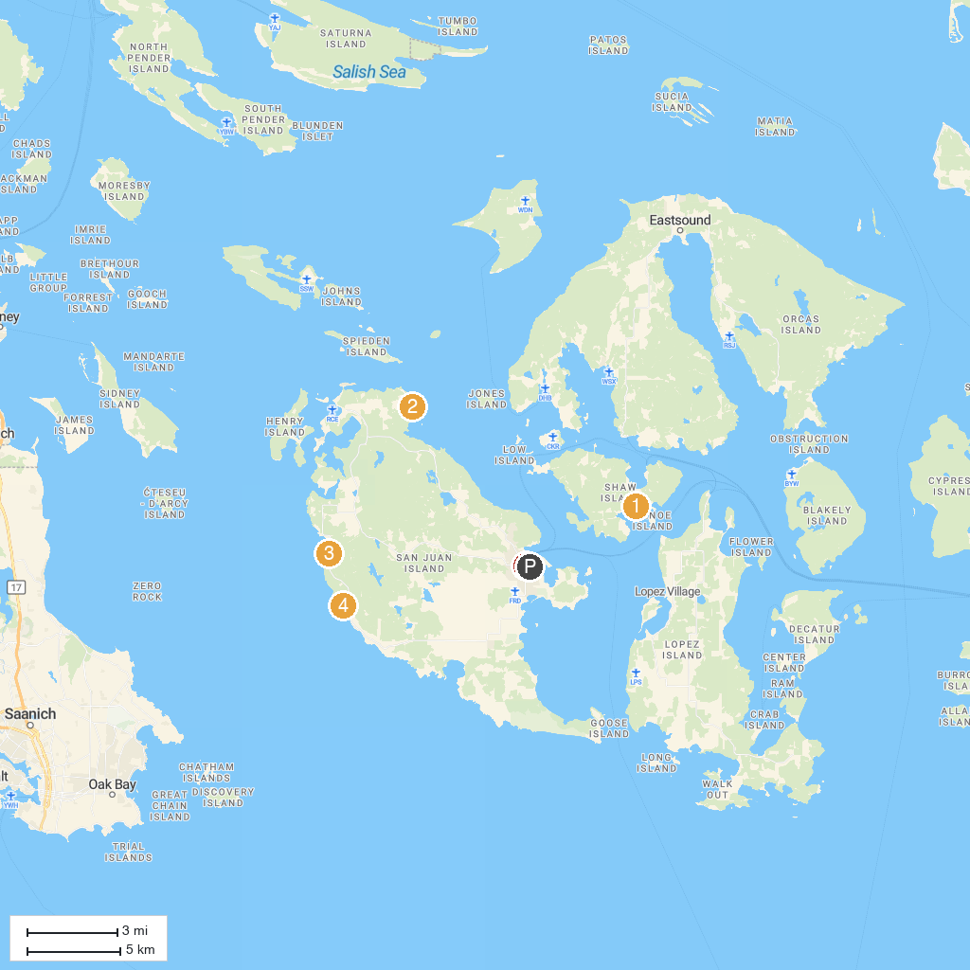
MAP KEY
1. Shaw County Park | 5. John S. McMillin Memorial Mausoleum
2. Reuben Tarte County Park | 6. Lime Kiln Point State Park
3. San Juan County Park | 7. Western Prince Whale Watching Adventures
4. San Juan Islands Sculpture Park & Nature Reserve | 8. The Whale Museum
P. Cruise port / terminal
Map © MapTiler © OpenStreetMap contributors · cruiseports.org

