San José del Cabo, Baja California Sur, Mexico
Skip the party strip — San José del Cabo is Baja's artsy, unhurried alter ego, with a 1730 mission church, open-air galleries, a wildlife estuary, and some of Mexico's best farm-to-table kitchens.
⚓ Tender via Cabo San Lucas marina · 🕒 Typical call: 8-10 hrs · 💵 USD widely accepted / MXN preferred · 🗣️ Spanish (English widely spoken in tourist zones) · 🚕 20-mile taxi/bus ride to town center
✍️ MY DAY IN PORT (FILL IN)
Ship / Date
In port | arrive ______ · all aboard ______
Booked excursion
Notes / meeting point
GETTING ASHORE
- Docking: Ships tender into Cabo San Lucas marina; San José del Cabo is ~20 miles NE by taxi or bus
- Walk to Center: Not walkable from ship — taxi $40-60 USD or public bus ~$3 to Plaza Mijares
- Best For: Art galleries, colonial architecture, estuary birdwatching, farm-to-table dining
- Don't Miss: Thursday Art Walk (Nov–Jun), Estero San José, Plaza Mijares & Mission church
GETTING AROUND
- 🚕 Taxi: $10–$20 USD — Official taxis wait outside Puerto Los Cabos pier. No meters — always agree on the fare before getting in. Cash (USD or
- 📱 Rideshare: ✅ Uber
TOP THINGS TO DO
- San José del Cabo Historic Art District — Stroll cobblestone Calle Álvaro Obregón and the streets around Plaza Mijares, lined with high-end galleries showing Mexican and…
- Estero San José Estuary Walk — A protected freshwater lagoon where the river meets the sea, just east of the hotel zone.
- Farm-to-Table Lunch at Flora Farms or Acre — San José del Cabo anchors one of Mexico's best farm-to-table scenes.
- Mission San José del Cabo & Plaza Mijares — Founded in 1730, this Spanish colonial mission faces the main plaza.
- ATV & Desert Off-Road Tour — Ride ATVs or UTVs through Baja's desert into arroyos and onto beach stretches.
BEST WALKS
- Plaza Mijares & Gallery District Loop: 1.2 km · 30-40 min · Easy cobblestones — Start at Plaza Mijares, visit the Mission church, then head east on Calle Álvaro Obregón through…
- Estero San José Boardwalk: 1.5 km · 40 min · Flat boardwalk — From the east end of the hotel zone, follow the estuary boardwalk along the lagoon edge.
WEATHER · DAYLIGHT · MONEY
Month | High °F | Low °F | Rainy days
May | 86 | 71 | 0
Jul | 91 | 80 | 5
Sep | 88 | 78 | 10
Daylight: May 5:37AM–6:52PM · Jul 5:42AM–7:06PM · Sep 6:05AM–6:21PM
cruiseports.org/san-jose-del-cabo · Confirm terminal & all-aboard time with your ship

San José del Cabo, Baja California Sur, Mexico — Port Map
Red = walkable sights · Amber = excursions farther out · P = cruise terminal
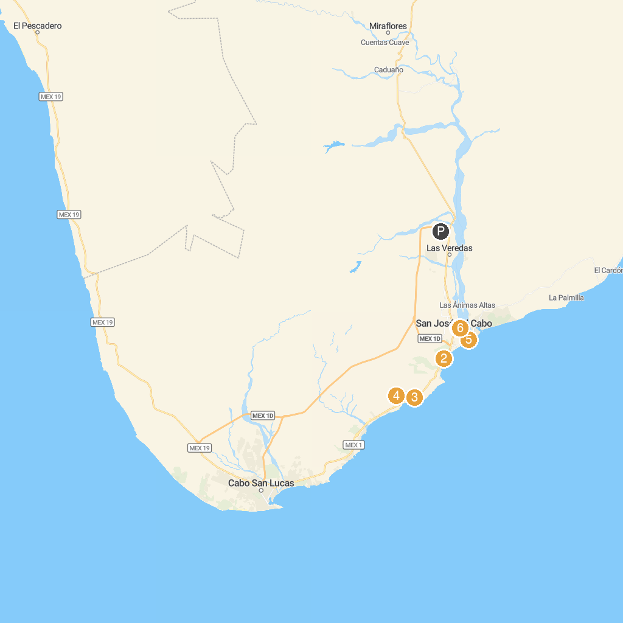
MAP KEY
1. Gallery District, San Jose de Cabo | 4. Cabo Real Golf Club
2. Costa Azul Beach | 5. Estero San José
3. El Dorado Golf & Beach Club | 6. Misión San José del Cabo
P. Cruise port / terminal
Map © MapTiler © OpenStreetMap contributors · cruiseports.org

