San Francisco, California, USA
Few cities pack an iconic punch like San Francisco. In a single shore day you can visit an island prison, ride a century-old cable car, and watch sea lions sunbathe 15 minutes from the ship.
⚓ Docked (pier) · 🕒 Typical call: 8–10 hrs · 💵 USD · 🗣️ English
✍️ MY DAY IN PORT (FILL IN)
Ship / Date
In port | arrive ______ · all aboard ______
Booked excursion
Notes / meeting point
GETTING ASHORE
- Docking: Pier 27 (James R. Herman Cruise Terminal) or Pier 35 — both on the Embarcadero, no tendering
- Walk to center: 10–15 min walk to Fisherman's Wharf; 20 min to Ferry Building
- Best For: History, iconic landmarks, food, city culture
- Don't Miss: Alcatraz Island — book tickets weeks in advance, they sell out fast
GETTING AROUND
- 🚕 Taxi: $15–$25 — Licensed metered taxis are available at cruise terminals (Pier 27 and Pier 35). The regulated base fare is $4.15 plus $3
- 📱 Rideshare: ✅ Uber, Lyft
- 🚌 Hop-on hop-off: ✅ Big Bus Tours / City Sightseeing
TOP THINGS TO DO
- Alcatraz Island Tour — Board the ferry at Pier 33 for the infamous federal penitentiary island.
- Bike the Golden Gate Bridge to Sausalito — Rent a bike near Fisherman's Wharf, ride across the Golden Gate Bridge, and descend into the charming waterfront town of Sausalito.
- Muir Woods & Sausalito — Head north across the Golden Gate to walk among ancient coastal redwoods in Muir Woods National Monument, then stop in…
- Chinatown & North Beach Walking Tour — Explore the oldest Chinatown in North America, then stroll into the Italian neighbourhood of North Beach for coffee and sourdough.
- Hop-On Hop-Off City Tour — Double-decker bus covering all major neighbourhoods — Fisherman's Wharf, Union Square, Haight-Ashbury, Castro, Golden Gate Park…
BEST WALKS
- Embarcadero to Fisherman's Wharf: 1.5 km · 20 min · Flat · No hills — Walk north from Pier 27 along the scenic waterfront past the Ferry Building, the historic piers…
- Fisherman's Wharf to Ghirardelli Square: 0.8 km · 10 min · Mostly flat — From Pier 39 stroll west past Boudin Bakery, the San Francisco Maritime National Historical Park…
- Cable Car Ride — Powell-Hyde Line: Approx 3 km · 15 min ride · Iconic — Board the Powell-Hyde cable car near Fisherman's Wharf for the classic San Francisco experience…
WEATHER · DAYLIGHT · MONEY
Month | High °F | Low °F | Rainy days
May | 63 | 52 | 2
Jul | 67 | 56 | 0
Sep | 71 | 58 | 1
Daylight: May 5:59AM–8:12PM · Jul 6:00AM–8:30PM · Sep 6:52AM–7:16PM
cruiseports.org/san-francisco · Confirm terminal & all-aboard time with your ship

San Francisco, California, USA — Port Map
Red = walkable sights · Amber = excursions farther out · P = cruise terminal
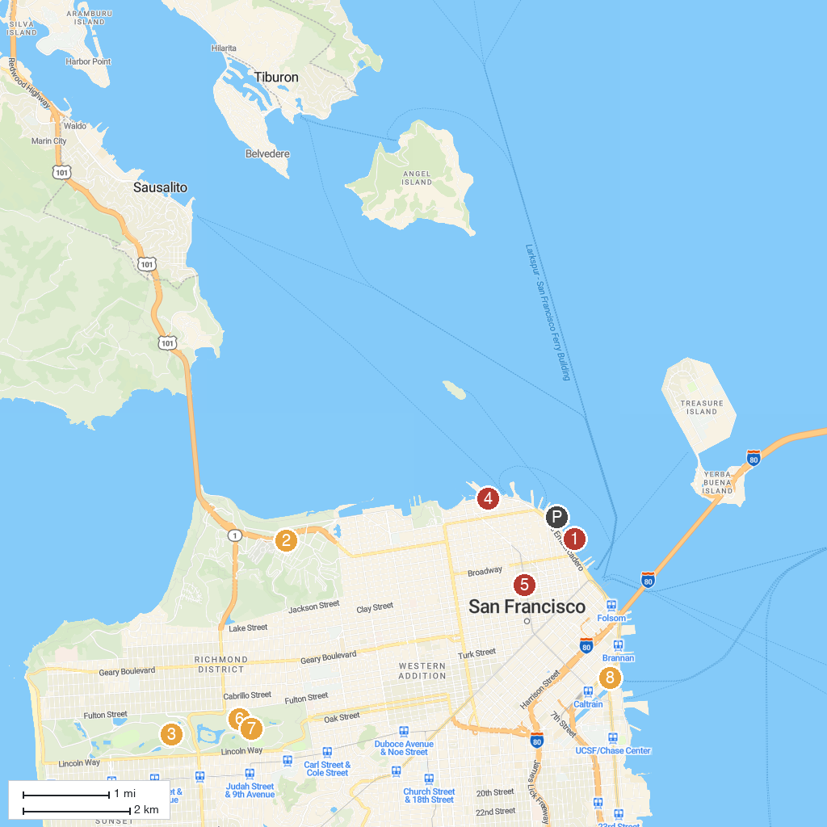
MAP KEY
1. Exploratorium | 5. Chinatown San Francisco
2. The Walt Disney Family Museum | 6. de Young Museum
3. Golden Gate Park | 7. California Academy of Sciences
4. Fisherman's Wharf | 8. Oracle Park
P. Cruise port / terminal
Map © MapTiler © OpenStreetMap contributors · cruiseports.org

