San Andrés Island, Caribbean, Colombia
A tear-shaped Caribbean gem off Colombia's coast, San Andrés dazzles with its famous Sea of Seven Colors — turquoise shallows shifting through seven distinct hues over living coral reefs. Duty-free El Centro, golf-cart circuits, and lazy snorkel stops complete an effortlessly fun shore day.
⚓ Tender port · 🕒 Typical call: 6-8 hrs · 💵 Colombian Peso (USD accepted) · 🗣️ Spanish & San Andrés Creole (English widely spoken) · 🛍️ Duty-free island
✍️ MY DAY IN PORT (FILL IN)
Ship / Date
In port | arrive ______ · all aboard ______
Booked excursion
Notes / meeting point
GETTING ASHORE
- Docking: Tender — ships anchor offshore; boats run to The Cove Embarcadero (new pier, 2023)
- To El Centro: ~15 km / 30-45 min by taxi or golf cart from The Cove Embarcadero (opposite end of island)
- Best For: Snorkeling, natural pools, duty-free shopping, fresh seafood
- Don't Miss: Johnny Cay islet, Acuario sandbar, West View natural swimming hole
GETTING AROUND
- 🚕 Taxi: COP 15,000–20,000 (~$4–5 USD) — Taxis are widely available near the tender pier. Fares are not metered — always negotiate the price before getting in.
- 📱 Rideshare: ❌ not available
TOP THINGS TO DO
- Johnny Cay & Acuario Snorkel Combo — Boat out to Johnny Cay — a palm-fringed coral islet with white sand and iguanas — then drift over the Acuario sandbar where…
- Golf Cart Island Loop — Rent a 2- or 4-seater golf cart and drive the full perimeter road in 45-60 minutes, stopping at El Hoyo Soplador blowhole, San…
- West View Natural Swimming Holes — Rocky-coast eco-park on the island's west side featuring massive natural swimming pools carved into coral rock, an underwater…
- Morgan's Cave & Pirate Museum — Explore the cave where pirate Henry Morgan allegedly stashed treasure, paired with a small museum covering pirate history and the…
- Rondon & Coco Loco Food Tour — Taste Raizal cuisine — the traditional rondon stew (fish, conch, coconut milk, yam, and dumplings), crab patties, coconut rice…
BEST WALKS
- El Centro & Spratt Bight Boardwalk: 1.4 km · 20 min · Easy · Flat paved promenade — After taxiing into town from the pier, stroll the duty-free streets of El Centro, then walk the…
- Cocoplum Bay to Rocky Cay Wade: Short drive then 200 m wade · 1.5 hrs · Easy · Sandy bottom — Take a taxi or golf cart to Cocoplum Bay on the east coast, then wade chest-deep across the channel…
WEATHER · DAYLIGHT · MONEY
Month | High °F | Low °F | Rainy days
May | 82 | 80 | 18
Jul | 83 | 80 | 24
Sep | 84 | 80 | 24
Daylight: May 6:02AM–6:44PM · Jul 6:09AM–6:56PM · Sep 6:16AM–6:27PM
cruiseports.org/san-andres-island-colombia · Confirm terminal & all-aboard time with your ship

San Andrés Island, Caribbean, Colombia — Port Map
Red = walkable sights · Amber = excursions farther out · P = cruise terminal
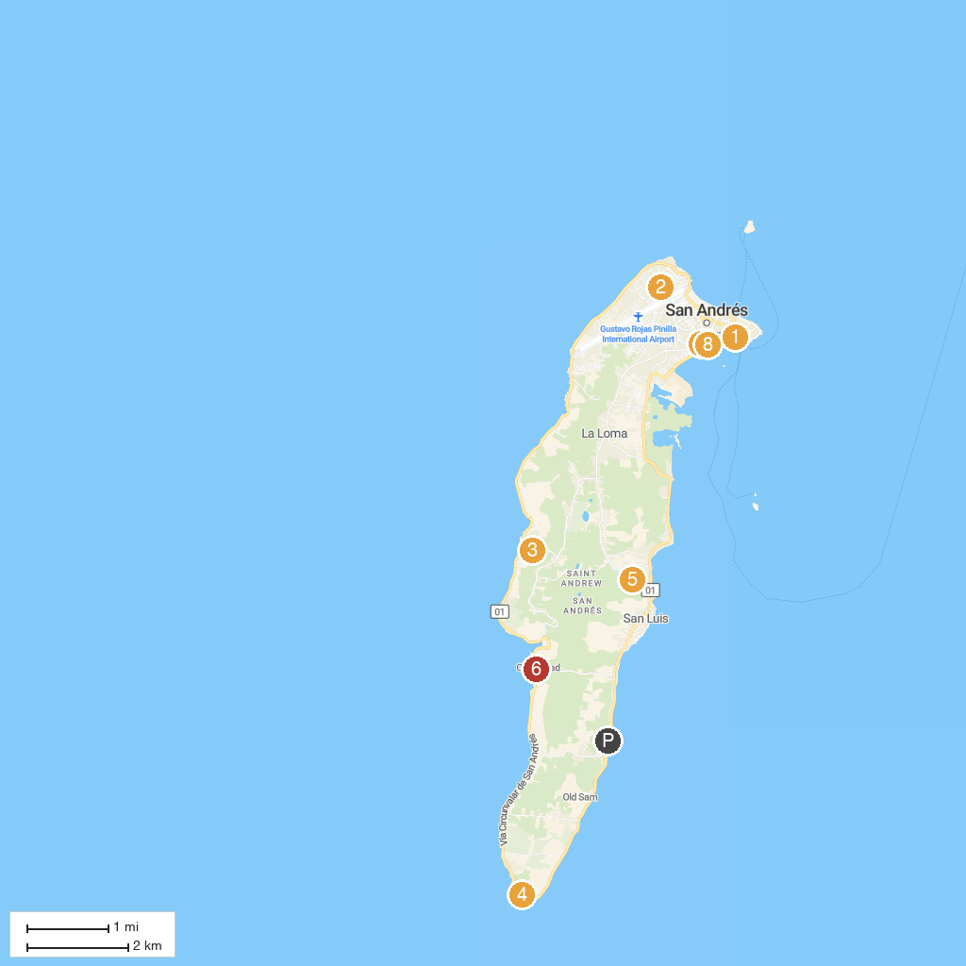
MAP KEY
1. Muelle Portofino | 5. Jardín Botánico de San Andrés
2. Sarie Bay | 6. San Andres Divers
3. Morgan's Cave | 7. Parque Simon Bolivar
4. Hoyo Soplador | 8. Plazoleta Coral Palace
P. Cruise port / terminal
Map © MapTiler © OpenStreetMap contributors · cruiseports.org

