Samothraki Island, North Aegean, Greece
One of Greece's wildest secrets — a rugged, forested island dominated by Fengari, one of the highest peaks in the Aegean, home to ancient mystery cults and emerald waterfall pools that feel untouched by time.
⚓ Docked (small ships) or tender (medium ships) · 🕒 Typical call: 6-8 hrs · 💶 Euro (€) · 🗣️ Greek · 🌿 Off the beaten path
✍️ MY DAY IN PORT (FILL IN)
Ship / Date
In port | arrive ______ · all aboard ______
Booked excursion
Notes / meeting point
GETTING ASHORE
- Docking: Small ships dock at Kamariotissa pier; medium ships anchor and tender in
- Walk to center: Immediate — cafés, rentals, and ATMs within 1-5 min of pier
- Best For: History lovers, hikers, and anyone craving raw, uncommercialized Greece
- Don't Miss: Sanctuary of the Great Gods (birthplace of the Winged Victory) and a swim in the Fonias vathres
GETTING AROUND
- 🚕 Taxi: Varies (higher than mainland) — A handful of local taxis are stationed near the lighthouse at Kamariotissa port. Fares are relatively high due to the sh
- 📱 Rideshare: ❌ not available
TOP THINGS TO DO
- Sanctuary of the Great Gods, Paleopoli — One of antiquity's most important religious sites — where the ancient Cabeirian mystery cult initiated members for centuries and…
- Fonias Gorge & Vathres Rock Pools — Hike 25-30 minutes through a plane-tree forest to the Fonias waterfall and its legendary vathres — icy, emerald natural rock…
- Chora — the Medieval Island Capital — A stone village built amphitheater-style on a mountain slope to hide from pirates.
- Therma Hot Springs — Natural sulfur hot springs known since Roman times, in a lush plane-tree grove near the north coast.
- Pachia Ammos — the Only Sandy Beach — Samothraki's sole sandy beach, tucked between dramatic cliffs on the south coast.
BEST WALKS
- Kamariotissa Waterfront Stroll: Easy · 30-45 min · Flat — Walk the harbor promenade from the ferry dock westward past cafés, fish tavernas, and souvenir shops.
- Sanctuary of the Great Gods Self-Guided Walk: Easy · 1-1.5 hrs · Gentle slopes — After driving to Paleopoli (6 km from port), follow the signed archaeological circuit through the…
WEATHER · DAYLIGHT · MONEY
Month | High °F | Low °F | Rainy days
May | 71 | 61 | 7
Jul | 85 | 74 | 2
Sep | 78 | 69 | 4
Daylight: May 6:01AM–8:27PM · Jul 6:00AM–8:47PM · Sep 6:59AM–7:26PM
cruiseports.org/samothraki-island · Confirm terminal & all-aboard time with your ship

Samothraki Island, North Aegean, Greece — Port Map
Red = walkable sights · Amber = excursions farther out · P = cruise terminal
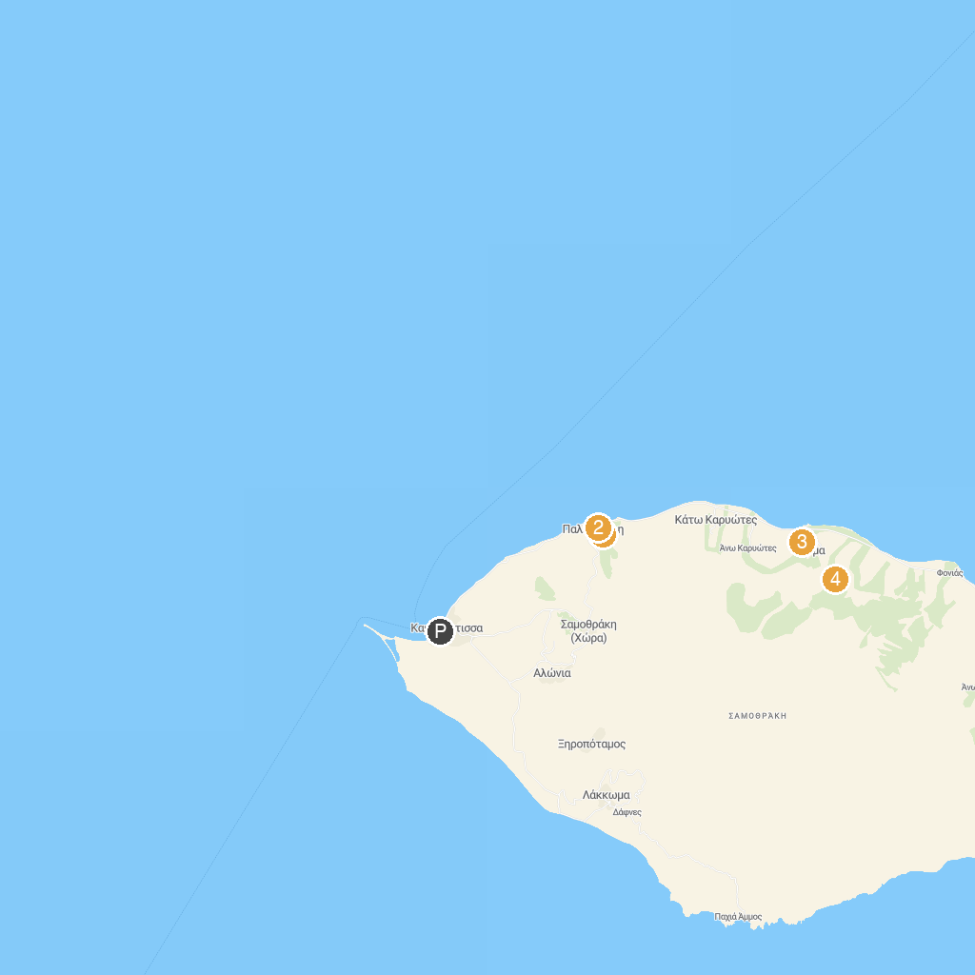
MAP KEY
1. Sanctuary of the Great Gods | 4. Waterfall Mikres Vathres
2. Archaeological Museum of Samothrace | 5. First Fonia's Waterfall
3. Thermal Baths
P. Cruise port / terminal
Map © MapTiler © OpenStreetMap contributors · cruiseports.org

