Salvador da Bahia, Brazil
Brazil's soulful first capital — a kaleidoscope of pastel colonial mansions, baroque gold churches, capoeira, and Afro-Brazilian rhythm, all stacked above a glittering bay.
⚓ Docked (central port) · 🕒 Typical call: 8–10 hrs · 💵 Brazilian Real (BRL) · 🗣️ Portuguese · limited English
✍️ MY DAY IN PORT (FILL IN)
Ship / Date
In port | arrive ______ · all aboard ______
Booked excursion
Notes / meeting point
GETTING ASHORE
- Docking: Porto de Salvador (central)
- To Pelourinho: Elevador Lacerda / walk
- Best For: History · Culture · Food
- Don't Miss: Pelourinho old town
GETTING AROUND
- 🚕 Taxi: R$15–R$20 to Pelourinho — Official metered taxis (white with red/blue stripe) queue outside the terminal. The historic center is under 1 km away —
- 📱 Rideshare: ✅ Uber, 99
- 🚌 Hop-on hop-off: ✅ Salvador Bus
TOP THINGS TO DO
- Pelourinho Walking Tour — The UNESCO-listed colonial heart — pastel mansions, the gilded São Francisco church (one of Brazil's most opulent), Largo do…
- Bonfim Church & Ribbons — The Igreja do Bonfim, Bahia's most beloved church, famous for its colorful wish-ribbons (fitas) and a fusion of Catholic and…
- Farol da Barra & Beaches — The lighthouse at Barra guarding the bay mouth, with a nautical museum and the city's most popular urban beaches for a swim and a…
- Acarajé & Bahian Food Tasting — Sample acarajé — the black-eyed-pea fritters fried in dendê palm oil by white-clad baianas — plus moqueca stew and other…
BEST WALKS
- Pelourinho old town: ~2 km · 1.5 hrs · easy (hilly) — From Praça da Sé through the Terreiro de Jesus and down the postcard slope of Largo do Pelourinho…
- Mercado Modelo & Lower City: ~1 km · 1 hr · easy — The handicraft market in the old customs house by the port — Bahian crafts, music, and capoeira — a…
- Farol da Barra waterfront: ~2 km · 1 hr · easy — The promenade around the Barra lighthouse where the bay meets the Atlantic — sunsets, sea breeze…
WEATHER · DAYLIGHT · MONEY
Month | High °F | Low °F | Rainy days
May | 80 | 75 | 24
Jul | 78 | 72 | 24
Sep | 79 | 73 | 18
Daylight: May 5:45AM–5:15PM · Jul 5:57AM–5:22PM · Sep 5:28AM–5:29PM
cruiseports.org/salvador · Confirm terminal & all-aboard time with your ship

Salvador da Bahia, Brazil — Port Map
Red = walkable sights · Amber = excursions farther out · P = cruise terminal
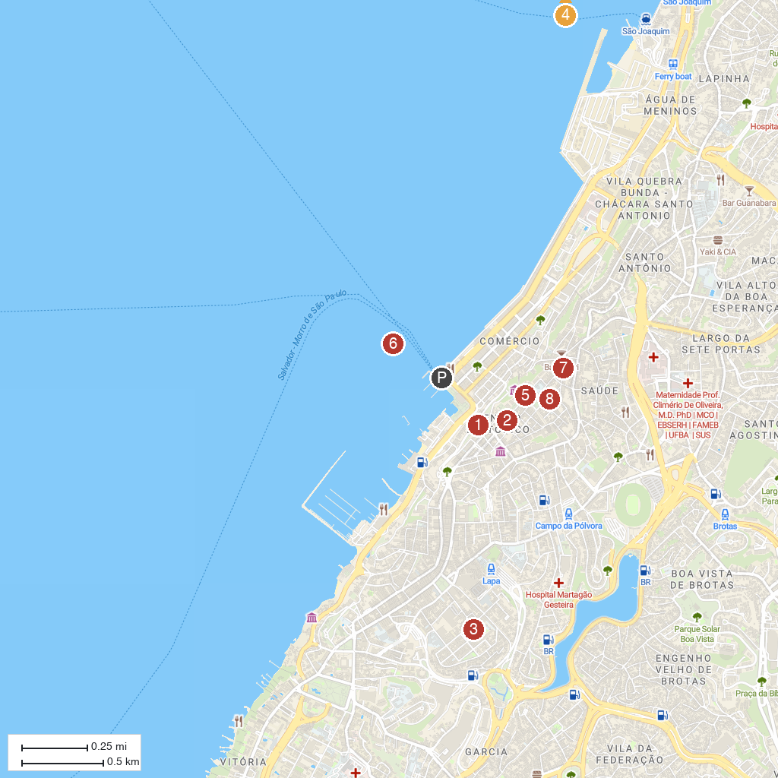
MAP KEY
1. Elevador Lacerda | 5. Cathedral of Salvador
2. Prefeitura Bairro Centro/Brotas | 6. São Marcelo Fort
3. Space Xisto Bahia | 7. Museu da Gastronomia Baiana
4. Basílica do Senhor do Bonfim | 8. MuNEAN- National Museum of Nursing Anna Nery
P. Cruise port / terminal
Map © MapTiler © OpenStreetMap contributors · cruiseports.org

