Salomague, Ilocos Sur, Philippines
The pier for Ilocos Sur drops you 45 minutes from Vigan — one of Asia's most intact Spanish colonial cities. Cobblestone streets, horse-drawn carriages, and double-fried bagnet await.
⚓ Pier (docked) · 🕒 Typical call: 8–10 hrs · 💵 Philippine Peso (PHP) · 🗣️ Ilocano / Filipino / English · 🌡️ Hot & dry — bring a hat
✍️ MY DAY IN PORT (FILL IN)
Ship / Date
In port | arrive ______ · all aboard ______
Booked excursion
Notes / meeting point
GETTING ASHORE
- Docking: Pier — ships dock alongside at Salomague Port, Cabugao
- Walk to Center: No walkable town center; Vigan is 45–60 min by van/bus
- Best For: UNESCO history, street food, heritage architecture, cultural day trips
- Don't Miss: Kalesa ride down Calle Crisologo and fresh Vigan empanada from a plaza stall
GETTING AROUND
- 🚕 Taxi: PHP 3,000–6,000 round trip (~$55–$110 USD) — Most practical option to reach Vigan City (~40 km, 45–60 min). Pre-book through your ship or local Ilocos travel groups;
TOP THINGS TO DO
- Vigan UNESCO Heritage City — Calle Crisologo is one of the best-preserved Spanish colonial streets in Asia.
- Bantay Bell Tower & Church — This 1591 watchtower sits on a hill above Vigan and served as a lookout post during Spanish rule and WWII.
- Pagburnayan Pottery Workshops — Ilocos artisans still fire traditional burnay clay jars using foot-powered wheels and underground kilns.
- Syquia Mansion Museum — Ancestral home of Philippine President Elpidio Quirino, preserved with 19th-century furnishings and period artwork.
- Pug-os Beach, Cabugao — A crescent of light-cream sand just 10 minutes by tricycle from the port.
BEST WALKS
- Calle Crisologo Heritage Stroll, Vigan: 1.5 km | Easy | 45–60 min drive from port — Start at Plaza Burgos — grab an empanada before you walk.
- Cabugao Town & Church Loop: 1 km | Easy | 10 min by tricycle from port — A gentle walk around Cabugao's town plaza, taking in St.
WEATHER · DAYLIGHT · MONEY
Month | High °F | Low °F | Rainy days
May | 88 | 79 | 22
Jul | 86 | 78 | 29
Sep | 85 | 78 | 26
Daylight: May 5:26AM–6:23PM · Jul 5:31AM–6:36PM · Sep 5:46AM–6:00PM
cruiseports.org/salomague-ilocos · Confirm terminal & all-aboard time with your ship

Salomague, Ilocos Sur, Philippines — Port Map
Red = walkable sights · Amber = excursions farther out · P = cruise terminal
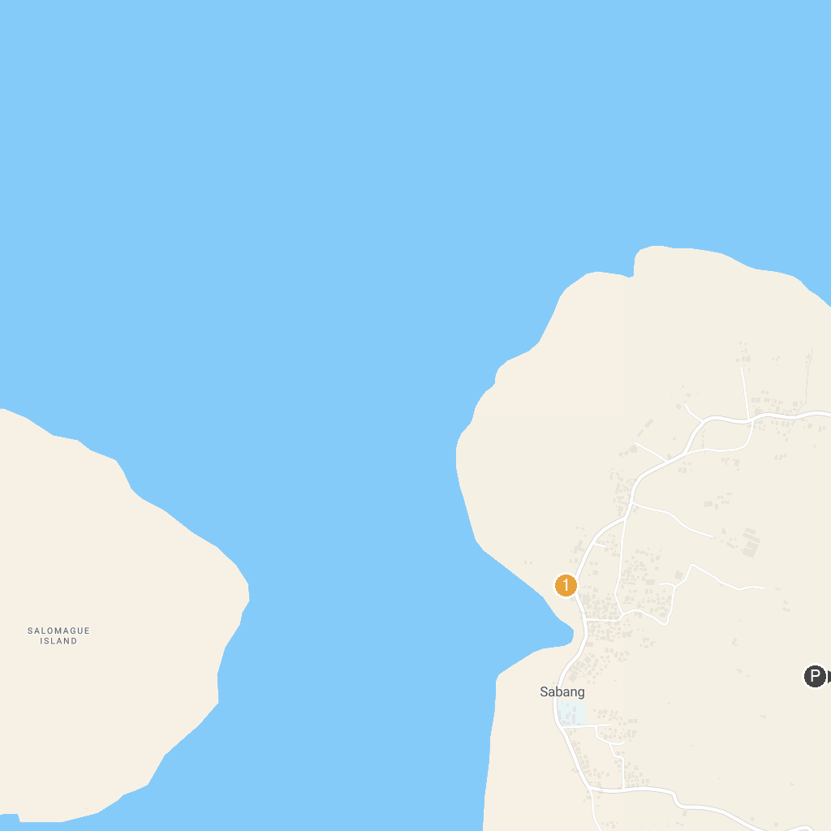
MAP KEY
1. Baluarte Resort and Mini Zoo | 3. Sabang Pier
2. National Museum of the Philippines - Ilocos
P. Cruise port / terminal
Map © MapTiler © OpenStreetMap contributors · cruiseports.org

