Saldanha Harbour, Western Cape, South Africa
South Africa's largest deep-water harbour hides a wild coast of turquoise lagoons, million-year-old fossils, and oysters plucked straight from the bay. Don't judge it by the iron-ore jetty — the beauty is minutes away.
⚓ Docked (multi-purpose quay) · 🕒 Typical call: 7-9 hrs · 💵 South African Rand (ZAR) · 🗣️ Afrikaans & English · 🌊 West Coast, 110 km north of Cape Town
✍️ MY DAY IN PORT (FILL IN)
Ship / Date
In port | arrive ______ · all aboard ______
Booked excursion
Notes / meeting point
GETTING ASHORE
- Docking: Ships dock at the General Cargo Quay; free shuttle to port gate (5-10 min)
- Walk to center: ~1 km from port gate to town waterfront — but transport is essential for most sights
- Best For: Shellfish lovers, birdwatchers, wildflower season (Aug–Sep), West Coast day trips
- Don't Miss: West Coast National Park, West Coast Fossil Park, oysters at the Slipway
GETTING AROUND
- 🚕 Taxi: ZAR 40–60 (~$2–3 USD) — The port is about 2.5 km from Saldanha town center. Local taxis are the most common option; agree on a fare before you g
- 📱 Rideshare: ✅ Uber
TOP THINGS TO DO
- West Coast National Park — Just 15 minutes from the port, this park wraps around the brilliant turquoise Langebaan Lagoon.
- West Coast Fossil Park — One of Africa's most important palaeontological sites, 25 minutes from port.
- Paternoster Fishing Village — 30 minutes north, this whitewashed village is one of the oldest on the West Coast.
- Oyster & Mussel Tasting in the Bay — Saldanha Bay is the shellfish capital of South Africa — the cold Benguela Current produces exceptionally sweet oysters and mussels.
- Langebaan Lagoon & Beach — A 20-minute drive across the bay brings you to Langebaan's famous turquoise lagoon — calm, warm-ish water popular for…
BEST WALKS
- Port Gate to Waterfront & Hoedjieskop: 1.5 km · 30-45 min · Easy — Walk from the port gate along the waterfront to the Slipway restaurant, then climb Hoedjieskop hill…
- Tabakbaai Beach Stroll: 1 km · 20 min · Easy — From the town centre, a short walk brings you to Tabakbaai Beach — a local favourite for picnics…
WEATHER · DAYLIGHT · MONEY
Month | High °F | Low °F | Rainy days
May | 67 | 53 | 5
Jul | 63 | 49 | 7
Sep | 66 | 52 | 6
Daylight: May 7:32AM–5:56PM · Jul 7:49AM–5:59PM · Sep 6:47AM–6:39PM
cruiseports.org/saldanha-harbour · Confirm terminal & all-aboard time with your ship

Saldanha Harbour, Western Cape, South Africa — Port Map
Red = walkable sights · Amber = excursions farther out · P = cruise terminal
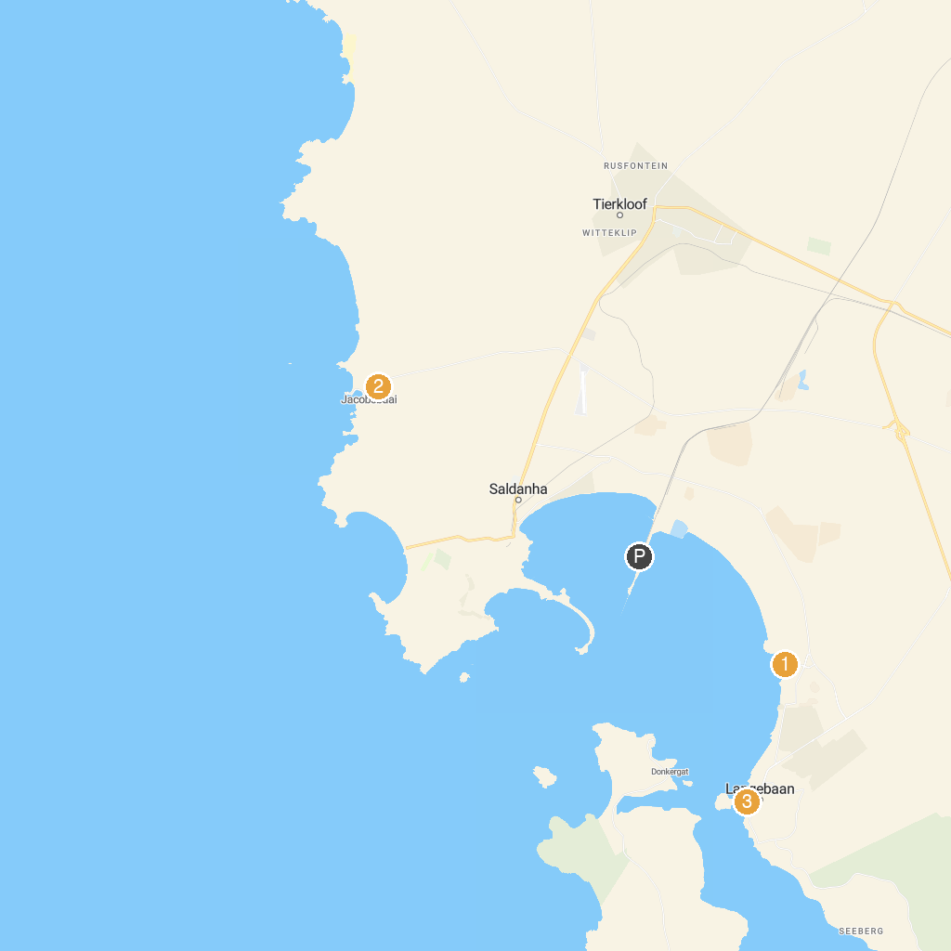
MAP KEY
1. Mykonos Casino | 3. The Pixie and Fairy Village
2. Sunnypark Fun Park Langebaan | 4. Langebaan Beach
P. Cruise port / terminal
Map © MapTiler © OpenStreetMap contributors · cruiseports.org

