Salaverry, Peru
A working industrial port on Peru's north coast, Salaverry is your gateway to Trujillo — a colonial city ringed by the greatest adobe ruins on Earth and a beach where fishermen still ride reed boats.
⚓ Docked — industrial pier, shuttle or tour required · 🕒 Typical call: 8–10 hrs · 💵 Peruvian Sol (PEN) · USD sometimes accepted · 🗣️ Spanish · little English outside hotels
✍️ MY DAY IN PORT (FILL IN)
Ship / Date
In port | arrive ______ · all aboard ______
Booked excursion
Notes / meeting point
GETTING ASHORE
- Docking: Industrial commercial pier
- To Trujillo center: ~15 km · taxi or tour bus
- Best For: Archaeology · Culture
- Don't Miss: Chan Chan UNESCO ruins
GETTING AROUND
- 🚕 Taxi: $9–$12 USD — Taxis wait at the port gate after the ship shuttle drop-off. Negotiate fare before boarding; the ride to Trujillo city c
- 📱 Rideshare: ✅ Uber, DiDi, InDrive
TOP THINGS TO DO
- Chan Chan: The Great Adobe City — The largest pre-Columbian city in South America and a UNESCO World Heritage Site, Chan Chan was the capital of the Chimú Kingdom…
- Trujillo Colonial City & Marinera — Peru's third-largest city wears its Spanish colonial past proudly: the Plaza de Armas is lined with candy-colored baroque…
- Huaca del Sol y de la Luna — Two massive mud-brick pyramids built by the Moche civilization (100–800 AD) rise from the desert south of Trujillo.
- Huanchaco Beach & Caballitos de Totora — A laid-back fishing village and surf town just north of Trujillo, Huanchaco is famous for the caballitos de totora — slender reed…
BEST WALKS
- Trujillo Historic Center Loop: 1.5 km · ~45 min · Easy — Start at the Plaza de Armas, admire the Cathedral and the baroque casonas, walk one block to the…
- Chan Chan Tschudi Complex: 2 km circuit · ~1.5 hrs · Easy flat paths — Follow the marked path through the restored royal compound, past the Ceremonial Courtyard and the…
- Huanchaco Waterfront Stroll: 1.5 km promenade · ~30 min · Flat — Walk the Malecón (beachfront promenade) from the fishing pier south past the colonial Iglesia de la…
WEATHER · DAYLIGHT · MONEY
Month | High °F | Low °F | Rainy days
May | 74 | 67 | 1
Jul | 71 | 63 | 0
Sep | 71 | 62 | 0
Daylight: May 6:20AM–6:04PM · Jul 6:31AM–6:12PM · Sep 6:09AM–6:12PM
cruiseports.org/salaverry · Confirm terminal & all-aboard time with your ship

Salaverry, Peru — Port Map
Red = walkable sights · Amber = excursions farther out · P = cruise terminal
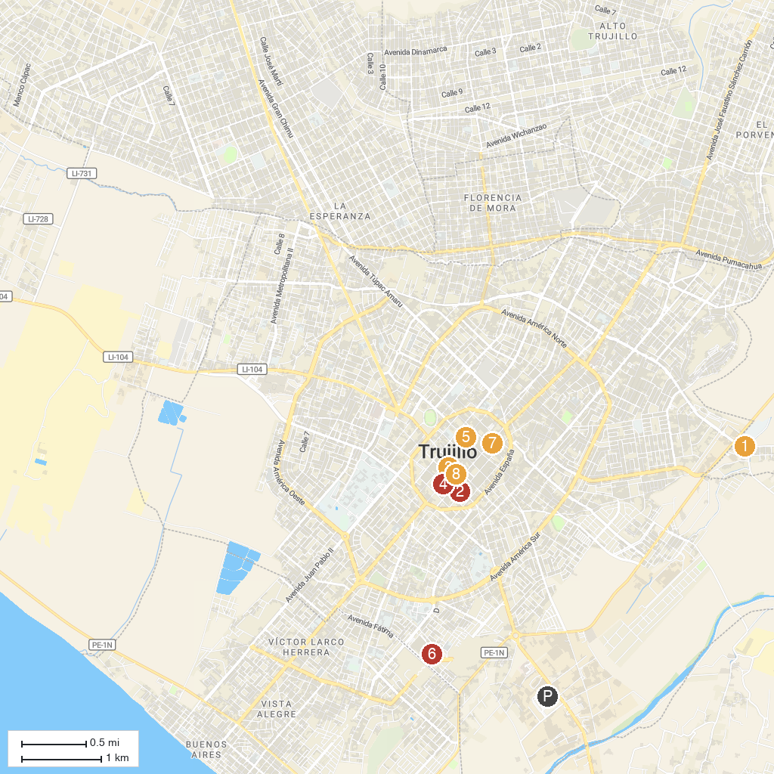
MAP KEY
1. Museum of Modern Art | 5. Trujillo Toy Museum
2. "Belen" Church | 6. Happyland
3. Plaza de Armas of Trujillo | 7. Carmen Monastery
4. Casa del Mayorazgo de Facalá | 8. Casa Urquiaga
P. Cruise port / terminal
Map © MapTiler © OpenStreetMap contributors · cruiseports.org

