Salalah, Dhofar, Oman
Arabia's green oasis, perfumed with the world's finest frankincense — Salalah is a land of UNESCO ruins, tropical beaches, and wild camels roaming limestone cliffs. It's unlike anywhere else on the Arabian Peninsula.
⚓ Pier (industrial container port) · 🕒 Typical call: 8-10 hrs · 💵 Omani Rial (OMR) · USD accepted · 🗣️ Arabic · English widely spoken · 🌿 Lush in Khareef (Jun–Sep)
✍️ MY DAY IN PORT (FILL IN)
Ship / Date
In port | arrive ______ · all aboard ______
Booked excursion
Notes / meeting point
GETTING ASHORE
- Docking: Pier at Mina' Raysut — 20 km west of city; walking in port prohibited
- Getting to Town: Ship shuttle to port gate, then taxi (~$15–20 one-way) or organized excursion
- Best For: UNESCO history, frankincense souqs, coastal scenery, cultural immersion
- Don't Miss: Al Baleed Archaeological Park & Museum of the Frankincense Land (UNESCO)
GETTING AROUND
- 🚕 Taxi: 12–20 OMR — Taxis are plentiful at the port but do not use meters — negotiate the fare before boarding. The city center is about 18
- 📱 Rideshare: ❌ not available
TOP THINGS TO DO
- Al Baleed Archaeological Park & Frankincense Museum — Walk the ruins of the ancient port of Zafar (12th–16th century), a UNESCO World Heritage site, then explore the Museum of the…
- Mughsail Beach & Marneef Cave Blowholes — Dramatic white-sand beach backed by limestone cliffs with natural blowholes — when the tide pushes in, seawater shoots through…
- Haffa Souq & Frankincense Shopping — Al Husn Souq (Haffa Souq) is the best place to buy authentic Dhofari frankincense resin, myrrh, traditional clay burners, and…
- Sumhuram (Khor Rori) Ancient Port — A second UNESCO World Heritage site — the ruins of an ancient fortified frankincense port overlooking a scenic coastal lagoon.
- Wadi Darbat Valley & Waterfalls — A lush valley carved through the Dhofar hills — during Khareef season (Jun–Sep) waterfalls pour into pools and wild camels graze…
BEST WALKS
- Al Baleed Park Ruins Walk: Easy · ~1 km loop · 45 mins — Once dropped at Al Baleed Archaeological Park, walk the marked trail through the ancient city ruins…
- Haffa Beach & Souq Stroll: Easy · ~1.5 km · 1 hr — From Al Husn Souq, walk south along Haffa Beach — a broad, palm-lined strand with fresh coconut…
WEATHER · DAYLIGHT · MONEY
Month | High °F | Low °F | Rainy days
May | 90 | 79 | 4
Jul | 84 | 77 | 10
Sep | 85 | 76 | 8
Daylight: May 5:52AM–6:47PM · Jul 5:58AM–7:00PM · Sep 6:11AM–6:25PM
cruiseports.org/salalah · Confirm terminal & all-aboard time with your ship

Salalah, Dhofar, Oman — Port Map
Red = walkable sights · Amber = excursions farther out · P = cruise terminal
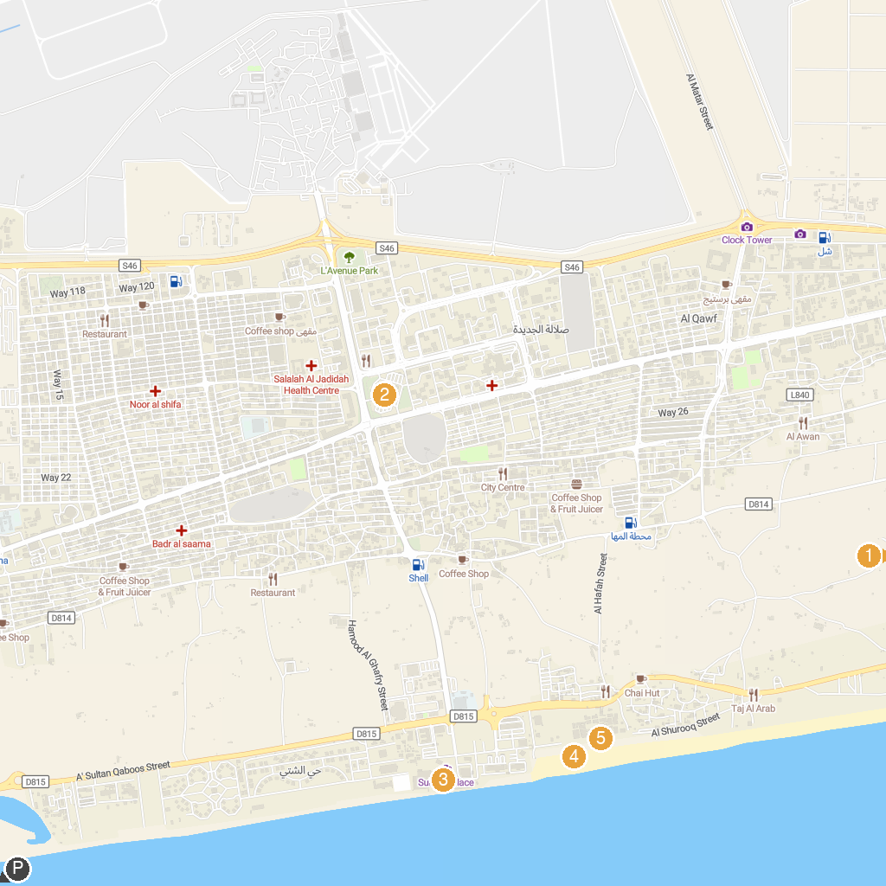
MAP KEY
1. Museum of the Frankincense Land | 4. Coconut beach
2. Sultan Qaboos Mosque Salalah | 5. Al Hafa Waterfront
3. Qasr al-Hosn
P. Cruise port / terminal
Map © MapTiler © OpenStreetMap contributors · cruiseports.org

