Sakata, Yamagata, Japan
One of Edo Japan's wealthiest port cities, Sakata trades on rice storehouses, a rare maiko teahouse, silky wonton ramen, and sweeping views of Mount Chokai across the Sea of Japan.
⚓ Pier (docked) · 🕒 Typical call: 8-10 hrs · 💴 Currency: Japanese Yen (JPY) · 🗣️ Language: Japanese · 🚌 Shuttle to city center
✍️ MY DAY IN PORT (FILL IN)
Ship / Date
In port | arrive ______ · all aboard ______
Booked excursion
Notes / meeting point
GETTING ASHORE
- Docking: Pier — outer industrial wharf, no tendering
- Shuttle to center: ~15 min (complimentary buses to Sankyo Soko or Sakata Station)
- Best For: Japanese history, architecture, local food & sake
- Don't Miss: Sankyo Soko storehouses, Somaro maiko performance, Sakata wonton ramen
GETTING AROUND
- 🚕 Taxi: ¥2,400–¥2,900 one way — Taxis cover the 5–7 km from port to city center in about 10–15 minutes. Not easily hailed from the street — ask port sta
TOP THINGS TO DO
- Sankyo Soko Rice Storehouses — Twelve black-walled wooden storehouses built in 1893 line a shaded zelkova-tree boulevard that has become Sakata's most…
- Somaro Maiko Teahouse — One of the only active maiko (apprentice geisha) cultures outside Kyoto.
- Former Honma Family Residence & Museum — Explore the estate of Japan's wealthiest merchant dynasty — so rich the locals said they'd rather be a Honma than a feudal lord.
- Kaikoji Temple — Self-Mummified Monks — Sakata's most unusual sight: two Sokushinbutsu — Buddhist monks who self-mummified through years of extreme diet and meditation.
- Dewa Sanzan — Sacred Mountain Shrines — About an hour by car, Mount Haguro is the most accessible of the three sacred Dewa mountains, featuring a 2,446-step cedar-lined…
BEST WALKS
- Historic Merchant District Loop: 2 km · ~2 hrs · Easy, flat — From the Sankyo Soko storehouses, walk through the historic downtown to the Somaro Maiko Teahouse…
- Honma Estate & Iimoriyama Park: 1.5 km · ~1.5 hrs · Easy — Walk from central Sakata to the Former Honma Family Residence, then continue to the Honma Museum of…
WEATHER · DAYLIGHT · MONEY
Month | High °F | Low °F | Rainy days
May | 67 | 52 | 14
Jul | 81 | 70 | 15
Sep | 76 | 65 | 16
Daylight: May 4:28AM–6:45PM · Jul 4:27AM–7:05PM · Sep 5:21AM–5:49PM
cruiseports.org/sakata · Confirm terminal & all-aboard time with your ship

Sakata, Yamagata, Japan — Port Map
Red = walkable sights · Amber = excursions farther out · P = cruise terminal
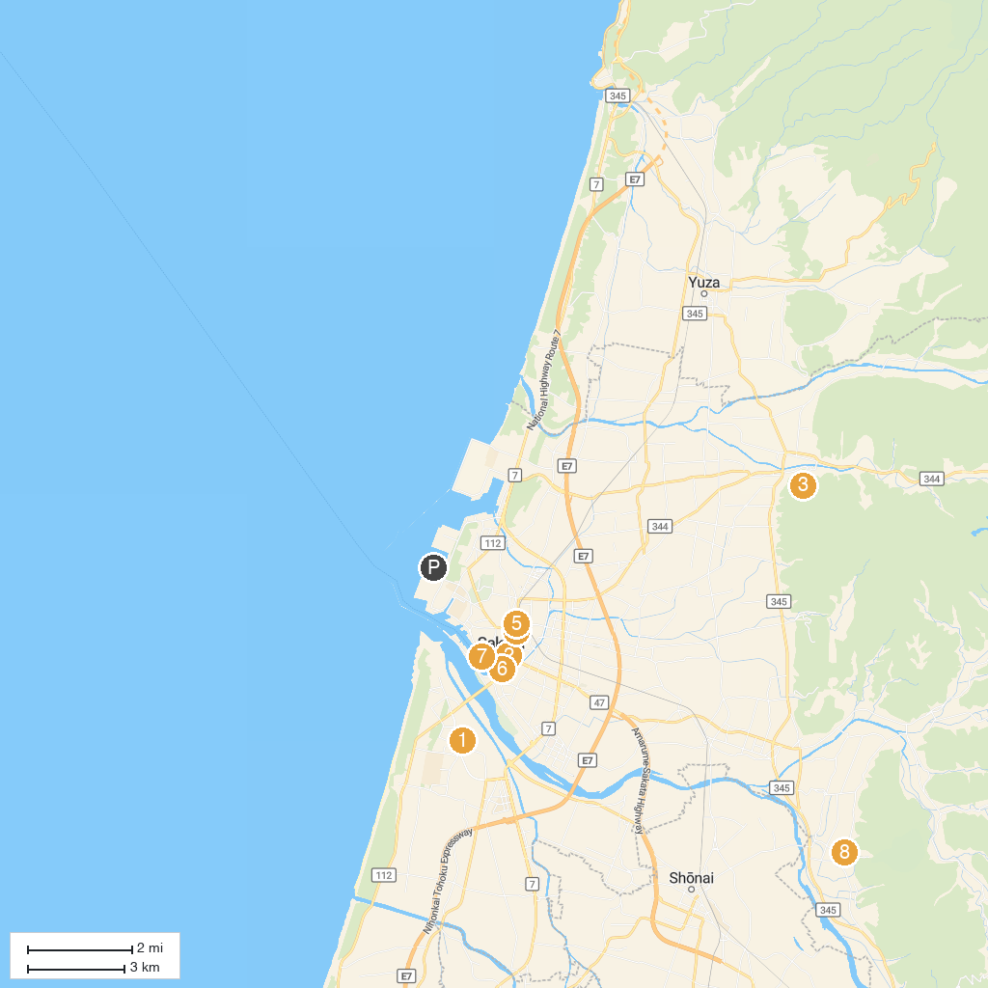
MAP KEY
1. The Ken Domon Museum of Photography | 5. Homma Museum of Art
2. 1. Homma Residence | 6. Sankyo Warehouse
3. Hachimori Natural Park | 7. Sakata Marine Center
4. Yakumojinja Shrine | 8. Matsuyama Cultural Lore Museum
P. Cruise port / terminal
Map © MapTiler © OpenStreetMap contributors · cruiseports.org

