Sakaiminato, Tottori / Matsue, Shimane, Japan
Birthplace of yokai manga and gateway to Japan's only original 'Black Castle', Sakaiminato pairs quirky street art with genuine samurai history — all within easy reach of the pier.
⚓ Pier (docked) · 🕒 Typical call: 6-8 hrs · 💴 Currency: Japanese Yen (JPY) · 🗣️ Language: Japanese
✍️ MY DAY IN PORT (FILL IN)
Ship / Date
In port | arrive ______ · all aboard ______
Booked excursion
Notes / meeting point
GETTING ASHORE
- Docking: Pier — Showa Kita Berth (smaller ships, walkable) or Takenouchi Minami Berth (large ships, free shuttle)
- Walk to center: 10-20 min from Showa Berth; shuttle from Takenouchi to Sakaiminato Station
- Best For: Manga fans, history lovers, Japanese garden seekers, seafood
- Don't Miss: Mizuki Shigeru Road and Matsue Castle moat boat ride
GETTING AROUND
- 🚕 Taxi: ¥1,000–¥2,500 (~$6–15 USD) — Taxis from Showa Wharf (smaller ships) to the city center cost around ¥1,000–¥1,300. From Takenouchi Wharf (larger ships
TOP THINGS TO DO
- Mizuki Shigeru Road — An 800-meter pedestrian street lined with 177 bronze yokai statues, themed eyeball streetlights, and monster-themed shops — the…
- Matsue Castle & Moat Boat — One of only 12 surviving original medieval castles in Japan, nicknamed the 'Black Castle' for its dark timber exterior.
- Adachi Museum of Art & Gardens — Consistently ranked the #1 Japanese garden for 20+ consecutive years.
- Izumo Taisha Grand Shrine — One of Japan's oldest and most sacred Shinto shrines, dedicated to the god of marriage.
- Sakaiminato Fish Market — Sakaiminato is Japan's top port for red snow crab (matsuba gani).
BEST WALKS
- Mizuki Shigeru Road Walk: 1.5 km · 20 min walk · Flat — Walk from the pier (or shuttle to Sakaiminato Station) and stroll the full 800 m of Mizuki Shigeru…
- Matsue Castle Quarter: ~1 km loop · 45 min walk · Flat — From Matsue Station, walk up to Matsue Castle, circle the moat, peek into the Lafcadio Hearn…
WEATHER · DAYLIGHT · MONEY
Month | High °F | Low °F | Rainy days
May | 69 | 58 | 10
Jul | 82 | 75 | 15
Sep | 77 | 71 | 16
Daylight: May 5:02AM–7:04PM · Jul 5:03AM–7:22PM · Sep 5:49AM–6:14PM
cruiseports.org/sakaiminato-matsue · Confirm terminal & all-aboard time with your ship

Sakaiminato, Tottori / Matsue, Shimane, Japan — Port Map
Red = walkable sights · Amber = excursions farther out · P = cruise terminal
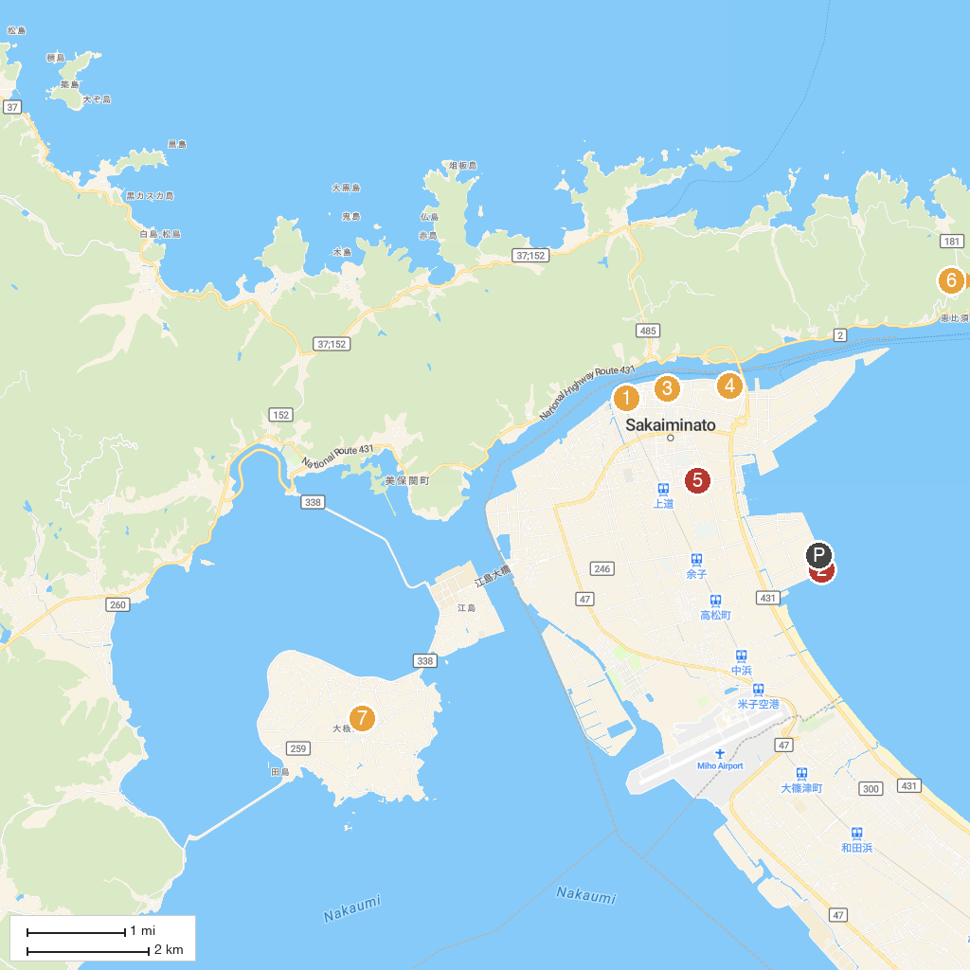
MAP KEY
1. Mizuki Shigeru Road | 5. Shofukuji
2. Yumeminato Tower | 6. Miho Shrine
3. Mizuki Shigeru Museum | 7. Ryukeido Lava Tunnel
4. Sakai Daiba Park
P. Cruise port / terminal
Map © MapTiler © OpenStreetMap contributors · cruiseports.org

